The Body’s Honest Invoice
Lifespan, Minds, and Why Ten Thousand Years Is Not a Straight Line
Lothar J. Musiol

The Body’s Honest Invoice: Lifespan, Minds, and Why Ten Thousand Years Is Not a Straight Line
Copyright © 2026 Lothar J. Musiol. All rights reserved.
Look First, Volume 3.
Kindle edition.
Photo credits for the store page are in the Amazon product description, not under figures.
No part of this book may be reproduced in any form without written permission from the author, except for brief quotations in reviews.

Contents
Prologue: The Capsule and the Hands
How to Read This Book
The Carrot, If You Start Here
A Note on the Series
Author’s Note
PART I — Local Fixes, Not Fountains
1. Her Hands Still Age
2. Lifespan Is Not Healthspan
3. Many Clocks, Not One Fuse
4. Every Clock Has a Cousin
5. Local Fixes
6. The Reset That Isn’t
7. Not a Fountain
PART II — The Organ You Already Use
8. We Already Use the Organ
9. Cognitive Enhancement, Two Temperatures
10. The Carrot Has No Off-Switch
PART III — Not a Straight Line
11. The Last Fifty Years Were Not a Straight Line
12. S-Curves and Invoices
13. Ten Thousand Years Is Not ×200
14. A Fast Trip Is Not a Long Life
15. A Long Sleep Is Not a Long Life
16. Coordination, Wars, Institutions
PART IV — The Honest Body
17. Medicine’s Invoices
18. Adjusting Is Not Spare Capacity
19. Copies, Uploads, and Cold Immortality
20. The Honest Body
APPENDIX — The Scientific Detail
How to Read These Notes
A0 / A1. A Local Dose Is Not a Species Change
A2. Life Expectancy, HALE, and the Supercentenarian Tail
A3. Hallmarks, the Dish Fence, and Why One Switch Is Not on the Counter
A4. Naked Mole Rats, Greenland Sharks, and the Limits of “No Aging”
A5. CRISPR-Class Edits: This Gene, This Tissue, This Invoice
A6. Four-Factor and Three-Factor Reprogramming: Papers, Dates, and the Teratoma Bill
A7. Cancer, Plumbing, Neurodegeneration: Many Doors
A8. The Ten-Percent Sentence, Lesions, and the Energy Bill
A9. Tools with Invoices: Sleep, Hearing, Stimulants, Implants
A10. Wanting, Liking, and Mismatch with More Calendar
A11. Vaccines, Packets, Sequence, Compute — and Named Walls
A12. Logistic Growth, Moore’s Bend, Sequencing’s Collapse
A13. Why 10,000 / 50 Is Arithmetic, Not a Method
A14. Proper Time, Time Dilation, and the Gravity of Clocks
A15. Torpor, Therapeutic Hypothermia, and What Slowing Metabolism Buys
A16. Meetings, Ledgers, Famines, Fronts
A17. Trials, Harm, and Who Pays for the Local Fix
A18. Plasticity Is Real and Expensive
A19. A File Is Not a Worldline
A20. Inventory of Claims, by Temperature
Equations at a Glance
Further Reading (tiered)
Glossary

Prologue: The Capsule and the Hands
A capsule arrives on the same delay as the orbiter’s voice. The label is optimistic. Her hands are not.
She works a greenhouse on a dead world — wet soil under LEDs the color of an overcast noon, a tray of basil that does not belong to this dirt, a radio that answers a quarter-hour late, or four minutes, depending on the week. There is no conversation. There is a stack of monologues that eventually, if everyone lives, amount to a plan.
The capsule is a local win in a blister pack. A joint that still works. A season she can still hit an airlock for. She takes the dose because local wins are the only kind biology has ever reliably sold. She does not become a different species. She names the basil, which is sentimental, and logs the pH, which is not.
This book is about what that scene is allowed to mean, and what a slide deck is not allowed to sell you on the back of it.
The short version, before it has been earned:
Lifespan is not healthspan. Aging is many clocks, not one fuse. A gene fix is a local repair — this instruction, this tissue, this invoice — not a fountain. The sentence we only use ten percent of our brain is false. You do not have a spare ninety percent in the cupboard waiting for a password. You have the organ you already use, plus sleep, plus practice, plus tools, plus other people. The carrot that makes a body chase a cue has no off-switch. A long life does not install one. And the last fifty years of real, uneven progress are not a method for drawing a straight line to the year 12,000.
Those are recognitions, not moods. They wear temperatures. The first chapter teaches the temperatures. The rest of the book spends them on mornings you would vote to repeat, on scissors with paperwork, on an energy bill the skull already pays, and on the walls that have names: energy, materials, attention, institutions, wars.
If you came for helium, you will not get helium. You may leave with a colder, better want: more mornings that are still worth logging.

How to Read This Book
Every claim in these pages wears one of three temperatures. The difference matters more than any slogan.
Hot — established. Measured, repeated, and used to predict new measurements. Lifespan and healthspan are different pots. The “ten percent of the brain” sentence is false. A sickle-cell-class gene edit — a fix for an inherited blood disease — can, in a growing list of cases, correct a broken instruction in a lineage of cells that will keep the correction. The last half-century produced real, uneven gains: vaccines that closed rooms of death, a genome you can read without a monastery, packets that keep a signal clear across a long delay, cheaper compute. Clocks that move fast, or sit deeper in a gravitational well, tick at different rates from clocks left behind.
Warm — working account. The best story we have, with real gaps. Aging is many clocks, not one fuse: the pieces are real; a single kitchen switch is not on the counter. Modest further gains in healthy years this century, in rich-country medicine, if institutions hold. Progress that is more often an S-curve than a ray. Whatever is invented will still pay energy, coordination, and the body’s invoices.
Cold — speculation dressed as a product. Allowed as a wish. Not selected by present levers. A body-wide rewind. A scheduled 150-year, 200-year, or thousand-year ape. Unlocking a hidden ninety percent of mind. Last fifty years × 200 = the furniture of the year 12,000. A file that is you, forever. A required last mind at the end of time. Progress as a law that fires if we wait. A fast trip sold as a longer life.
A claim can change temperature. A local gene fix that was a paper in 2012 can be a clinic in 2023. A fountain does not get warmer because the local fix did. Do not let a hot win launder a cold catalog.
On a standing rule from the rest of this series: string theory, if it is named, cannot currently be tested. It is a large mathematical framework. It has not produced a unique, risky prediction that would kill it if the experiment came out otherwise. This book barely needs it. If a slide uses “quantum” as incense over a longevity claim, ask for the invoice, not the incense.
A few scenes are stories: a greenhouse on a dead planet, a radio that answers late, a capsule that may keep a joint useful, a committee that cannot agree, a founder with a straight line on a wall. They are thought experiments with dirt on them. The numbers in them are real. The people are invented. They are here so the clocks have somewhere to sit besides a diagram.
The main chapters keep the numbers in the sentence, the way a good explainer talks at a table. A handful of relations are important enough to sit still.
where HALE is healthy life expectancy — years you would, on present evidence, vote to repeat — not the years a wall clock can still be embarrassed by a pulse.
Those numbered marks, and the tables behind them, live in the Appendix. If you want the scaffolding, it is there. If you want the argument, you can finish the book without opening the back.
You do not need a medical degree. You do not need Book 1. You need curiosity and a willingness to let a miracle come apart into pots.

The Carrot, If You Start Here
Book 1 of this series taught a kitchen fact about wanting: a lineage that must copy, search, and pay will not last if the staff treats the invoice as optional. Pleasure is staffing. The cue can be turned up until a fake outbids the thing. The carrot has no off-switch labeled this is only a picture.
That book said it about a feast and a fake. You do not need those pages. The fact is still true if the feast is a long life.
A Pleistocene wanting-loop — seek, tag, chase, get a stamp, seek again — in a body that lasts 120 years is not a wise king. It is a mismatch with more calendar. Sugar, a slot, a feed that never ends, a slide that says enhancement: same family. Wanting is one juice. Liking is another. The off-switch was never hired. Look first before you call the extra years an upgrade. Chapter 10 teaches the loop in full. One courtesy is enough. The rest of this book will not assign Book 1 as homework.

A Note on the Series
This book is Volume 3 of Look First. It is a complete book. You are not being assigned homework.
If you already have Volume 1, The Universe Has No Now, you will recognize a woman, three temperatures, and a habit of looking first. You do not need its leftover glow, its courtroom about the first three minutes, or its map of other solvents. Those rooms stay there. This kitchen is the body, the organ you already use, and the lie of the straight line.
If you already have Volume 2, A Permit Is Not a City, you will recognize the same greenhouse and a ruder question about camps. This book does not reopen landing windows. A pill is not a downtown.
A backward point in these pages is a courtesy, not a chore. The loaf — the idea that all the times are already on the inventory — gets at most one sentence here. You can finish without it. Chapter 14 does borrow one corner of Book 1’s ground, the clock a path keeps, and rebuilds it from a pencil and a page, so you never need the other book.
You can stop here. Her hands will still age tomorrow. That is not a tragedy the cosmos owes you a refund for. It is the starting fact.

Author’s Note
Most people meet the future of the body in the wrong order.
First comes a headline about a gene. Then a chart that goes up and to the right. Then a sentence that says we only use ten percent of the mind, so the other ninety is a tank. Then — if the talk has nerve — a straight line from the last fifty years of gadgets drawn across ten thousand years of furniture nobody can name. Time is treated as a fuse you can pull. DNA is treated as a fountain. The brain is treated as a cupboard. Civilization is treated as a transistor with a calendar.
That order is commercially understandable. It is roughly the order a slide deck discovers these things. It is not the order that makes the invoices easiest to see.
This book runs a different sequence on purpose. It starts with a pair of hands that still age after a useful dose, because that is what a local win looks like when you refuse helium. Only after lifespan and healthspan have been split into two pots does it turn to the many clocks, the local scissors, the organ you already staff, the carrot that will not switch off, and the cartoon that multiplies a real half-century by two hundred and calls the product a kitchen.
John D. Barrow’s short books are still the formal model: brief chapters, no swagger, a clean line between a measurement and an idea for ideas. The biology neighbors are the honest histories — the gene as a local object, medicine as an S-curve, the brain as an energy bill — not the startup keynote. Where a clinic and a keynote disagree, the disagreement is the point.
The pictures in Chapter 14 owe their method to Lewis Carroll Epstein’s Relativity Visualized, which teaches relativity by drawing the picture first, with a pencil and graph paper. The drawings here are new. The habit of drawing the path before doing any algebra is his.
A book like this should not succeed because a reader can recite a hallmark of aging. It should succeed if a sequence of recognitions arrives and stays:
that years on a wall clock are not years you would vote to repeat;
that aging is many clocks, and a shout at one does not reset the kitchen;
that a gene fix is this tissue, this invoice — a class of win, not a fountain;
that a 150-year scheduled product is a wish, and a thousand-year ape is colder still;
that the ten-percent sentence is false, and idle-looking tissue is still on duty;
that plasticity is real and expensive, not a spare tank;
that education, sleep, a hearing aid, a stimulant with a known bill are tools, not unlocks;
that the carrot has no off-switch, and a longer life is more calendar for the mismatch;
that the last fifty years were real and are not a method;
that progress is more often an S-curve, and diminishing returns are a kitchen fact;
that fifty into ten thousand is two hundred, which is arithmetic, not physics;
that a fast trip is a skip, not a long life, because the body keeps its own clock;
that the limit is often a meeting, a ledger, a famine, a front;
that a file is not a worldline;
and that the honest product, if you want one, is a morning still worth hitting an airlock for.
That last recognition is not a counsel of despair. It is the opposite. If helium is not scheduled, meaning is made in the useful season — this copy, this joint, this pH.
Readers of The Universe Has No Now will notice a family resemblance: start with the variable that makes the hygiene simple, not the variable that got sold first. There, the variable was the event. Here, it is the clock the body actually keeps — many of them — and the difference between a local fix and a sermon.

PART I — Local Fixes, Not Fountains

1. Her Hands Still Age
The airlock sticks on cold mornings. She hits it with the heel of her glove, the way you hit a jammed kitchen drawer, and it sighs. Inside, the greenhouse is the only room that smells like a lie: wet soil, torn basil, a sweetness that does not belong to this planet. The lie is maintained with LEDs and a tray of water she melted, yesterday, from a vein of ice the color of dirty chalk.
A capsule arrives on the same delay as the orbiter’s voice. Twenty minutes, or four, depending on the week. The label is optimistic. A small paragraph about support and maintenance and a season that can still be used. Her hands are not optimistic. The knuckles have begun to look like a map of a place she has already walked. The joint that used to open a jar without a thought now asks for a meeting.
She takes the dose because a joint that still works is a local win, and local wins are the only kind biology has ever reliably sold. She does not become a different species. She names the basil, which is sentimental, and logs the pH, which is not. On a dead world, sentiment is allowed as long as it does not get to vote.
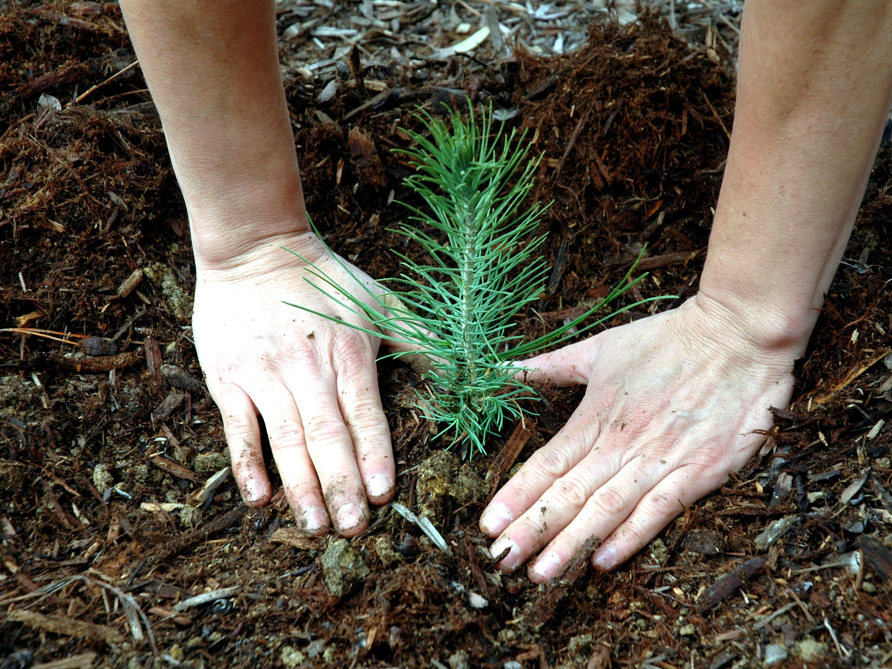
Figure 1. Working hands over a basil tray in hard light; a plain blister at the edge. The dose is local. The hands are still the hands.
This is the only honest picture of “the future of us” this book will allow in the near term. Not a downtown on a poster. Not a thousand-year ape with a product number. A body you can weigh. A chemistry you can bully. A radio that is late on purpose. A useful season, if the invoice clears.
The rest of the book is about what that scene is not allowed to launder.
People meet a capsule and promote it.
The promotion has a few favorite costumes. The dose becomes a species change. The gene becomes a fountain. The brain becomes a cupboard with ninety percent still in the wrapping. The last fifty years of gadgets become a ruler you can lay across ten thousand years of unnamed furniture. Each costume is useful to someone who sells keys. None of them is a measurement.
This book will keep a kitchen habit about claims. Every sentence that matters wears a temperature.
Hot means established: measured, repeated, used to predict the next measurement. Her hands age. That is hot. A pulse can embarrass a wall clock for a long evening in a chair, and those extra years are not the same pot as years you would vote to repeat. That split is hot. The sentence we only use ten percent of our brain is false. That correction is hot. In a growing list of cases, a broken instruction in a lineage of cells can be reached and corrected, and the lineage keeps the correction. That class of win is hot.
Warm means a working account with real gaps. Aging is many clocks, not one fuse. The clocks have names and papers. A single switch that resets the kitchen is not on the counter. Modest further gains in healthy years this century, in rich-country medicine, if the institutions that run trials and pay invoices still exist. Progress that rises, drunk, and then meets a wall more often than it rises forever. Whatever is invented will still pay energy, coordination, and the body’s bills.
Cold means a wish allowed by talk, not selected by present levers. A body-wide rewind. A scheduled product at 150 years, or 200, or 1,000. Unlocking a hidden full brain. Last fifty × 200 = the year 12,000’s kitchen. A file that is you, running forever. A required last mind at the end of time. Progress as a law that fires if we wait.
A claim can change temperature. A local edit that was a clever paper can become a clinic. A fountain does not become a clinic because the local edit did. The laundering is the sport this book is here to spoil.
If you have Volume 1 of this series, you have already met the temperatures on a different kitchen clock — the one that pretended the universe shared a now. You do not need those pages. The hygiene travels. The leftover glow does not. We will not reopen that courtroom.
If you have never met the temperatures, you have them now. Use them on the capsule. Use them on the slide. Use them on the sentence that says DNA as if DNA were a tap.
She is an invented person. The numbers around her are not invented.
Worldwide, on the most recent count anyone has bothered to run properly, something like 595 million people carry osteoarthritis in some joint, and roughly 194 million of those cases sit in the hands specifically — hers is not a rare complaint, it is one of the most common diagnoses a human body ever files. A human joint is cartilage, bone, a little sac of fluid, a staff of cells that keep a surface honest. The staff gets worse at the job. Inflammation writes graffiti. The surface pits. Pain is not a metaphor. Pain is a measurement the nervous system makes and will not stop making because a label was optimistic. A drug that lowers the graffiti, or a lubricant the body will accept, or a replacement that a surgeon can bolt in, is a local win. Local is the word that has to sit still.
where local means this tissue, this season, this invoice — not a reset of the house.
The same woman still copies DNA with a small error rate. She still shortens the little caps on the ends of chromosomes — the long strands of coiled DNA inside a cell — in the lineages that divide. She still runs mitochondria that leak and forget. She still keeps an immune system that has learned too many grudges and forgotten some of its tact. She still accumulates cells that refuse to die and then spoil the room. She still wears grooves in a brain that has been on duty since the first language she learned. Chapter 3 is those clocks. Chapter 1 is the refusal to let one useful dose pretend it wound them all back.
Look first.
That rule, in Volume 1, meant do not plague a dark sea because you were lonely for a cousin. Here it means a narrower, ruder thing: do not overwrite a genome, or a childhood, or a morning you already know how to staff, because a slide said enhancement. The slide is a cue. The carrot that makes a cue feel like a feast has no off-switch. Chapter 10 teaches the loop. You do not need a prior book to take the warning. If a capsule arrives with a sermon attached — this is the first day of the new species — put the sermon down and keep the joint, if the joint is what you paid for.
She logs the pH because the dirt has a chemistry, and the chemistry can be bullied, and bullying is a measurement. Sentiment names the basil. Sentiment does not get to vote on whether the tray is too alkaline. The future of the body is the same kitchen. You can name the hope. You log the clocks.
A word about helium, so we do not waste it later.
Helium, in this series, is the thing a slide wants you to treat as already on the loading dock: immortality, a downtown on a dead world as a product this decade, a required mind at the end of time, a spare brain in the cupboard, a straight line to furniture we cannot name. Helium is cold when it is sold as scheduled. Useful seasons are not helium. A hearing aid is not helium. A vaccine that closed a room of death is not helium. A sickle-cell-class edit that lets a person walk without a crisis is not helium. Those are tools. Tools have invoices. Helium is what you wait for instead of hitting the airlock.
She does not wait for helium. She hits the airlock. The rest of this book is the argument that this is not small-mindedness. It is the only size biology has ever reliably sold.
Local is a pharmacist word before it is a slide word. A dose that keeps a joint useful for a season is a win with a blister and a delay. It is not a species change. Marketers borrow the noun and promote it until the hands look like a footnote. Put the hands back in the frame. They still age. That is hot. The capsule may buy a Tuesday she would vote to repeat. It will not buy helium. On a dead world, sentiment may name the basil. Sentiment does not get to vote. Log the pH. Hit the airlock. Take the local win. Walk past every colder costume that tries to launder it into a fountain.
Appendix A1 writes what “local” has to mean when a pharmacist and a marketer share a noun. Here, keep the hands. They still age. That is the first hot fact. Everything colder will have to walk past it.
Where the popular version goes wrong.
The slide promotes the noun and crops the receipt. Look first: ask what was measured, what still needs Earth or a body, what the checklist still leaves empty.
Rule: Hands still age after a useful dose. Take the local win. Put helium down.

2. Lifespan Is Not Healthspan
Lifespan is not healthspan.
Lifespan is how long the clock on the wall can be embarrassed by your pulse. Healthspan is how many of those years you would vote to repeat. You can add frail years. That is easy to mistake for a miracle. It is a longer evening in a chair. The honest product, if you want one, is mornings that are still worth hitting an airlock for.
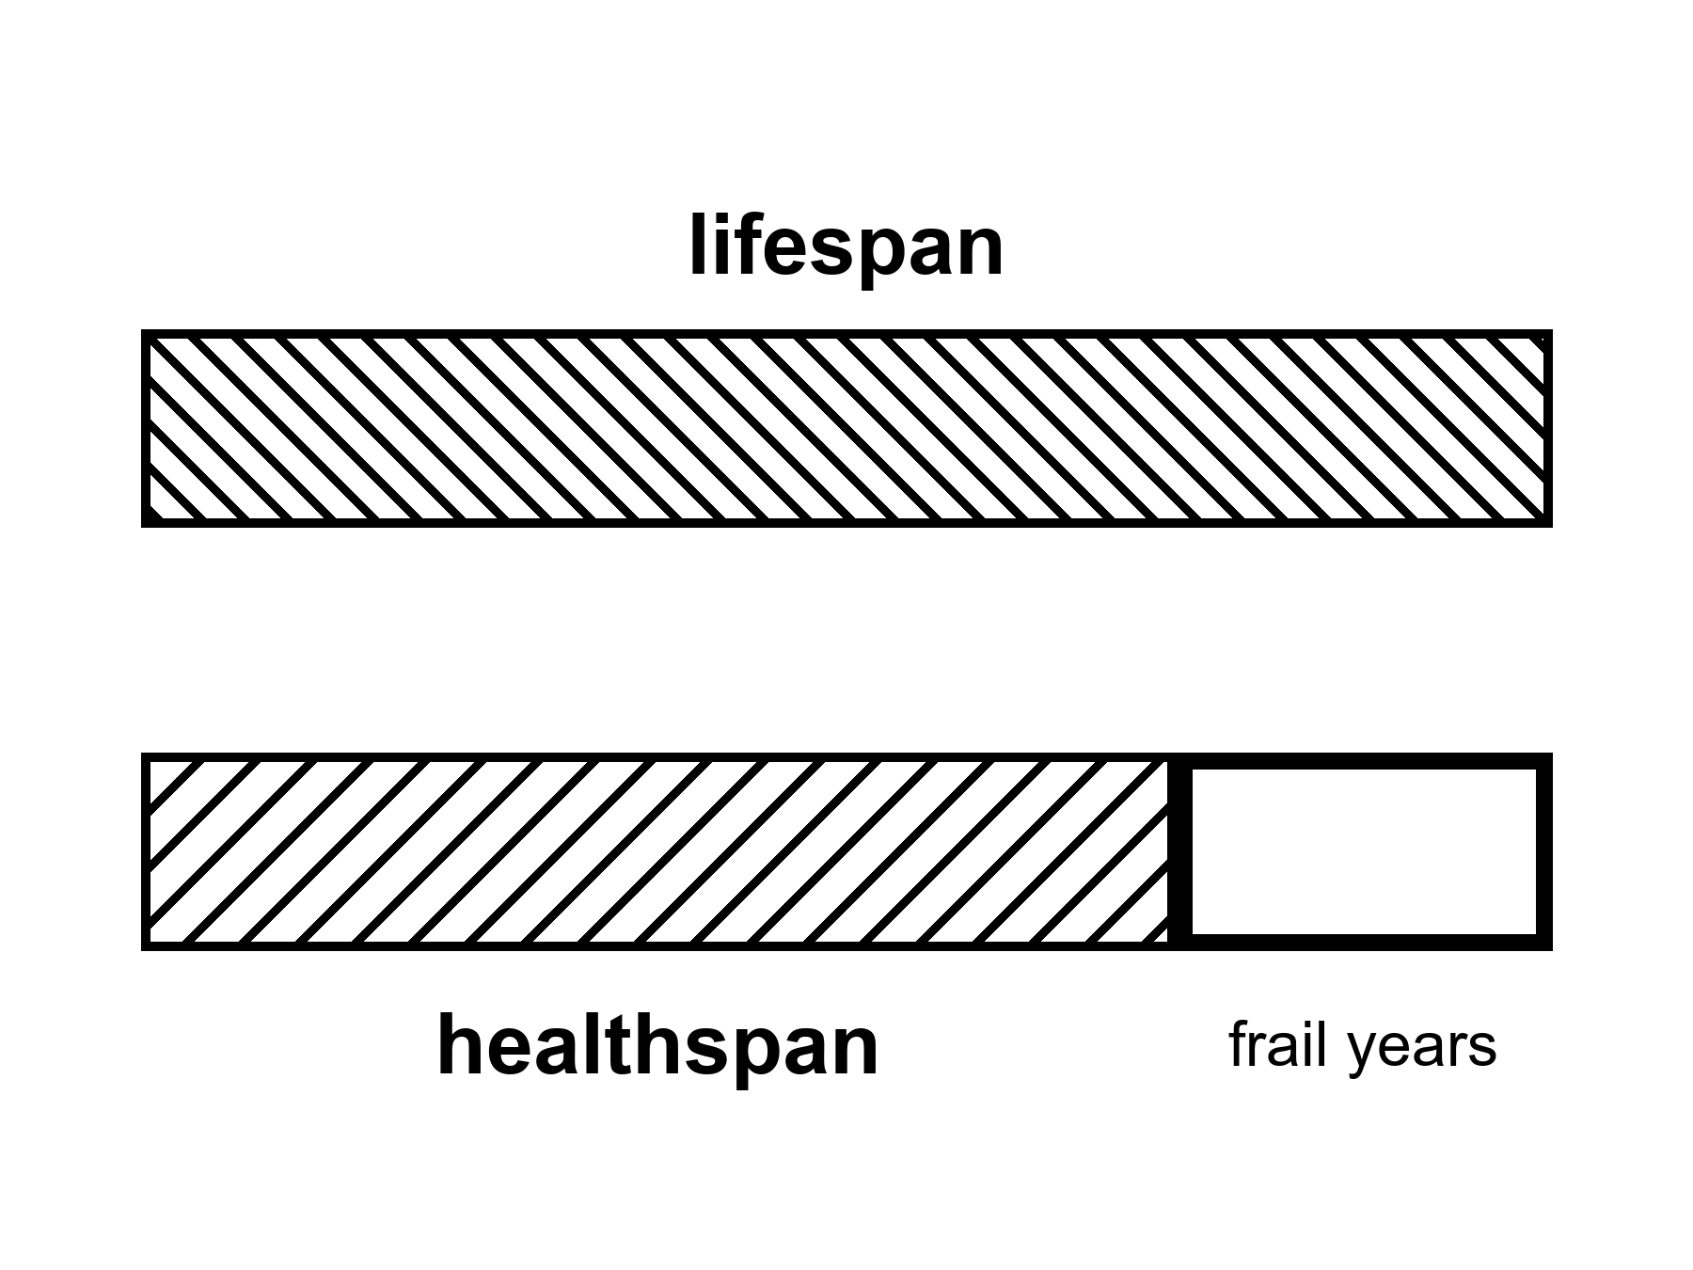
Figure 2. Two full-width bars: lifespan and healthspan. The leftover hatch is frail years. Notice which bar people think they bought.
The split is hot. Demographers have been running it for decades under plainer names. Life expectancy at birth is a summary of death rates in a year, not a promise to a baby. Healthy life expectancy — HALE, in the World Health Organization’s ledger — subtracts years lived with disability, weighted by how much function was lost. The subtraction is ugly and necessary. A country can raise the first number by keeping people alive in a bed. The second number tells you whether the extra was a morning.
where HALE is the years lived in a state you would, on present evidence, vote to repeat.
In rich countries the wall-clock number sits in the low-to-mid eighties for women, a little lower for men. Japan, Switzerland, Spain, Australia, Italy, the Nordic kitchens: that band. The United States runs lower — the high seventies in recent ledgers, after a ugly dip and a partial climb — because a rich country can still fail at the boring work: guns, opioids, metabolic disease, a medical bill that is also a maze. Global life expectancy rose by decades across the twentieth century. Most of that rise was not a fountain. It was clean water, vaccines, antibiotics, midwifery, food that arrived. Child death is a slaughter of years. Stop the slaughter and the average leaps. That leap is hot, and it is mostly finished in the places that already have pipes.
Healthspan lags. The lag is the point. A person can live into the eighties and spend the last eight or ten years in a narrowing of the room: the walk that became a shuffle, the names that need a prompt, the joint that will not take the airlock, the breath that makes a sentence a project. Those years count on the wall. They do not automatically count as the product people heard when they heard we are living longer.
Compression of morbidity is the warm hope with a name. You keep the bad years short and stacked against the end. Expansion of morbidity is the easy mistake: you stretch the bad years because you are good at not letting the pulse stop and less good at keeping the morning. Both happen. Different diseases, different countries, different decades. The honest ledger is not a vibe. It is two numbers and a fight about the weights.
The longest well-documented human life ended at 122.
That sentence is a tail, not a product. Her name was Jeanne Calment, a Frenchwoman with a documented life that ran from 1875 to 1997, and the documentation has been picked at, as tails always are: a researcher argued in 2018 that she and her daughter had swapped identities decades earlier for a tax dodge, which would have made the real record younger by a generation. Demographers went back through birth, marriage, and property records and found the swap did not hold up; the 122 years stood, the most thoroughly checked age claim on record precisely because someone tried hard to break it. Take the number as ~122 and sit it still. It is the far end of a distribution, not a mean you can schedule. Supercentenarians — 110 and over — are rare enough to be a sport for validators. The sport is not a clinic. Nobody has a protocol that prints 122. Nobody has a protocol that prints 150 as a SKU. The tail says a human body can, under a lottery of genes, luck, and a century that did not kill her early, run that long. The tail does not say your slide can order the lottery.
Maximum lifespan and life expectancy are different pots again. Life expectancy is a population average that moves when children stop dying and when seventy-year-olds stop dying of things we learned to treat. Maximum lifespan is the right-hand fence of the species as observed. The fence has not sprinted. The averages did. That is why a chart of “we doubled life” can be true about the average and a liar about the fence. We doubled the average mostly by not losing the young. We did not double the right-hand fence.
A person who wants helium hears 122 and adds a gene. The arithmetic feels like science because both sides have numbers. It is not a method. Chapter 7 is the cold water. Here, keep the two pots. You can raise a mean without moving a fence. You can move a fence in a mouse and not in a woman. You can add years to a pulse and subtract them from a vote.
What would a vote even mean?
Not a survey in a mall. A vote, in this book, is the test you already know how to run. Would you take this Tuesday again? The Tuesday with the walk, the work, the name of the basil, the radio that is late, the pain that is a two and not an eight. If the answer is yes, that year is healthspan even if a doctor’s form has a code on it. If the answer is no, and the no is not a mood but a room that has closed, that year is lifespan without the product.
People lie to themselves about the vote. A slide can make a chair look like a morning. Grief can make a morning look like a chair. The scientific point is narrower than therapy. When a company says years of life, ask which pot. When a government boasts a rising expectancy, ask what happened to HALE. When a founder says 150 is conservative, ask for the fence, the species, and the invoice.
Rich-country medicine in the last seventy years added a great deal of lifespan and a real, smaller deal of healthspan. Hip replacements, cataracts, blood pressure pills, statins, HIV turned from a cliff into a condition, some cancers turned from a sentence into a long negotiation. Those are hot as classes of win. They are also a demonstration of the split. You can walk on a metal hip and still be running many clocks. You can see the basil again and still be tired in a way sleep does not fix. The product was the walk and the sight. The sermon was we are becoming immortal. The sermon was cold.
Modest further gains in healthy years this century, in the kitchens that already have pipes and trials, are warm. Not a law. A continuation of a slowing curve if the institutions hold. Everyone on Earth shares those gains: cold as a default. The invoices are unequally paid. Chapter 17 is that inequality with the lights on. Here, notice that a global average can rise while a neighborhood falls, and that a neighborhood can rise while a body in it is still a chair.
She would vote for a morning that includes the airlock. She would not vote for a longer evening in which the radio still answers and the hands will not. The capsule, if it works, buys the morning. That is already a great deal. It is not a different species. It is not a fence moved to 200. It is a joint.
Healthspan is the product people thought they bought when the wall clock lost. A longer pulse is not a Tuesday you would vote to repeat. Demographers split the pots long ago; marketers glue them back together for a slide. Ask for HALE, or for the morning test, before you pay for a calendar. The 122-year fence is a tail on a distribution, checked hard and still standing, not a ship date for a brand. Averages rose mostly by sparing the young from slaughter. That leap is mostly finished where pipes, vaccines, and midwives already run. Keep the two bars hatched differently. If a founder sells lifespan as if it were healthspan, ask which bar is on the invoice.
Where the popular version goes wrong.
The slide promotes the noun and crops the receipt. Look first: ask what was measured, what still needs Earth or a body, what the checklist still leaves empty.
Rule: Lifespan is not healthspan. Want mornings you would vote to repeat, not a longer evening in a chair.

3. Many Clocks, Not One Fuse
Aging is not one fuse. It is many clocks.
That sentence is hot-to-warm. Hot as a refusal of the single-switch story. Warm as a map of mechanisms that are real, incomplete, and still being argued by people who do this for a living. The map is not a product. The map is why a pill that shouts at one clock does not reset the kitchen.
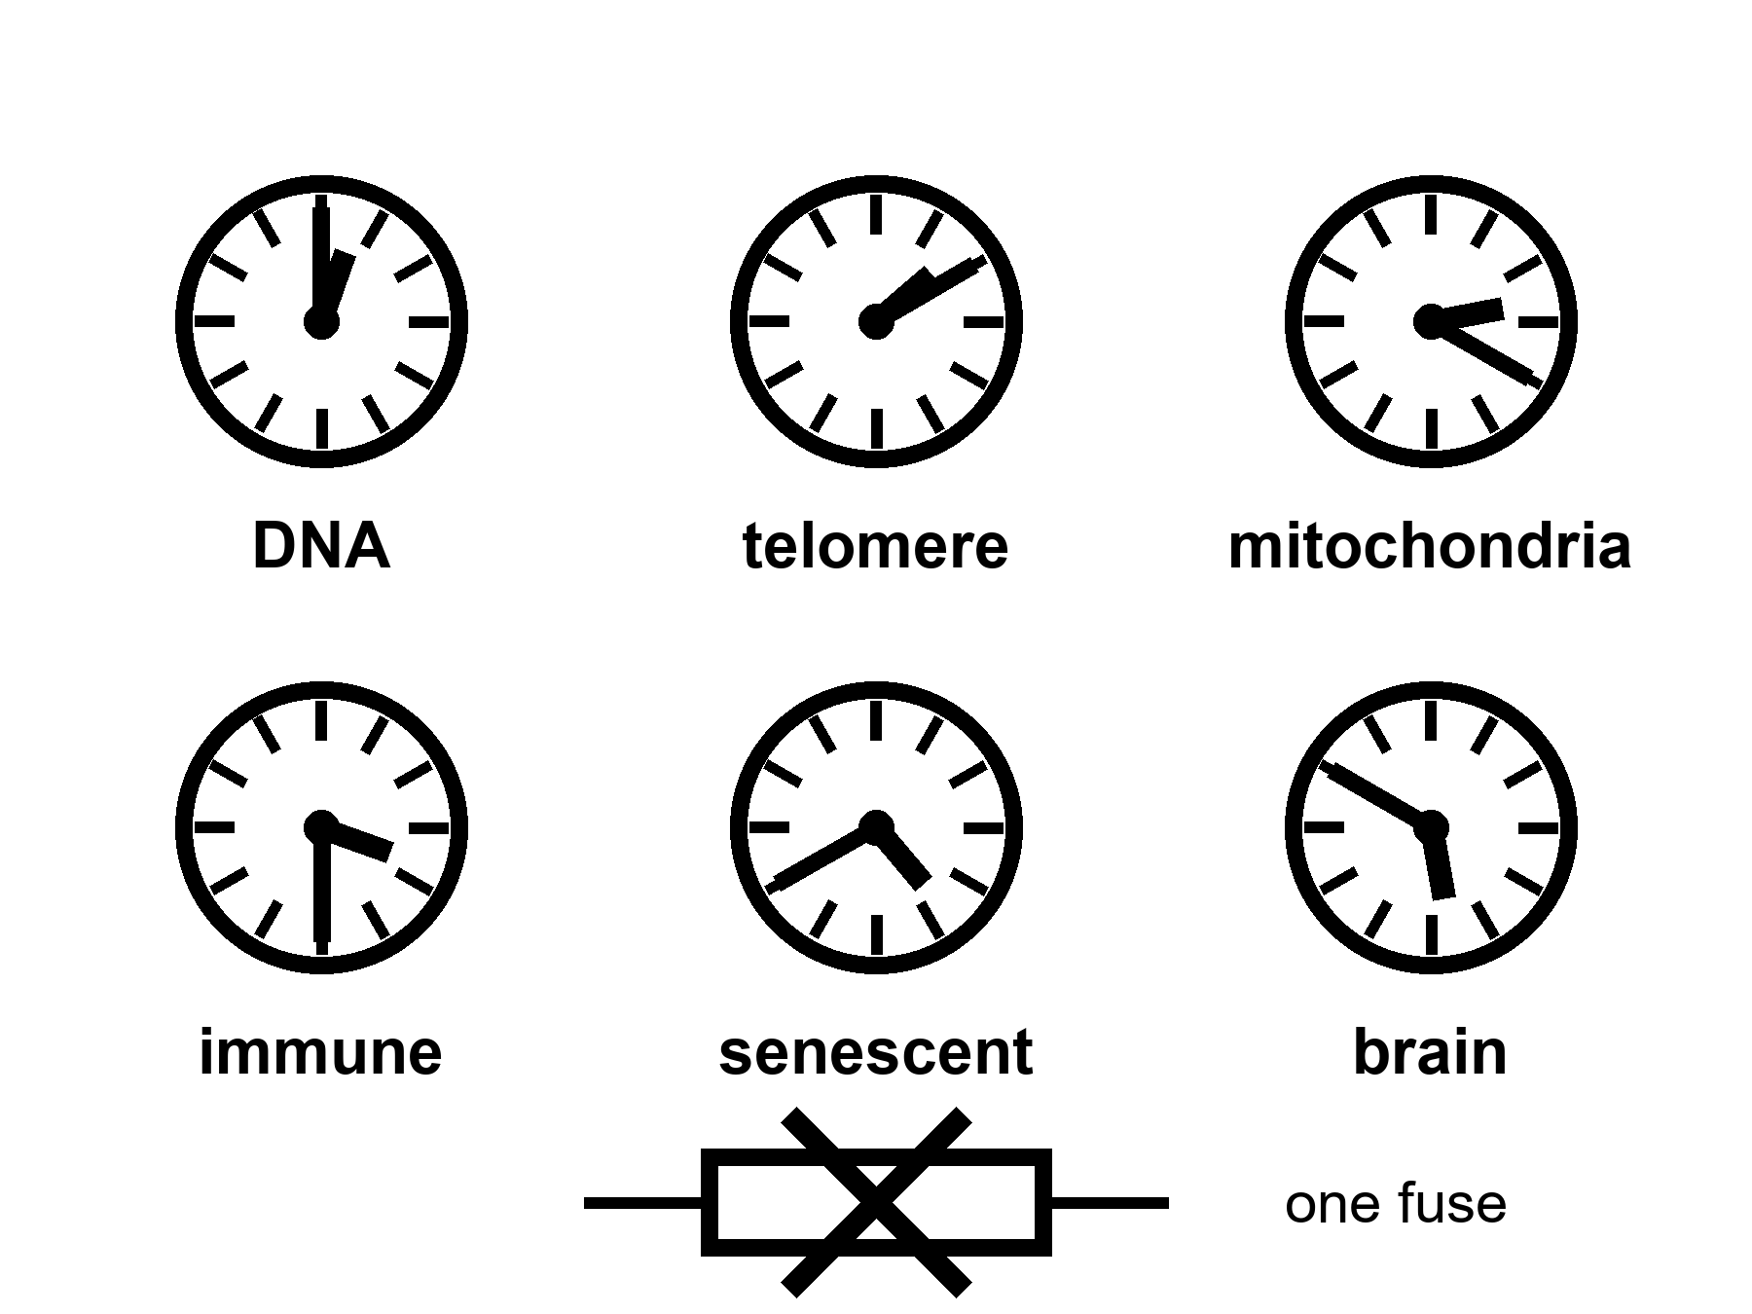
Figure 3. Six kitchen clocks, one fuse crossed out. DNA, telomere, mitochondria, immune, senescent, brain. A shout at one is not a rewind.
Start with the letters.
DNA is a chemical that copies. Copying has a residual error rate even when the staff is sober. Ultraviolet light, oxidation, a replication fork that stalls, a repair crew that arrives late or guesses: the book acquires typos. Most typos in a cell that will die next week do not matter. Typos in a stem cell, or in a lineage that keeps dividing, can matter a great deal. Cancer is one way a typo becomes a career. Loss of function is another. Genomic instability is the grown-up name. It is a clock because damage accumulates and the repair budget is not infinite. It is not the clock. People with unusually clean repair can still go gray, go stiff, go slow. People with a broken repair gene can get a specific cancer young and still not explain why a heart stiffens at seventy.
Telomeres are the plastic tips on the shoelace.
Each time a linear chromosome copies, the very end is an awkward job. The cap shortens. An enzyme, telomerase, can pay the cap back. Most of your somatic cells do not run that enzyme as a lifestyle. A limit appears.
where the cell-division fence is the observation that many human cell types in a dish divide about forty to sixty times and then stop.
The dish fence is not a mystic number. It is a dish fact with a molecular accent: short caps, a DNA-damage alarm, a cell that refuses to copy. In a body the story is messier. Stem cells have more telomerase. Cancers often steal the enzyme and become rude. A mouse is not a woman; mice have longer telomeres and shorter lives, which is already a warning against a single-clock sermon. Lengthening telomeres in the wrong cell is a cancer dare. Short telomeres in the right cell are a worn joint. The clock is real. The rewind is not a free lunch.
Mitochondria forget their job.
They are the old bacterial hires that make the majority of a cell’s ATP and leak reactive oxygen as a side effect of being a furnace. Their own small genome sits next to the furnace, which is a staffing error evolution never quite filed. Damage, deletion, a cell that becomes a mosaic of good and bad power plants: tissues that spend energy — brain, heart, muscle — feel it first. Mitochondrial disease in the young is a specific tragedy. Mitochondrial decline in the old is a background weather. A pill that makes mitochondria “happier” in a worm is a paper. A pill that resets a seventy-year-old woman’s furnaces without touching the rest of the house has not clocked in as a scheduled product. Warm as a target. Cold as helium.
The immune system grows bitter.
It learns. Learning is the point of adaptive immunity. Learning also means a repertoire that fills with old grudges — viruses you met in childhood, a cytomegalovirus — a common virus most people quietly carry for life — that never quite leaves, a library of memory cells that occupy seats a naive cell might have used for a new flu. The innate side gets louder and sloppier: a background inflammation with a nickname, inflammaging, that is rude to vessels, to joints, to brains. Vaccines work less well in the old because the staff is tired and the library is crowded. That is a clock. It is why a flu shot is a tool and not a sermon. It is why “rejuvenate the immune system” is a research program and not a SKU.
Senescent cells refuse to die and then spoil the room.
A cell that has taken too much damage, or hit a telomere alarm, or been shoved by an oncogene — a gene damaged into pushing runaway growth — can enter a state where it does not divide and does not leave. It secretes a cocktail — the SASP, if you like letters — that tells neighbors to inflame, remodel, and sometimes misbehave. In a young tissue a few of these cells are a cleanup crew. In an old tissue they are squatters. Senolytics are drugs that try to evict them. In mice, evictions have made pretty graphs. In people, the graphs are early, mixed, and not a fountain. A senescent cell is one clock. Clearing some of them is a local experiment. The house still has the other clocks.
The brain wears its own grooves.
Neurons are mostly not a renewing lawn. They are a long-staffed office. They accumulate waste proteins that clump. They lose the tact of synapses. White-matter cables thin. Blood vessels stiffen and sprinkle silent insults. Sleep, which is when a good deal of the cleanup is supposed to run, fragments. The skull’s immune cells, the microglia, get their own bitterness. Alzheimer’s is not “aging.” It is a disease with aging as a steep risk factor and with its own ugly, plural mechanisms. Ordinary slowing — the name on the tip of the tongue, the night driving that became a negotiation — is another clock, overlapping, not identical. Chapter 8 will refuse the idea that this office was ninety percent empty. Here, notice that a brain clock can ruin a healthspan while a pulse is still embarrassing a wall.
Those six are not a complete inventory. They are a kitchen tour.
Researchers who try to be complete publish hallmarks: a list that began as nine and grew to twelve when the papers needed more drawers. Genomic instability, telomere attrition, epigenetic marks that drift, proteins that misfold and are not cleared, nutrient-sensing that forgets the difference between feast and famine, mitochondria, senescence, stem cells that exhaust, communication between cells that turns into gossip, autophagy — a cell’s own cleanup-and-recycling crew — that slacks, chronic inflammation, a gut ecology that goes off. Appendix A3 writes the list the way a review writes it. Here, the list is a warning. A list of twelve is already a confession that there is not one fuse.
Epigenetics deserves a sentence because it has become a product costume. Marks on DNA and its packaging change with age in ways you can train a clock to read. The clock is a predictor. It is hot as a correlate. It is warm as a mechanism. It is cold as a proof that wiping the marks wipes the person back to twenty. A predictor is not a fuse. You can have a gray hair and a young epigenetic score, or the reverse. You can reset marks in a dish and still have the same mitochondria, the same senescent neighbors, the same skull.
Nutrient sensing is the other costume. Calorie restriction lengthens life in some species and makes a miserable kitchen in others. Rapamycin (a transplant drug that quiets the immune system), metformin (an old, ordinary diabetes pill), a fasting ritual: each has a paper trail. Some of the trail is real. None of the trail is a species change. A worm is not a woman. A mouse is not a woman. A thin, closely watched monkey is not a woman in a suburb with a night shift. The warm claim is that metabolism and aging talk. The cold claim is that we have the talking stick.
Why do people want one fuse?
Because one fuse is a product. Many clocks are a clinic, a budget, a set of local wins, a refusal. A slide that says aging is a disease is doing two jobs at once. One job is useful: it asks insurers and agencies to treat function as a target, not as fate. The other job is a laundering: if aging is one disease, it might have one drug. The second job is not selected by the hallmarks. The hallmarks selected a messy kitchen.
A filter, not a craftsman. Bodies that lasted long enough to copy were bodies that spent the repair budget on the reproductive years and not on an infinite warranty. There is no committee that chose seventy as a moral. There is a mesh that did not pay for a 200-year ape because a 200-year ape was not the cheaper way to get the next copy. That is not a purpose. It is why a fountain would have to fight a staffing decision that is older than agriculture.
She can take a capsule that helps a joint and still be running the other clocks. The basil does not care. The pH log does not care. A shout at telomeres does not rewind the immune grudges. A clearance of senescent cells in a knee does not unclump a protein in a hippocampus. This is not pessimism. It is the reason local wins are worth taking and sermons are worth putting down.
Appendix A3 writes the dish-division range, the hallmark table, the mouse-to-human translation problem. Here, keep the six clocks and the crossed-out fuse. If a founder shows you one knob, ask which five they left in the drawer.
Where the popular version goes wrong.
The slide promotes the noun and crops the receipt. Look first: ask what was measured, what still needs Earth or a body, what the checklist still leaves empty.
Rule: Aging is many clocks, not one fuse. A shout at one clock does not reset the kitchen.

4. Every Clock Has a Cousin
Chapter 3 said aging is many clocks, not one fuse, and meant it inside a single body. The same sentence holds up between bodies. No species found the one switch either. Some species just built a very different staff.
Hot: at least four lineages combine an ordinary body plan with a hazard of death that barely climbs, or a clock that runs for centuries, or a way to reset a cell’s job description after damage. Cold: that nature is hiding one trick, and finding it hands you a capsule.
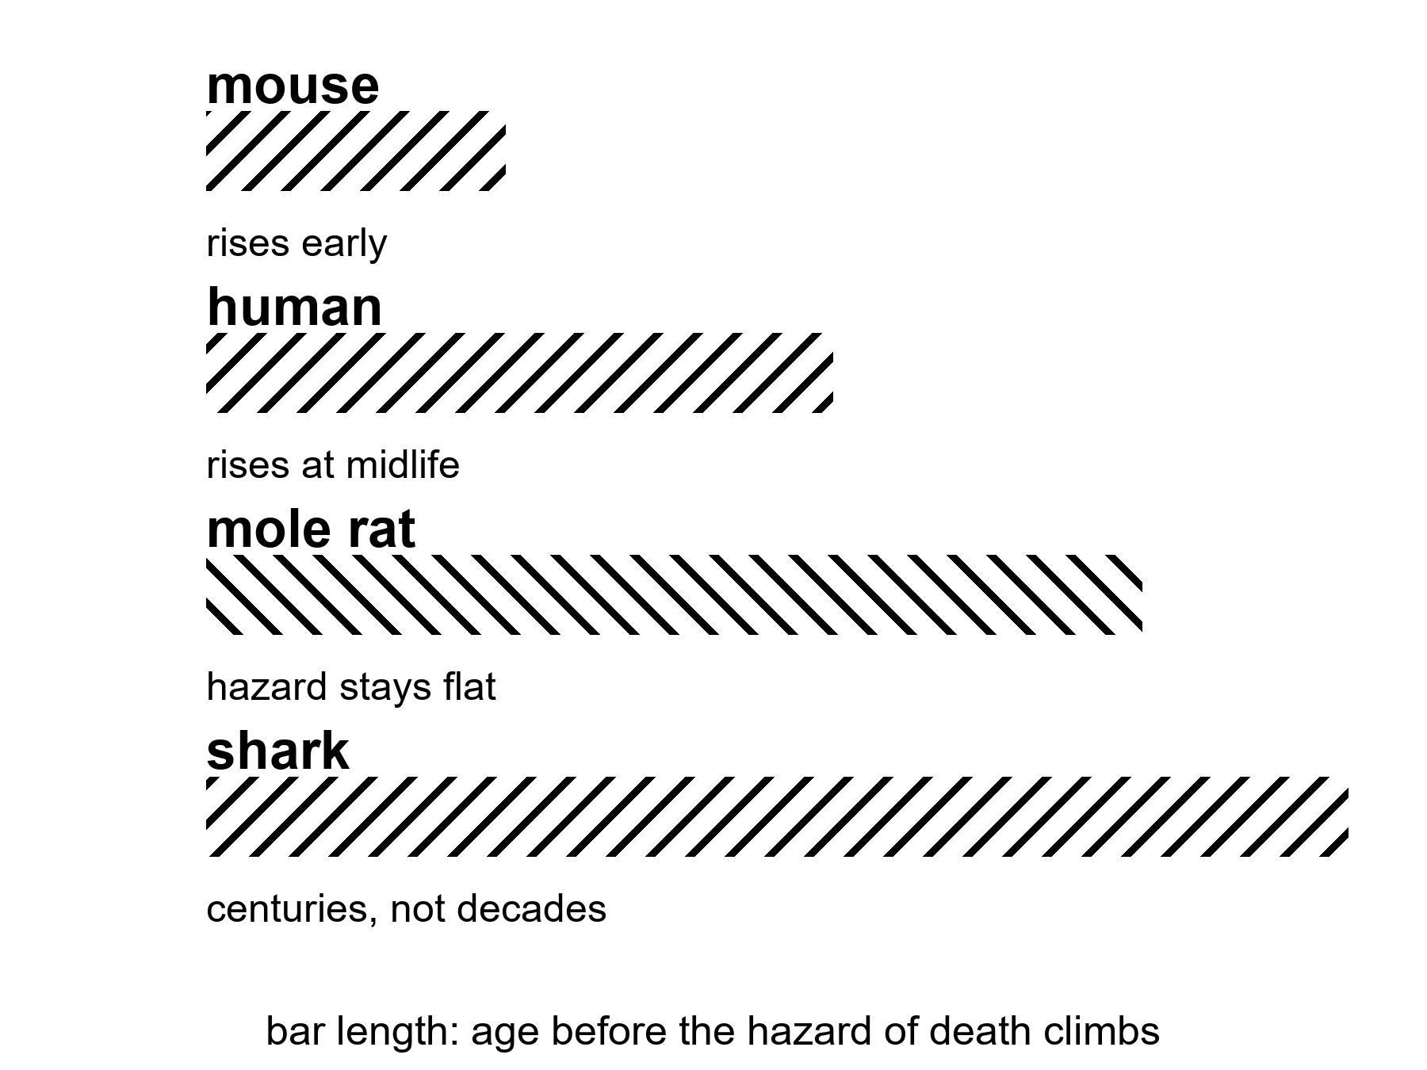
Figure 4. Four hazard curves on one chart: mouse climbs fast, human climbs at midlife, mole rat stays low and flat, shark barely rises at all. None of them touch zero.
where a hazard curve plots the chance of dying in the next year against age; a rising curve is what “aging” means at the level of a population, and a flat curve past maturity is what these four species show instead.
Start with a rodent about the size of a mouse that outlives a mouse by a factor of ten.
The naked mole rat is not larger, not colder-blooded, not especially rare, and not, on first inspection, an animal anyone would nominate for greatness. It looks like a thumb that has given up. It lives in burrows in East Africa, is roughly mouse-sized, and can live past thirty-seven years where a laboratory mouse manages two or three. Past its own maturity, its hazard of dying does not rise the way every other studied mammal’s does — not zero, not immortal, just flat, for a rodent that by every other lab measure should be reading a calendar the way a mouse does. It keeps breeding into its third decade. It almost never gets cancer. It has, in short, done everything right while looking like nothing at all.
One mechanism is on the record. Naked mole-rat cells make a form of hyaluronan — a jelly-like molecule in the space between cells — that runs more than five times larger than the human or mouse version. It gums up the machinery that lets a cell ignore its neighbors and divide without permission. In 2023 a lab put the mole rat’s gene for making it into ordinary mice. The mice made the oversized hyaluronan, got less cancer, ran cooler inflammation, and lived longer and healthier than their unmodified littermates. That is Chapter 5’s local fix arriving a chapter early: one gene, borrowed wholesale from a different animal, doing one job, in mice, not yet in a clinic, not a rewrite of what aging is.
Take the clock that barely moves at all.
The Greenland shark lives in the cold water off the Arctic, grows about a centimeter a year, and does not mature until roughly a century and a half into its life, which is a career path no careers advisor would recommend. In 2016 researchers radiocarbon-dated the lens of the eye — a tissue laid down once, in order, like tree rings, and never replaced — in twenty-eight female sharks. The oldest was estimated at nearly four hundred years, with the study’s own uncertainty running from about two hundred seventy up to five hundred, which is either an admirably honest error bar or a shrug dressed up in statistics, depending on your mood. It is the longest-lived vertebrate found so far: a heart, a brain, a liver, a hazard curve, just stretched over a clock running at a fraction of a mammal’s speed, in water barely above freezing.
Nothing here is a stopped clock. It is the same clock, run cold, slow, and with absolutely nowhere to be.
Take the animal that resets its own job description.
Turritopsis dohrnii, the “immortal jellyfish,” is a few millimeters across as an adult, which is roughly the size of the gap between what its nickname promises and what it delivers. Damaged or starved, instead of dying it can revert: mature cells lose their assignment and become the stem-like cells of an earlier stage, and the whole animal rebuilds itself as a juvenile polyp. In principle the cycle can repeat without limit. In practice, individuals are still eaten, still get sick, still die of something — nature having apparently decided that a loophole in aging is no reason to close the loophole marked predation. What resets is a colony’s bookkeeping, not a particular animal’s uninterrupted memory of being that animal. Immortal is doing a great deal of unpaid overtime in that nickname. Chapter 19 will come back to exactly this distinction, for a very different kind of copy.
Take the one that used no trick at all.
Jonathan, a Seychelles giant tortoise living on Saint Helena, is a reasonable one hundred ninety-three years old as this book is written, and was already an adult when he arrived on the island in 1882 — which makes him, among other things, a British colonial civil servant who simply never got around to retiring. He is blind from cataracts and has lost his sense of smell. He is not negligibly senescent — he shows the ordinary wear of a very old body, gamely carried on. His whole trick is being large, cold-blooded, and unhurried: a slow metabolism and a body too big for most predators, stacked for two centuries. No molecule made him a special case. Size, patience, and a complete lack of urgency about anything were enough.
None of the four rewrote Chapter 3’s six clocks. Each leaned on one and left the rest standing.
The mole rat did not silence its DNA-damage clock or its immune clock; it changed the rules for its senescent-cell and cancer clock specifically, with one oversized molecule, and kept breeding into its third decade on the strength of that one change. The shark did not invent a seventh clock; it turned every one of the six down at once, the way a cold room turns down a whole kitchen rather than one burner. The jellyfish did not defeat its cellular clocks; it found a door back to an earlier reading on them, the way a stem cell already can inside a body that is not reverting. The tortoise ran the same six clocks a human runs, just slower, on a furnace sized for a very large, unhurried, cold-blooded animal. Four species, four different bets on which existing clock to lean on — not one of them a fifth or sixth hallmark nobody has met before.
Rohan attaches the mole rat gene study to his weekly packet, with a note that arrives, like everything he says, several minutes after he has stopped thinking about it.
“So we just need the mole rat’s gene,” his message says, with the cheerful confidence of a man who has never had to file a permit for anything.
She logs the pH, thinks about it for a day, and records her reply for the next window. “And its burrow, and its oxygen chemistry, and to stop being the size we are,” she says. “The paper got healthier mice. Not younger mice, not mice with an off-switch. Mice with less cancer and calmer inflammation. That’s a real invoice, and it’s a rather good one, as these things go. It is not a secret nature was hiding from us out of spite, or waiting for the right committee to declassify it.”
His reply, when it lands, has clearly been composed before hers arrived, the two of them always half a conversation out of step. “The shark got four hundred years,” it says.
She answers it anyway, as if the joke were still fresh, because by the time either of them hears anything the other has already moved on to a different sentence. “At a body temperature you would not survive an hour in, growing a centimeter a year, doing none of what you are doing right now, which I gather mostly involves standing there being disappointed in a rodent.” She caps the pen. “Every one of them paid for what they got. None of them got to skip paying. Nature doesn’t do loyalty cards.”
Days later, his answer to an answer he never heard: “So the secret of eternal life is being a bad-tempered, freezing, four-hundred-year-old fish who never got anywhere in a hurry.”
She does not wait for that one to land before recording the last word, because on a delay the last word is a decision, not a reflex. “The secret of eternal life is that there isn’t one. There’s just an extremely long list of things you’re not allowed to be if you want the extension, and warm, quick, and in a rush is not on it. You’re disqualified on page one.”
Here is the invoice underneath all four.
The mole rat’s trick is one molecule, tied to a burrowing rodent’s whole chemistry; only the molecule, not the burrow, has so far crossed into a mouse, and it bought health, not a stopped clock. The shark’s trick is metabolic patience purchased with cold water and two centuries to reach adulthood — not a schedule a warm, fast, hurried animal can adopt. The jellyfish’s trick requires giving up being one continuous animal with a nervous system in order to become, briefly, something simpler that can start over; the price is identity, not metabolism. The tortoise’s trick is size, a slow furnace, and no rent due on a nervous system built for urgency. Every one of the four still dies of something. None of them is a capsule sitting in a rainforest waiting to be found.
Temperatures, applied to comparative biology.
Hot: at least four real lineages combine an ordinary vertebrate or near-vertebrate body with a hazard of death that stays flat, runs on a multi-century clock, or resets after damage; the mole-rat mechanism has already been moved into a mouse and measurably helped it.
Warm: more species will likely turn out to combine other tricks with other costs; comparative biology is an active field, not a closed inventory.
Cold: that one of these tricks is a suppressed answer waiting for funding, transferable to a human body without also transferring the burrow, the ocean, the reset, or the size.
Where the popular version goes wrong.
The slide holds up an animal and asks why we don’t just have what it has, as if evolution left a working part on the shelf out of neglect. Look first: ask what the animal gave up to get that part, and whether the part was ever separable from the whole animal it belongs to.
Appendix A4 keeps the four citations and the exact numbers. Here, keep the four clocks: a flat hazard bought with a molecule and a burrow, a slow hazard bought with cold and patience, a reset bought with identity, a plain hazard bought with size. None of them is one switch.
Rule: Other species did not skip the bill. They just wrote it in a different currency.

5. Local Fixes
Gene fixes are local. That sentence should be printed on every slide that says DNA as if DNA were a fountain.
Hot: we can, in a growing list of cases, reach into a lineage of cells and correct a broken instruction — a blood disease, a rare enzyme, a tissue that will take the edit and keep it. CRISPR and its cousins are tools. They are not magic. They are scissors with paperwork.
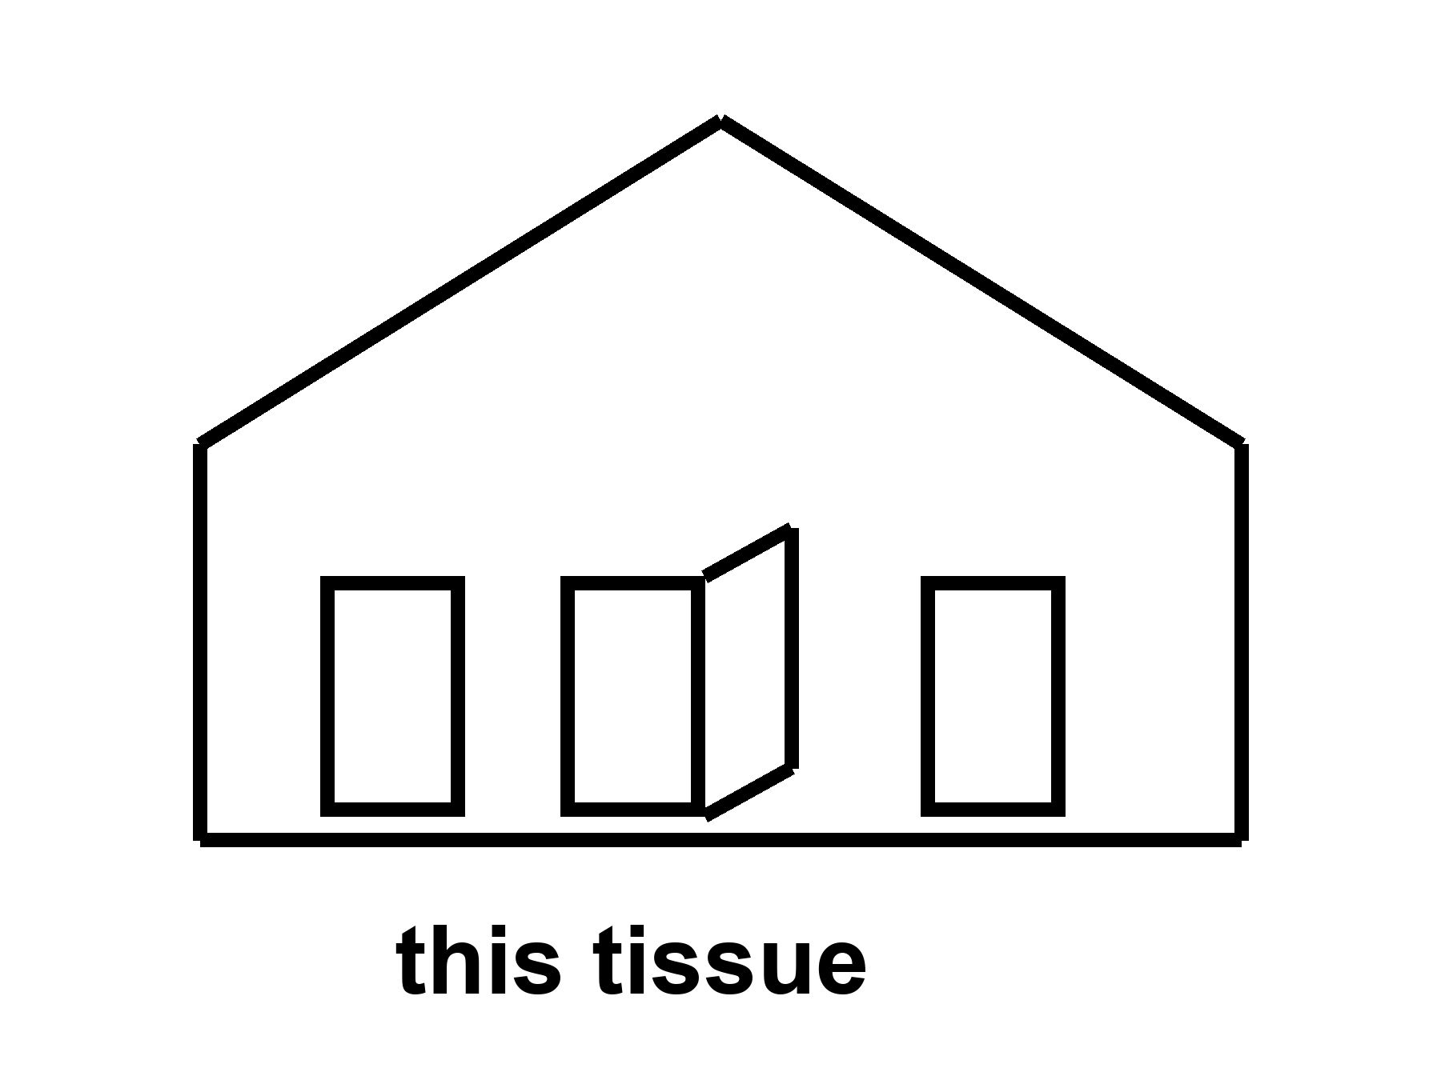
Figure 5. One door unstuck in a simple house. The label is this tissue. Scissors with paperwork, not a fountain.
Start with the scissors, because the brand names will rot and the class will not.
A genome is a long string. A disease can be a single wrong letter, a missing chunk, a control switch stuck in the wrong position. For a long time the only way to change that string in a person was luck: a bone-marrow transplant from someone whose string was kinder, a virus we did not design well, a prayer. Gene therapy, as a field, spent decades in the wilderness of immune reactions and leukemia scares and invoices that could bankrupt a kingdom. Then the scissors got sharper.
CRISPR, in the kitchen, is a bacterial memory system hired as a cutter. You supply a guide that finds a sequence. You supply an enzyme that cuts. The cell’s own repair crew then either wrecks the site (sometimes that is the point) or, with more paperwork, inserts a template. Base editors and prime editors are cousins that try to rewrite a letter with less of a cut. Viral vectors — a hollowed-out virus put to work as a truck, in classes called AAV and lentivirus — are delivery trucks. Delivery is most of the problem. A truck that reaches the liver is not a truck that reaches the brain. A truck the immune system remembers is a truck you may not send twice.
where a local fix means this gene, in this tissue, in this person, at this price, with this known damage as the entry fee.
The sickle-cell-class win is the one that should be taught in every school that already teaches Mendel.
Sickle cell disease is a single-letter change in the adult hemoglobin gene. The wrong letter makes a protein that can stack, and the stack makes a red cell into a blade, and the blade jams vessels and wrecks childhoods. Everyone carries two copies of most genes, one from each parent. The heterozygote — one copy of the wrong letter — is a malaria bargain the mesh kept. The homozygote — two copies of the wrong letter — is a chronic emergency. For decades the local fix was a matched donor’s marrow, if you had a match and a center and a body that could survive the conditioning. Now there is a class of autologous edits: take the person’s own blood-forming stem cells, edit them outside the body, wipe the old marrow with chemotherapy hard enough that the edited cells can take the seats, put the edited cells back.
One version of the class does not even correct the original letter. It wakes fetal hemoglobin, the version you used before you were born, by breaking a switch (BCL11A and its enhancer) that had turned the fetal gene off. The fetal protein dilutes the sickle protein. The crises fall. That is a local fix with a long invoice: manufacturing, a hospital stay, a conditioning regimen that is not a vitamin, a price that, in present ledgers, sits in the low millions of dollars per person. It is still a win. It is hot as a class. It is not a fountain. The person’s telomeres did not rewind. Their arteries did not become twenty. Their brain did not unlock a cupboard. Their children, if the edit was only in blood, still inherit the letter unless a different, ruder conversation is had about germline work.
Name the class, not a halo. Exagamglogene-class CRISPR for sickle cell and transfusion-dependent beta thalassemia — another inherited blood disorder — is a 2023-era clinic fact. Lentiviral gene-addition cousins sit in the same drawer. The brand on the box will change. The structure will not: this lineage, this instruction, this bill.
The pivotal trial’s own numbers are the invoice, printed plainly. Forty-four people received the edited cells. Of the thirty followed long enough to judge, twenty-nine, ninety-seven percent, went a full year without a single vaso-occlusive crisis, and every one of the thirty avoided a crisis-related hospital stay for that year. Those are hot numbers, published in a medical journal in April 2024, not a keynote slide. They describe a lineage of blood cells in a person’s own marrow, wiped and reseeded once, at a price that runs to the millions and a conditioning regimen that is itself a small ordeal. They do not describe a telomere, an artery, or a brain. The crisis stopped. The person did not become someone who does not age.
Rare enzymes are the other honest drawer.
A child missing one metabolic enzyme can be a tragedy that a protein infusion, or a gene truck to the liver, or an edit in the right cells, can interrupt. Spinal muscular atrophy, a handful of immunodeficiencies, a retinal disease that steals a childhood’s sight: each has a story in which a local delivery changed a life. Each story has a graveyard next to it — the trials that triggered immune storms, the doses that did not reach the tissue, the prices that made a cure a rumor for everyone who did not live near the right zip code. Chapter 17 is the graveyard and the zip code. Here, keep the structure. A rare, monogenic, accessible tissue is the kind of lock these scissors were forged for. Aging is not that lock. Aging is the house.
Cancer, ironically, is already a gene-therapy customer and still not a fountain. CAR-T cells are a local rewrite of an immune cell to hunt a blood cancer. The rewrite can save a life and still leave the person aged by chemotherapy, aged by cytokine storms — the immune system overreacting to the treatment itself — aged by the clocks that were never the target. Solid tumors are ruder. A thousand-year ape would still need a cancer policy. Chapter 7 is that policy.
Germline editing — changing the string in a sperm, an egg, or a first clump of cells so that every tissue and every descendant carries the change — is a different door. It is technically closer than it was. It is ethically and politically a front, not a kitchen gadget. A front is Chapter 16’s kind of wall. This book will not print a catalog of designer children. Look first. A slide that says enhancement about a child who cannot consent is the carrot with a new face. The off-switch was not hired.
What CRISPR is not.
It is not a search-and-replace for “old.” Old is not a sequence. Old is the many clocks. You can imagine, cold, a future in which many tissues are edited, many times, for many letters, at a price a village can pay, with delivery trucks that know the brain and the heart and the stem-cell niches. You can imagine it. Imagination is not a schedule. The present kitchen is: a short list of monogenic wins, a longer list of trials, a delivery problem, an immune memory, an invoice, and a house that still ages while you celebrate the one door you unstuck.
She will not get a CRISPR for being fifty-eight and having hands. She might, in a later decade, get a better joint drug, or a better way to quiet a senescent crowd in a knee, or nothing new except the same bullying of chemistry she already knows. The capsule on the radio delay is honest if it stays local. It becomes a lie when the label starts talking about the species.
Delivery is the unpaid invoice of every headline that says CRISPR as if the word were a method for forever. This tissue, this lineage, this conditioning regimen, this zip code that can reach a trial site: that is local. A sickle-cell-class win is hot as a class. A body-wide rewind stays cold. Do not let a hot door launder a cold house. Mara takes a capsule for a joint. She does not become a different species, and she does not become proof that her sister on the coast gets the same dose.
Scissors with paperwork: consent, a delivery vector, an off-target worry, a marrow wipe that can kill on the way to a save. Headline CRISPR is incense for a conference. A class-of-edit is a door in one room of one house. Clinics keep score in adverse events and follow-up years, not in applause. Do not remodel the cosmos because one latch moved. Local. Tissue. Invoice. Keep saying those three until the fountain slides look cheap.
Appendix A5 writes the sickle-cell-class schematic, the delivery problem, and why “CRISPR” in a headline is not a method for helium. Here, print the sentence again. Gene fixes are local. Keep it.
Where the popular version goes wrong.
The slide promotes the noun and crops the receipt. Look first: ask what was measured, what still needs Earth or a body, what the checklist still leaves empty.
Rule: Gene fixes and tools are local. A fountain is cold. Keep the invoice on the counter.

6. The Reset That Isn’t
Chapter 5 drew the line: a local fix is this gene, this tissue, this invoice, not a fountain. One line of research keeps getting sold as the fountain anyway, because for once the picture looks almost like one. It is worth a chapter of its own, because it is the best real candidate the popular version has, and it is still not what the slide says it is.
Hot: cells carry a partial, recoverable record of an earlier state, and biologists can nudge some of them to read from it again. Cold: that this means aging can be reset, in a body, the way a document reverts to an earlier save.
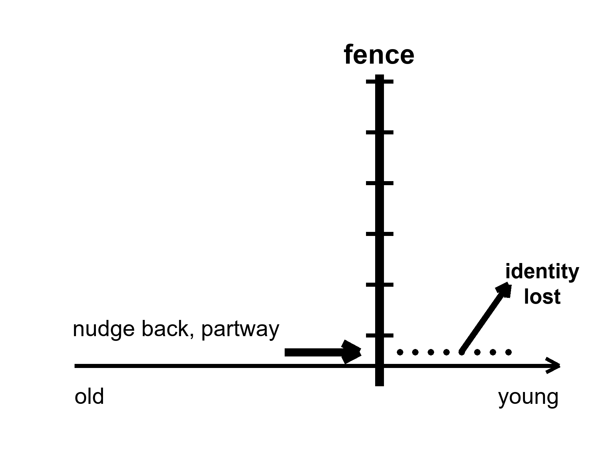
Figure 6. A cell’s clock hand pushed back partway, then stopped by a fence. Past the fence: an unlabeled door marked “identity lost.”
where the fence is not a mystery; it is the difference between nudging a cell’s markings younger and erasing what kind of cell it is.
Start with the four keys and the door they open too far.
In 2006 a Japanese lab showed that four proteins — a cocktail now taught in every stem-cell course — can take a skin cell all the way back to an embryonic-like state in a dish. That discovery, done outside a body, won a Nobel Prize and built the entire field of induced stem cells. It also came with a receipt, because good news in biology is contractually obliged to arrive with one. In 2013 a European team ran a version of the same four-protein cocktail briefly inside living mice, and tumors called teratomas grew from multiple organs — the stomach, the intestine, the pancreas, the kidney, all of them apparently keen to try something new. Full reprogramming does not know when to stop. Taken all the way, a cell does not get younger. It forgets it is a stomach cell at all, and starts building the wrong parts, with the enthusiasm of an intern given no job description.
That is the fence. The question since 2013 has been whether the same clock can be nudged partway, and held there, without walking through the door marked identity. Two different answers have since shipped, and they are not the same trick.
The first answer kept all four proteins and changed the rhythm instead of the recipe.
In 2016 a lab ran the full four-protein cocktail in mice bred with a severe, accelerated-aging condition — not ordinary old age, a specific genetic defect that mimics it — but ran it in short pulses, two days on and five days off, rather than the steady pressure that grew tumors in 2013. At that cyclic dose the mice showed improved markers across several of Chapter 3’s clocks at once, and lived measurably longer: about a third longer at the midpoint of the group, about a fifth longer at the far tail. No teratomas were reported at that schedule. The lesson was not that the four proteins were ever safe. It was that a cell reads a steady four-protein signal as an order to become embryonic, and reads a brief, interrupted one differently — closer to a correction than an instruction.
In 2020 a lab published a second answer that used three of the four proteins, not all four, and left the fourth — the one most associated with runaway growth — on the shelf. In mice, aimed at the optic nerve, the three-factor cocktail restored a younger pattern of DNA marking in retinal ganglion cells, helped injured nerve fibers regrow, and reversed vision loss in both an eye-pressure model of glaucoma and in ordinary old mice. The effect required two enzymes, TET1 and TET2, that erase old chemical marks on DNA — the marks a cell’s methylation clock actually reads. The finding was not that a cell got younger. It was that some of what the clock reads is a stored, partly recoverable record, not a one-way ledger entry, at least in this tissue, at this dose, for this outcome.
The chapter title is not being cute. This is a reset. It is not the reset the slide sells.
The dose that helped an eye is not a dose that has been given to an entire mouse, let alone a whole person. On 28 January 2026 the FDA cleared the first human trial of a reprogramming therapy built on exactly this recipe — three factors, without the fourth, delivered by injection into one eye, for two specific optic diseases. That is the real, current, hot fact: a human trial exists, as of this writing, for one organ, one delivery route, one narrow set of conditions, seven years after the mouse result and thirteen years after the version that grew tumors. Nobody has cleared a trial for a body. Nobody has cleared a trial for “younger.” The trial that exists is for an eye that has stopped working.
Mara reads the trial announcement on the same downlink that carries her mail, and records her line before she has finished deciding what she thinks of it.
“They’re testing it on people now,” she says.
The reply is waiting for her a day later, sent, she suspects, before he had finished reading past the headline. “On an eye,” Rohan’s message says. “One eye. For a nerve that’s already dying. It’s not exactly a press release for eternal youth, is it.”
She lets that sit for an evening before she answers it. “It could reach a knee eventually. A whole knee.”
His answer to that has the unhurried shape of something written, deleted, and written again. “Eventually is doing a lot of work in that sentence. Thirteen years between the tumor mice and the eye mice. Seven more to a human trial for the eye alone. You want to bet on a knee inside your own paperwork, or would you rather I quoted you odds?”
“You’re very cheerful about this,” she tells a version of him that, by the time he hears it, will have moved on to some other argument entirely.
He has. His reply answers a comment she made two exchanges ago, the two of them permanently a little out of season with each other. “I’m delighted. A field that spent thirteen years politely not growing tumors in anyone is my idea of a rollicking success story. Ask me again in another thirteen.”
She doesn’t answer. She logs the pH instead, which has never needed thirteen years to tell her the truth.
Here is the invoice underneath the headline.
Model is the first line. The 2016 lifespan numbers come from mice built with one severe genetic defect, not from ordinary old mice living out an ordinary span; a rescue of a specific broken part is not yet a demonstration that healthy aging responds the same way, at the same dose, on the same schedule. Dose is the second line. Too little reprogramming does nothing measurable. Too much erases what a cell is and grows a tumor instead of a fix — the 2013 result is not a footnote, it is the ceiling the entire field designs against. Route matters as much as dose: an injection that reaches one accessible nerve is not a systemic therapy, and nobody has shown the same three factors are safe delivered to a whole body rather than one contained organ. Timeline is not a detail: fourteen years passed between the discovery that full reprogramming works and a cleared human trial for the safest, narrowest version of it, in the one place — an eye, with its own barrier from the rest of the body — where a mistake stays local. A slide that shows the 2020 mouse photograph next to a caption about reversing human aging is skipping every one of those four lines on the invoice.
Temperatures, applied to reprogramming.
Hot: a cyclic, all-four-protein schedule extended lifespan in a mouse model of one severe aging-mimicking defect; a partial, three-protein version restored a younger DNA-methylation pattern and function in specific mouse tissue; a human safety trial for the three-protein approach, aimed at one organ, exists as of January 2026.
Warm: the same approaches may extend to other organs, other kinds of damage, and ordinary aging rather than one genetic defect, over the coming decade; partial reprogramming by either route is an active, well-funded research program, not a dead end.
Cold: whole-body reprogramming, a reprogramming pill, or reprogramming as a general reversal of aging rather than a local repair of one tissue’s readable record.
Where the popular version goes wrong.
The slide shows the mouse eye photograph and calls it proof that aging is reversible, full stop, coming soon. Look first: ask which factor was left out on purpose, which organ took the injection, and how many years sit between the photograph and the trial it is standing in for.
Appendix A6 keeps the four papers, the dates, and the dose problem in more detail. Here, keep the fence: a partial nudge back, held short of the door marked identity lost, tested first in the one organ that can fail alone.
Rule: The record is partly recoverable. The cell is not a document with an undo button.

7. Not a Fountain
A local fix is not a reset of every clock.
That is the laundering this chapter exists to stop. Chapter 5 gave you a hot win. This chapter will not take the win away. It will refuse to let the win rent a halo.
Cold: a body-wide rewind. A thousand-year ape as a scheduled product. Helium. The rest of the house still ages while you celebrate the one door you unstuck. Cancer is not one door. The brain’s long goodbye is not one door. Atherosclerosis is a plumbing problem with a biological accent. Local is the word. Keep it.
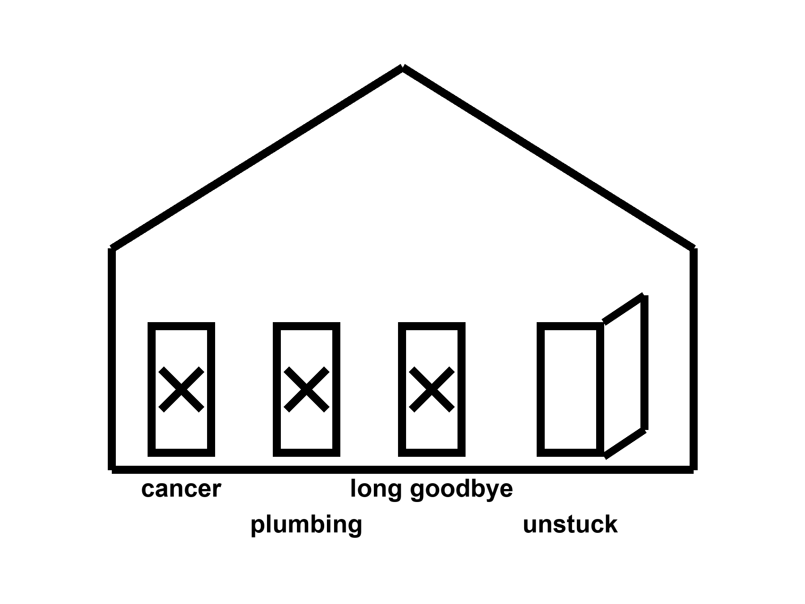
Figure 7. The same house. Three doors still stuck: cancer, plumbing, long goodbye. One unstuck door is not a remodel.
Cancer is not one door.
Cancer is hundreds of careers a cell can take when the copy-edits and the brakes and the immune surveillance fail in combination. A blood lineage you can harvest and rewrite is one kind of fight. A pancreas, a lung, a glioblastoma behind a barrier that keeps trucks out, a metastasis that has already rented rooms in bone: other fights. Prevention — do not smoke, vaccinate against the viruses that set up shop, find the polyp while it is a polyp — is still the cheap, rude, hot work. Treatment has become, in some cancers, a long negotiation with targeted drugs and immune checkpoint tricks and local rewrites. Five-year survival moved for some diagnoses and barely moved for others. Curing one blood cancer in a twenty-year-old does not make her immortal. It makes her a person who will now have to die of something else, later, which is exactly the point of medicine and exactly not a fountain.
A body that lasted 200 years would be a longer exposure to the same mutational weather. More copies, more chances, more careers for a rude cell. Unless you imagine a surveillance state inside every tissue that never sleeps and never errs — cold, as a scheduled product — the long ape is a cancer problem with more calendar. The mesh did not have to solve that problem. A product that claims to have solved aging without a cancer policy has not read the house.
Atherosclerosis is plumbing with a biological accent.
Fat, calcium, immune grudges, a lining that scars, a clot that finishes the job: the pipes of the heart and brain. Blood-pressure pills, statins, smoking cessation, a stent, a bypass — local, incremental, hot as classes of win. They moved rich-country death. They did not make arteries into a twenty-year-old’s pipes on demand. A gene that lowers an ugly lipoprotein can be a local fix for a family that inherited a disaster. It is not a rewind of seventy years of shear stress and dinner. The long ape would still have fluid dynamics. Fluid dynamics does not care that your slide is exponential.
The brain’s long goodbye is not one door.
Alzheimer’s, Parkinson’s, Lewy bodies (a different clumping protein, a different disease), vascular scraps, frontotemporal ruin (a dementia that eats personality and language before it eats memory), the ordinary narrowing that is not a named disease and still steals the vote: plural. Amyloid — one of those clumping waste proteins from Chapter 3 — is a character in one of the plays and not the whole theater. A drug that clears a plaque and buys a modest delay is a local, expensive, argued win — warm-to-hot as a class of result, not as a resurrection. Two amyloid-clearing antibodies reached the clinic on trials that measured the delay honestly: one slowed decline on the standard dementia scale by about a quarter over eighteen months, the other by roughly a third, with a share of patients on that second drug showing no measurable progression at all after a year. Those are real numbers, hard-won, worth having. They are also a quarter and a third of a decline that still continues, in a disease that is still plural, not a name struck from the list. A 200-year skull would need a waste-clearance policy, a vascular policy, a sleep policy, a protein-folding policy, and a theory of what a self is when the office has been restaffed. Chapter 19 is the cold version of that last sentence. Here, notice that you can fix a blood letter and still lose the names.
150. 200. 1,000.
Those numbers arrive on slides the way helium arrives in balloons: they look like they are already flying. Mark them.
Typical human life to 150 years as a scheduled product: cold. Allowed as a wish. Not selected by present levers. We have a tail at ~122 and a mean in the eighties in the lucky kitchens. We do not have a protocol.
200: colder. You have left the observed fence and entered a different animal.
1,000: costume. A thousand-year ape is a science-fiction staffing problem — cancer, brain, pipes, teeth, boredom, the carrot with no off-switch, the institutions that would have to keep the insulin coming — dressed as a roadmap. This book will not print the roadmap. It will name the invoices.
Modest further gains in healthy years this century in rich-country medicine: warm. A few more mornings, if the boring work continues and the trials stay honest and the pipes do not fail. Not a law. Not a species change. Everyone shares them: cold as a default. The zip code still votes.
A note on “aging is a disease.” If the phrase gets a trial endpoint that measures walking speed and cognition and hospitalization, it can be a useful bureaucratic trick. If the phrase gets a supplement aisle and a founder who is already 150 on the slide, it is a costume. Temperatures, not vibes.
She will die of something.
That sentence is not cruelty. It is the block the pulse occupies. A local fix changes the something and the when and, if you are lucky, the number of Tuesdays she would vote for. It does not promote her to a different species. It does not unlock a brain she was not using. It does not pay the energy bill of a civilization that wants to multiply the last fifty years by two hundred and call the product a kitchen.
The dirt still has a chemistry. The chemistry can be bullied. That was always the whole trick. The trick is already enough to grow basil under a lie of LEDs. It is not enough to purchase helium. Do not wait. Hit the airlock. Log the pH. Take the capsule if the joint is the thing it buys. Put the sermon down.
Cancer is plural doors with different locks. Solid tumors hide behind barriers drugs do not cross for free. Blood cancers and sickle-cell-class lineages can be different sports. Vessels are arithmetic with blood: pressure, plaque, a clot that arrives on a Tuesday. Brains are overlapping messes — plaques, tangles, vessels, sleep, inflammation — without a single product SKU. Aging itself is not one lock labeled rewind. Triage and local repair stay hot because they land at addresses. A skeleton key stays cold because it has nowhere to ship. Chapter 5 opened one honest door. This chapter refuses to sell the house as unlocked. Keep naming doors. Take the master-key slide off the deck.
Appendix A7 writes cancer as a plural, vascular risk as a ledger, neurodegeneration as a set of overlapping messes, and why a mouse that lived longer is not a woman who will. Here, keep the house with three stuck doors. Chapter 5 unstuck one. That was honest. This chapter is the honesty that follows.
Where the popular version goes wrong.
The slide holds up the one unstuck door and photographs it as the whole house. Look first: ask how many other doors the disease has, and whether the mouse in the photograph was ever asked to live a human Tuesday.
Rule: A local fix is not a remodel. Cancer, plumbing, and the long goodbye are still three stuck doors.
Part II is the other cartoon: the cupboard in the skull. The hands still age. The organ was already on duty.
Where the popular version goes wrong.
The slide promotes the noun and crops the receipt. Look first: ask what was measured, what still needs Earth or a body, what the checklist still leaves empty.
Rule: Not a fountain. Modest further healthy years are warm; everyone shares them on a schedule is cold.

PART II — The Organ You Already Use

8. We Already Use the Organ
Then the sentence that will not die, because it is useful to people who sell keys: we only use ten percent of our brain.
False. Hot as a correction.
Imaging, lesions, the energy bill — the organ is on duty. Tissue that looks idle in one snapshot is still a staff with a shift you did not catch. You do not have a spare ninety percent in the cupboard, waiting for a password so you can meet “new challenges.” You have the organ you have, plus sleep, plus practice, plus tools, plus other people. That is already how we adjust. Plasticity is real and expensive. It is not a tank of unused mind.
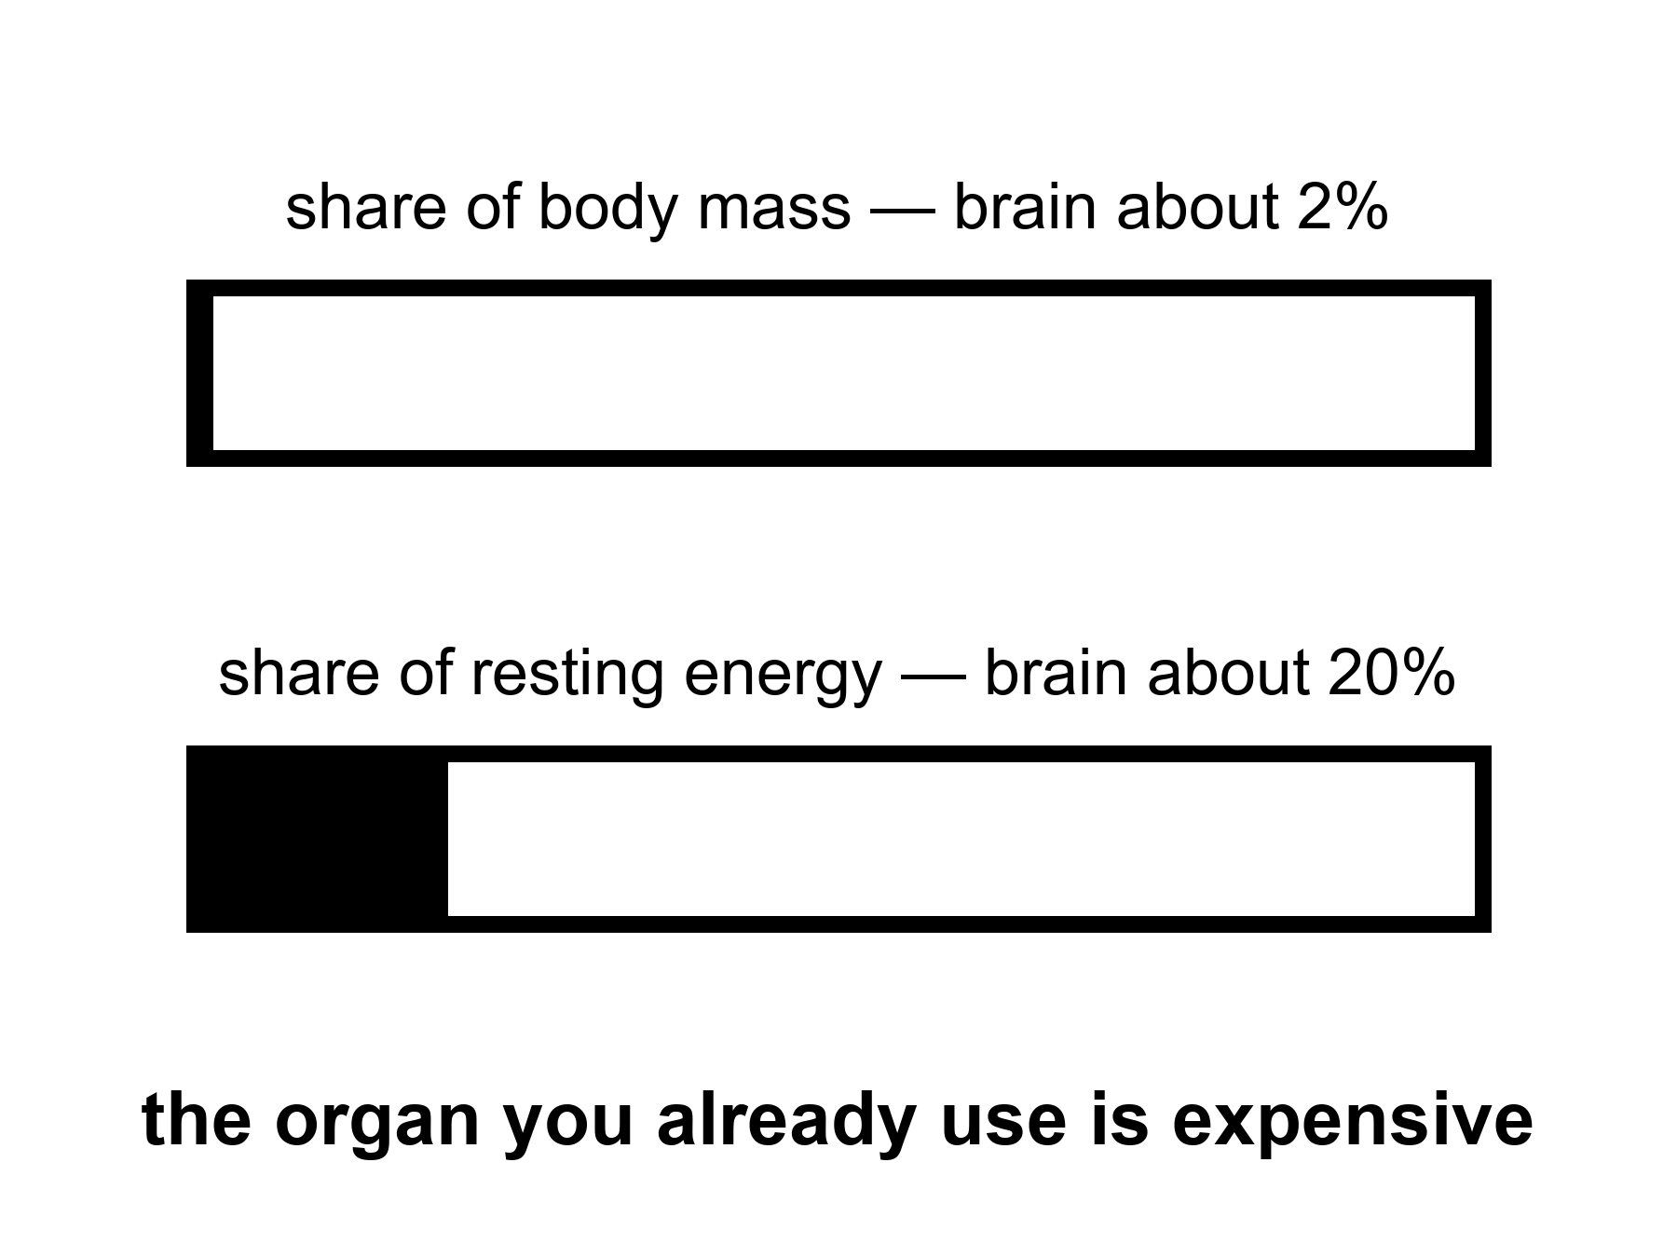
Figure 8. A hatched share: the brain is about two percent of mass and about twenty percent of resting energy. Idle-looking is not off-duty.
The sentence is a zombie because it is flattering. It tells you that the person you already are is a draft. It tells you that a course, a pill, a headset, a founder’s password will open the real draft. It turns a limit into a treasure hunt. Treasure hunts sell. Limits do not.
Where did it come from? Not from a measurement you can cite and keep. It gathered like kitchen grease: a misread of early neurologists who noticed that large injuries sometimes left surprising function; a self-help habit of turning “we do not understand everything” into “ninety percent is waiting”; a cartoon of unused neurons sitting in the dark like unused guest soaps. A century-old moral sentence said we live below our limits. That is effort-talk. It is not a volumetric survey of cortex. The ten-percent figure is a mutation of effort-talk into a floor plan. The floor plan is wrong.
Start with the bill, because the bill does not flatter.
The brain is roughly two percent of a body’s mass and takes roughly twenty percent of the resting energy.
where the twenty percent is of resting metabolic rate — the quiet kitchen, not a sprint.
Twenty percent of the quiet kitchen is an outrageous line item for an organ that, in the ten-percent story, is mostly on unpaid leave. Evolution is a miser about watts. A miser does not keep a ninety-percent dark warehouse of tissue that costs like a furnace and does nothing. The wattage is not a vibe. It is glucose and oxygen, measurable in a PET scanner, a machine that tracks where the brain is spending fuel, measurable as a reason you get faint when blood sugar drops, measurable as a reason a small animal with a large brain had better have a good reason. Humans paid the reason: social prediction, language, hands that can bully chemistry, a childhood long enough to load the software. We did not pay for a decorative loaf of unused cortex.
The number is not “twenty percent of thought.” Thought is not a pie you can slice that way. The number is energy. Energy is what a cupboard of idle tissue would still owe. Idle tissue that owed this much would have been fired by the mesh — this book’s name for the sieve of natural selection, keeping some traits and dropping others — unless it was doing something. The something is the rest of this chapter.
Lesions are the rude teacher.
If ninety percent of the organ were spare, large injuries would be polite. They are not polite. A small clot in the left posterior frontal lobe can take speech and leave the rest of you watching. A strip of motor cortex can take a hand. A hippocampus — the structure that stamps a day into memory — on both sides can take the ability to mint a new Tuesday. A cut in the white-matter cables — the wiring, not the gray offices — can disconnect a function as surely as removing the office. Stroke maps, tumor maps, gunshot maps, the old wartime files: they are a cartography of on duty. The cartography is not complete. The brain is plastic, and Chapter 18 will not insult that fact. Plasticity is what a staff does when a colleague is gone: overtime, rerouting, a worse but livable shift. Overtime is not proof that the colleague was decorative. It is proof that the remaining staff were already working and can work differently at a cost.
People point at the opposite anecdote: a person missing a startling amount of tissue who can still talk, walk, joke. The anecdote is real and does not rescue the ten percent. Hydrocephalus — fluid pressure building up inside the skull — that thinned the cortex, the brain’s outer working layer, a hemispherectomy — surgery that removes or disconnects half the brain — in a child with a raging epilepsy, a slow tumor that stole a lobe while the staff moved: these are demonstrations that development and time can reassign jobs, and that some jobs were already shared. A child is not a cupboard. A child is a construction site. Construction sites can reroute. Adults reroute less, and pay more, and still do not reveal a hidden ninety.
The cerebellum — the hind loaf that looks, to a skimmer, like a bonus — contains a huge fraction of the neurons and is not a bonus. Damage it and you get a drunk walk, a drunk reach, a timing that will not keep a beat. The “extra” neurons were timing the body. They were not waiting for your podcast.
Imaging is the other teacher, and it is easy to lie with.
A functional MRI picture is not a lamp that turns a region on. It is a slow, indirect hint that blood flow changed, which is a hint that cells did more, which is a hint you must not treat as a photograph of a thought. The pictures that make magazines — a blob on a medial surface labeled love — are the worst ambassadors. The honest use is statistical and humble: when a person does this task, this set of regions changes its bill a little, compared with that other task. Almost the entire organ can be shown to change its bill under some contrast if you are patient and not picky. Sensory sheets, motor sheets, language networks, attention networks, a default-mode set that lights when you stop the assigned task and start being a person with a past: they are all expensive. The default-mode set is the one a ten-percent story wants to call idle. It is the opposite of idle. It is the staff that keeps a self, a gossip, a plan, a replay of the argument, a simulation of the orbiter’s next late message. When it is damaged, people do not become superheroes with free watts. They become unmoored.
Tissue that looks quiet in one snapshot is still a staff with a shift you did not catch. A voxel — one cube of a brain scan, the smallest unit a machine can report — that does not pass a threshold in a love-blob study is not a spare bedroom. It may be working in a way the contrast did not pay to see. It may be inhibitory. It may be waiting, which in nervous tissue is often a job — a ready pool, a tuned silence. Silence can be duty. A night watchman who is not shouting is not unemployed.
Single-neuron recording, where we have it (animals, and the rare human electrode for epilepsy), finds cells that care about astonishingly specific things and cells that care about many things, and very few cells that care about nothing and are just hanging around in case a founder needs them. Glia — the brain’s other big population of cells, alongside neurons — are not decoration either. They are metabolism, insulation, cleanup, immune mood. The ten-percent sentence sometimes mutates into “we only use ten percent of our neurons,” as if the other cells were packing peanuts. They are not packing peanuts.
Why the zombie survives.
Because unused potential is a kinder story than used limits. Because a school system that fails a child would rather say the child’s tank was never opened than say the organ was on duty and hungry, tired, untaught, or afraid. Because a marketplace of “unlock your mind” cannot sell a hearing aid and a nap as loudly as it can sell a secret switch. Because the phrase is short. False sentences that are short outcompete true paragraphs.
Hot as a correction means you do not get to dress the myth back up as a future. “We only use ten percent today; tomorrow we will use the rest” is the same sentence with a calendar glued on. There is no rest. There is practice, sleep, tools, other people, and a bill. Chapter 9 is the tools with temperatures. Chapter 18 is the expensive rerouting. This chapter is the refusal.
She does not have ninety percent of a mind in the cupboard. She has a morning, a radio delay, a basil plant, a joint that may take a capsule, and an organ that has been paying twenty percent since before she learned the names of the herbs. The organ is why she can name them. It is not waiting for a password to start.
About two percent of mass, about twenty percent of resting energy: that bill is not how a miser keeps a dark warehouse. Lesions teach the same lesson from the other side — lose a piece and a function fails; there was no spare loft labeled ninety percent. Quiet voxels are not off-duty cupboards. Idle-looking is not unlocked potential. You already use the organ. Tools and sleep and other people are how you meet new work, not a password to a tank.
Appendix A8 writes the energy fraction, the lesion logic, and why a quiet voxel is not a spare tank. Here, if you take one thing, take the bill. A miser does not keep a dark warehouse at those rates. You already use the organ.
Where the popular version goes wrong.
The slide promotes the noun and crops the receipt. Look first: ask what was measured, what still needs Earth or a body, what the checklist still leaves empty.
Rule: We already use the organ. The ten-percent sentence is false. Hot as a correction.

9. Cognitive Enhancement, Two Temperatures
Cognitive enhancement, two temperatures.
Education, eyeglasses, a hearing aid, a stimulant with a known invoice: warm-to-hot as tools. A chip that returns a lost function: a local fix again, with scars. Unlocking a hidden full brain: cold. Do not dress the myth up as a future.
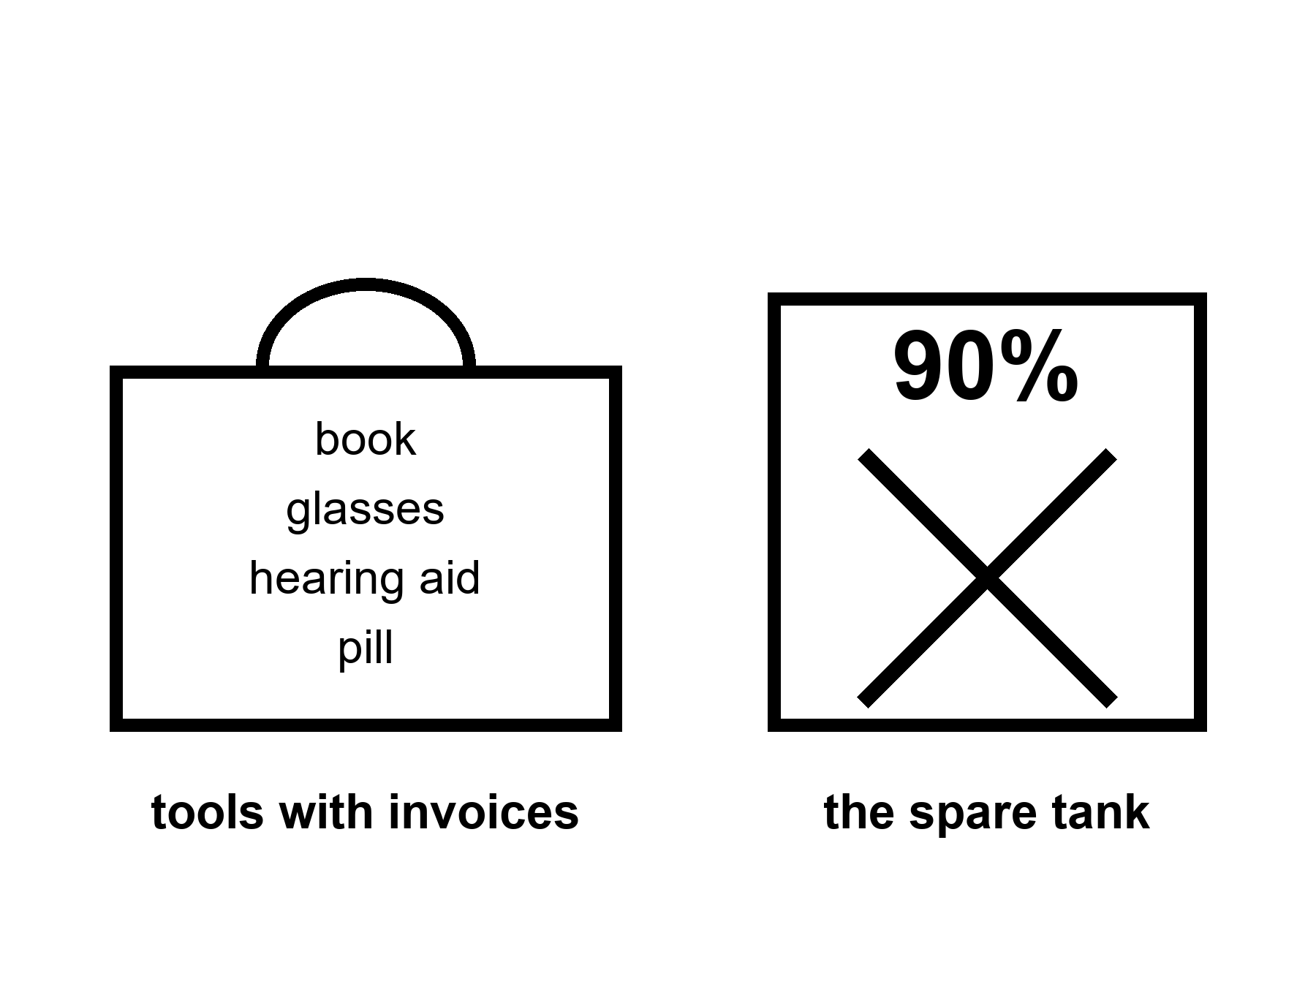
Figure 9. A toolbox on the left — book, glasses, hearing aid, a scored pill. An empty tank marked 90 percent, crossed out, on the right.
A tool is a bargain you can name.
Eyeglasses are the cleanest example in the house. The organ was on duty. The lens in front of it was the wrong shape. A ground piece of glass returns a function the cortex already knew how to use. Nobody serious calls spectacles “unlocking the unused ninety.” They are a local optical fix. They have an invoice. They have side effects if you get the prescription wrong. They changed literacy, craft, and the age at which a person can still thread a needle or read a radio checklist. Hot as a class of win. Not helium.
Hearing aids sit in the same drawer and are more neglected. Hearing is not a luxury input. It is how a social primate keeps the room. When the input fades, the organ does not gain a spare tank. It spends overtime on guessing, withdraws from the conversation, and, in the ugly correlations, walks toward isolation and cognitive narrowing. A major dementia-prevention review has named uncorrected hearing loss the single largest modifiable risk factor it could find — modifiable meaning a cause you can actually do something about, unlike age or genes — ahead of every other habit on the list, worth on its own something like a twelfth of the population’s dementia risk, roughly one case in twelve; a later update spread the case across fourteen such factors and put roughly half of all dementia cases within reach of some combination of them. Aiding the ear is not a miracle for dementia. It is a tool that keeps a channel the brain was already using, and the invoice for skipping it is larger than vanity usually admits. The temperature is warm-to-hot as prevention of a preventable narrowing, not as a cure for every plaque. People skip the aid because of vanity and cost and fiddle. They do not skip it because the science said the ear was decorative.
Sleep is a tool that looks like nothing.
It is not nothing. It is clearance, consolidation, a reset of the day’s staff schedule, a metabolic and immune negotiation. Take it away and the organ does not reveal hidden capacity. It reveals a drunk. The last fifty years sold sleep as optional because the lights became cheap. That sale was a mismatch, and Chapter 10 will name the carrot that made the sale easy. Here, the temperature is hot as a requirement and warm as a protocol. How much, exactly, for this person, this age, this job: argued. That you cannot enhance a mind by permanently subtracting the night: not argued, except by people who are selling the subtraction.
Education is the slowest tool and the one that actually moved civilizations.
It is not a chip. It is other people, over years, installing compression tricks — reading, numbers, a trade, a way to notice that a claim has no invoice. It changes what a worldline — this book’s word for one person’s path through time — can do without changing the species. It has a brutal invoice: childhood hours, teachers who themselves had to be made, a state that decides who is in the room. It is hot as a lever. It is cold as a promise that a headset in a weekend will do the same job. The ten-percent story loves the headset because the headset can be boxed. A childhood cannot.
Stimulants are a warmer, messier drawer.
Caffeine is the world’s most popular cognitive enhancer and nobody puts it on a slide next to helium. It buys alertness with a known jitter, a known sleep theft if you take it late, a known habituation. Amphetamine-class drugs, in a person with a diagnosed attention disorder, can be the difference between a life that will vote for Tuesdays and a life that will not. In a person without that disorder, they can be a borrowed morning with an afternoon invoice: appetite, sleep, a heart rate, a temptation to raise the dose when the borrowed morning becomes the new floor. Warm as tools with trade-offs. Cold as a species upgrade. The honest kitchen labels the score. It does not pretend the score is free.
Other pharmacological “enhancers” — a wakefulness drug, a memory-ish candidate, a psychedelic with a therapy wrapped around it — live in the same temperature band when they live at all: small, messy effects, trial-shaped, not a cupboard opening. Many do not live. They live in talks. A talk is cold until a protocol can fail in public.
A chip that returns a lost function is Chapter 5’s logic in metal.
Cochlear implants are the existence proof: a microphone, a processor, an electrode string in the cochlea, the coiled inner-ear organ that turns sound into a nerve signal, a brain that already knew how to do hearing and will, over months, learn this new, cruder code. Scars, batteries, a range of outcomes, a culture argument about what a cure is. Local. A motor-cortex implant that lets a paralyzed person move a cursor or a robotic hand: local, scarred, astonishing, and not a spare-tank unlock. Deep-brain stimulators that quiet a tremor: local, and increasingly closed-loop, meaning the device senses the tremor starting and answers on its own instead of running a constant, unguided signal. The temperature is hot as restored channel in the cases that work, warm as how far this generalizes, cold as and then we upload the rest. Do not let a restored channel launder a hidden ninety.
What would a real enhancement look like, if we keep the word?
A tool that raises a function above the person’s own baseline in a domain they already had, with an invoice they can name, without pretending the organ was off. Caffeine in a tired surgeon is a small, real instance. A well-taught method for a calculation you used to fumble is a larger one. A future drug that safely lifts working memory by a slice would be news. It would still be a tool. It would still meet the many clocks. It would still meet the carrot. It would not be a different species.
The cold costume is specific.
It says: new challenges are coming — ten thousand years of them, or a Mars city, or a job that does not exist — and therefore we must unlock the unused mind. The “therefore” is a smuggle. New challenges are met the way old ones were: with the organ on duty, with other people, with tools, with time, with institutions that do not snap. Chapter 16 is the meeting. Chapter 18 is the expensive reroute. Chapter 13 is the refusal to let a calendar do physics. Here, notice that the costume needs the ten-percent lie the way a lockpick needs a lock. If the organ is already in use, the unlock is unemployed.
Look first before you overwrite a childhood because a slide said enhancement. A child’s brain is a construction site, not a tank. Stimulants, if they are the right tool, are a tool. A marketplace of “make your child 150 percent” is the carrot aimed at a parent. The parent has a wanting-loop too. The child cannot consent to a species project. They can consent, later, to glasses.
She uses checklists because memory is a staff, not a miracle. She sleeps in a bunk that smells faintly of basil and dust because the organ has a night shift. She does not wait for a chip to make the radio delay shorter. The delay is light. Light is late on purpose. A mind that is already on duty can still be a mind that uses a notebook.
A toolbox is not a confession of defeat. Writing that holds a day, checklists that catch a miss, hearing aids that return a room, scored pills that land on time, closed-loop stimulators that quiet a tremor, a cochlear code a brain must relearn for months: local restorations with scars and schedules. Cold is the empty tank labeled ninety percent, as if the label filled it. Warm is the trade-off you can name out loud. Hot is the false ten-percent sentence that dies every time it is printed and somehow returns in the next pitch deck, because a lockpick needs a lock. Keep the toolbox. Evict the loft. Take the tool if the Tuesday votes for it. Put the spare-tank sermon down before it hires the carrot.
Where the popular version goes wrong.
The slide promotes the noun and crops the receipt. Look first: ask what was measured, what still needs Earth or a body, what the checklist still leaves empty.
Rule: Cognitive tools have two temperatures. Restoration can be warm; unlocking a spare tank stays cold.

10. The Carrot Has No Off-Switch
The carrot has no off-switch.
Book 1 said it about a feast and a fake. It is still true if the feast is a long life. You do not need those pages. The loop can be taught in this kitchen. A Pleistocene wanting-loop in a body that lasts 120 years is not a wise king. It is a mismatch with more calendar. Look first before you call that an upgrade.
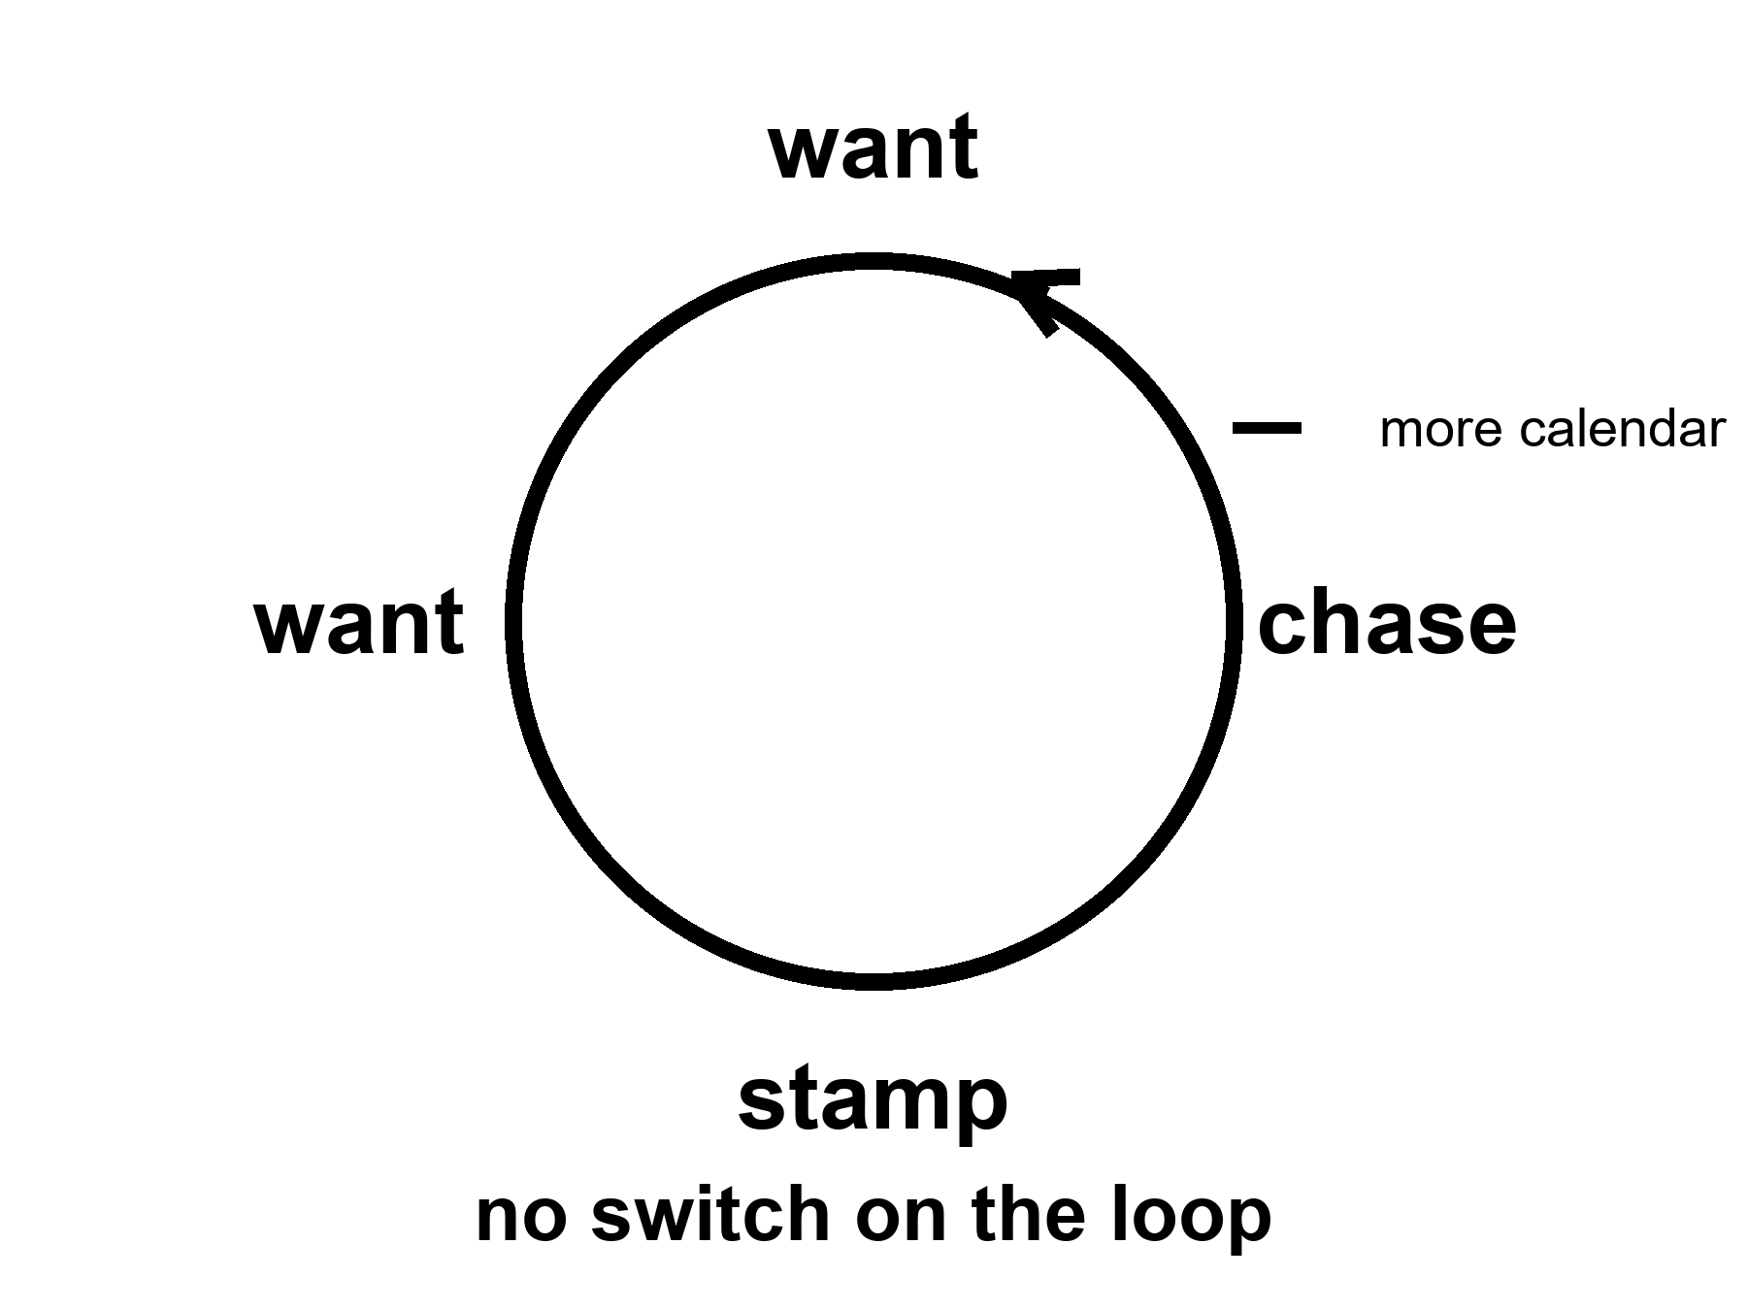
Figure 10. A loop: want, chase, stamp, want. No switch. One extra tick marked more calendar.
Food is not a sandwich. Food is a slope.
A body stays organized by running downhill on a difference: hot to cold, charged to spent, food-molecule to ash. The kitchen name for the ash is waste. Heat is the waste you cannot hide. A nervous system is a staff hired to keep the slopes coming — to find the fruit, the salt, the copy, the ally, the shade. The staff does not mail a pamphlet titled reproduce, then maintain. It mails a carrot. Those who found the act reinforcing left more descendants. Those who found it a chore, all else equal, left fewer. Pleasure is not the cosmic point.
where the point is: a copy that ships, and a body that lasts long enough to ship it.
Wanting is one juice. Liking is another.
Wanting is the seek loop: a cue tagged as worth chasing, a go, a narrowing of the room until the cue is got. Dopamine — a brain chemical that carries signals between neurons — in the popular mouth, is this juice, and the popular mouth is not entirely wrong and is too simple. Liking is the completion stamp: do that again. The stamp can be small. The seek can be huge. A person can want a thing they no longer like. A person can like a thing they barely chase. Addiction, in the ugly cases, is a seek loop that has uncoupled from the stamp and from the vote you would cast on a Tuesday. This is not a sermon about vice. It is staffing. The same house hired people who barely want the old feasts, or want a different menu. That is allowed. A lottery that must work on average will throw off quiet tickets.
The carrot has no off-switch labeled this is only a picture.
A gull will sit a giant fake egg in preference to its own. A fish will attack a slab of the right color more fiercely than a rival. That is a supernormal stimulus: the cue, turned up, outbids the thing. We are a primate with cheap infinite pictures, cheap infinite sugar, cheap infinite almost-wins. The factory sells the cue without the invoice — no second person who can leave, no pathogen, no child, a new face every thirty seconds; a cupboard of sweetness that would have been a week of hunting; a feed that never ends. Novelty re-opens the wanting. Industry industrialized the novelty. Hot as a mechanism. Not a verdict on a species, and not a proof that everyone bought a ticket. Plenty of people shrug. Plenty of people drown. Both are allowed by the same wiring.
If you have Book 1, Chapter 30 was this loop in the service of a shuffle and a fake. Courtesy: that is all. The rest of the argument, here, does not need a second origin or a solvent paper. It needs a long life.
A longer life is more calendar for the same loop.
That is the sentence the helium slide does not print.
Give a wanting-loop more Tuesdays and you have not given it wisdom. You have given it more cues. More years to chase a status that will not stamp. More years to open a cupboard. More years to refresh a feed. More years to sit a fake egg because the fake egg is larger than the real one and the off-switch was never hired. Some people will use the years for basil and a log. Some will not. The mesh did not select for a 120-year philosopher. It selected for a seeker who did not die before the copy shipped. The philosopher is a late, expensive hobby of a well-fed ape. The hobby is real. It is not a default setting that clocks in when the joint is fixed.
Look first.
A slide that says enhancement is a cue. It is designed — by people who also have a loop — to tag as worth chasing. The tag can be healthspan, which this book will defend as a product. The tag can be a different species by Friday, which this book will not. The difference is not a mood. It is whether the invoice can be named and whether the many clocks were consulted. A parent chasing an enhanced child is a loop aimed at a construction site. A founder chasing 1,000 years is a loop aimed at a fuse that Chapter 3 said is not on the counter. A reader chasing a spare ninety percent is a loop aimed at a cupboard Chapter 8 emptied.
Mismatch is the grown-up word.
A body built for scarcity meets a kitchen of cheap cues. A sleep system built for a dark night meets a cheap light. An attention system built for a leopard and a gossip meets a pocket that never stops gossiping. A status system built for a village meets a planet of strangers who can see you fail. None of this is new as a complaint. It is hot as a pattern, and the industry that builds the pocket has said so out loud: engineers have described tuning a feed’s reward on the same intermittent schedule a slot machine uses, because a payout that arrives unpredictably keeps the seek loop running longer than one that arrives on a clock. A device meant to be checked has, in recent surveys, been checked by its owner well over a hundred times a day. That is not a moral failing measured in willpower. It is a supernormal cue doing exactly the job supernormal cues have always done, built by people who read the same wiring diagram this chapter just read.
The new, ruder fact is what happens when medicine becomes good enough to add calendar without adding an off-switch. HIV became a condition and left people with decades the virus would have stolen — a hot win — and those decades are still lived with the same loops, the same cupboards, the same unkind feeds. The win was the decades. The sermon that the decades would automatically become a wise kingdom was cold.
What would an off-switch even be?
Not a lobotomy. Not a moral lecture. A tool, if it exists, would be something that lets wanting stay hired for the mornings you vote for and stay quieter for the fakes you do not. Sleep is a weak, real version: the night ends the day’s seek. A hearing aid is a weak, real version: the room comes back and the isolation-loop loosens. Education is a slow version: you learn to notice a cue that has no invoice. Therapy, for some, is a practice of uncoupling seek from stamp. None of these is a master switch. The cold version is a drug that deletes wanting. That is not enhancement. That is a different kind of chair.
A second origin might have hired a different carrot, or no carrot, or a committee instead of a skull. Courtesy: that zoo is not this book’s. This ape is. This ape’s loop is old, cheap to spoof, and not a king.
She wants the basil to live. That is a loop. She logs the pH anyway. That is a tool she uses on the loop: a measurement that can embarrass a sentiment. The capsule arrives with an optimistic label. The label is a cue. She takes the dose for the joint, which is a Tuesday she would vote for, and not for the species-change, which is a fake egg. The radio is late. Wanting will not make it early. Light does not care.
The honest upgrade, if you want the noun, is not a longer seek. It is more Tuesdays you would vote to repeat, with the seek still in the house, and a kitchen that knows the difference between a tool and a fake. Chapter 2 split the pots — lifespan in one, healthspan in the other. This chapter says why the pots get confused. The carrot will still be running at 80, and at 100, and at 122 if you are the tail. Plan the morning as if that were true. It is.
Mismatch with more calendar is the polite name for a Pleistocene wanting-loop living in a body the savannah never budgeted for. Wanting stamps; liking is another juice; the off-switch was never on the hiring plan. Sugar, feeds, slots, slides that say enhancement: same family, same mechanism, the cue turned up until it outbids the thing. Look first. A longer healthspan without loop hygiene is more chase dressed as wisdom. Time bought without attention paid is not a win you would vote to repeat.
Where the popular version goes wrong.
The slide promotes the noun and crops the receipt. Look first: ask what was measured, what still needs Earth or a body, what the checklist still leaves empty.
Rule: The carrot has no off-switch. A longer life is more calendar for the same loop. Look first.

PART III — Not a Straight Line

11. The Last Fifty Years Were Not a Straight Line
The last fifty years were real. Vaccines that closed rooms of death. A genome you can read without a monastery. Packets that make a radio on Mars feel like a rude kitchen. Compute that got cheaper while we were looking at the basil. None of that is a myth.
None of it is a method for year 12,000.
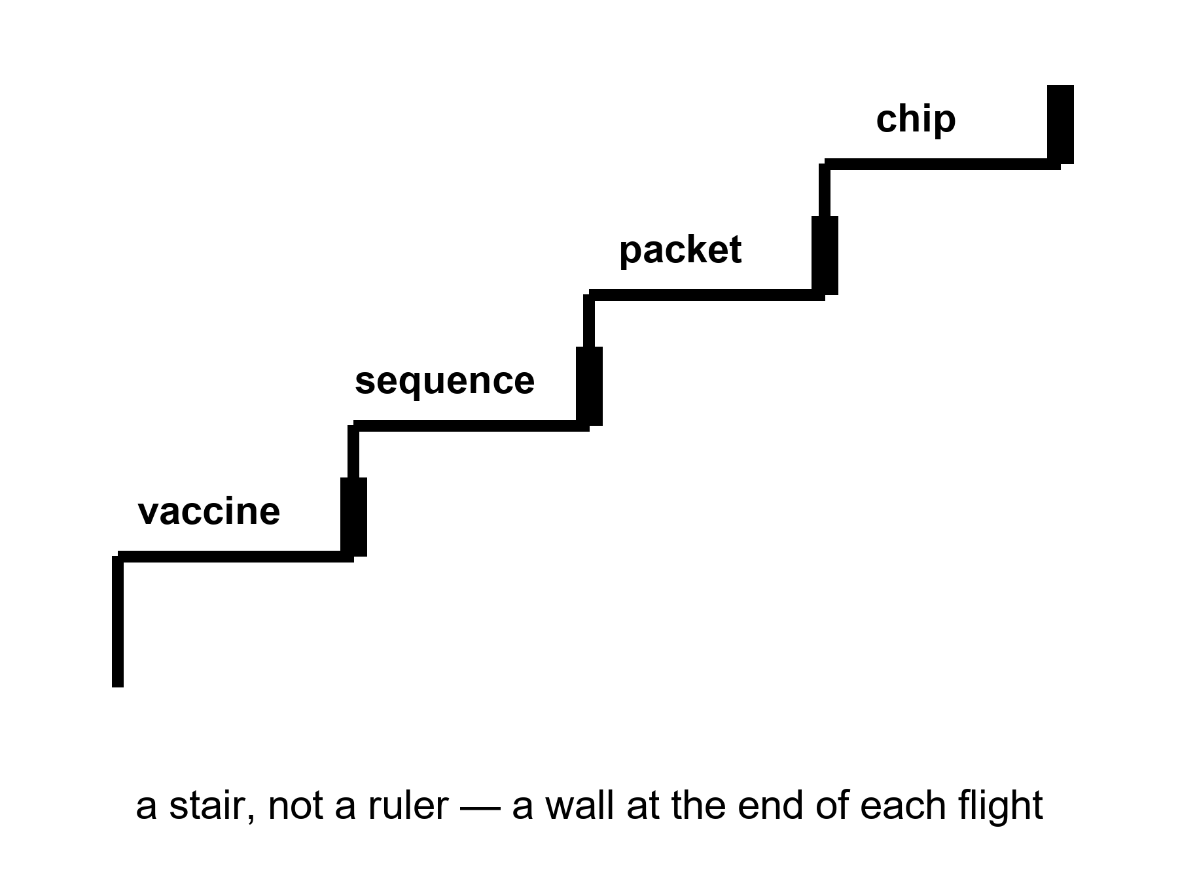
Figure 11. A stair, not a ruler: vaccine, sequence, packet, chip. A wall at the end of each flight.
Hot: the last half-century, in the lucky kitchens, saw uneven, huge gains in a handful of sports. A child in 1975 died of diseases a child in 2025 can miss. Smallpox was already gone; polio was being cornered; measles was a failure of a program when it returned, not a failure of a molecule. Hepatitis B got a shot. HPV got a shot that can close a room of cancers decades later. mRNA platforms, in a pandemic year, turned a sequence into a vial faster than a monastery would have turned a prayer. That is a class of win. It is not a ruler.
A genome you can read without a monastery: the first human draft cost on the order of three billion dollars and thirteen years of argument, finished in 2003. A generation later, the same order of letters can be sequenced for a few hundred dollars in a day — a drop of three or four orders of magnitude, one of the steepest cost curves any technology has ever managed, and still a curve, not a hole through the planet. It bought clinics real diagnoses and researchers real cohorts. It did not buy a monastery’s worth of wisdom about what to do with the letters once you have them. Chapter 12 is the curve. Here, keep the fact: we learned to read a book we already had, cheaper, not to write a better one.
Packets: a radio on a dead world that can carry a voice, a picture, a software load, a slipped date. The delay is still light. The clarity is a gift of coding, of error correction, of a network that treats a bit as a bit. Cheap compute sat under the packets and under the sequences and under the slides that now abuse both. A machine that fits in a pocket and outruns a room that used to fill a basement is a real stair. The stair has a wattage, a mine, a dump, and an attention bill. The walls have names.
The walls were always in the house.
Energy. A bit is cheap. A civilization is not a bit. Aluminum, ammonia, steel, a data hall that wants a river, a camp that wants a reactor, a body that wants a thousand watts of food-and-heat: these do not follow a transistor curve. They follow mines, grids, politics, thermodynamics. The last fifty years made some of this cleaner in some zip codes and dirtier in others. They did not repeal heat.
Materials. You can print a model of a pump. You cannot yet print a spare civilization. Rare earths, copper, lithium, a catalyst, a sterile vial, a glove that survives dust: each has a supply chain that can snap. The last fifty years globalized the chain and called the globalization a law. A pandemic and a war taught the kitchen that a chain is a choice.
Attention. A pocket that never stops is not an extra brain. It is a cue factory aimed at Chapter 10’s loop. The last fifty years invented a way to spend a species’ mornings on a feed. That is a gain only if you liked the feed. It is a wall if you wanted the mornings.
War. The same decades that sequenced a genome also spent treasure and blood on fronts that ate both. Knowledge can be lost in a fire. A lab can be a crater. A generation of technicians can be a grave. Progress is not a law that fires if we wait. Institutions fail. Chapter 16 is that failure with the lights on.
None of this cancels the stairs. It stops you from laying a ruler on them and calling the far end a kitchen you can name.
A techniques board has two columns: what got cheaper and what did not. Vaccines, sequences, packets, transistors: cheaper, then slower, then a wall. Hospital cleaning, a night nurse, a peace, a grid that stays up in a heat wave: not cheaper in the same way, and sometimes dearer. The board will not let a student draw a line from 1975 to 12,000 and write therefore. Therefore is a smuggle.
Mara’s radio is a packet gift and a light-time insult. The gift is fifty years. The insult is Einstein, who is older. She logs the pH with a meter that used to be a lab and is now a tool. The tool is a stair. The basil is still a plant. The plant does not care that the meter got cheaper. The plant cares that the film is honest.
A ledger of the uneven, so “the last fifty years” cannot mean one kitchen.
In the lucky zip codes, childhood death became rare enough to forget, which is how it becomes possible again. In other zip codes the same decades were a fight to keep a fridge cold and a nurse paid. A global average of life expectancy rose, then stumbled, then rose in pieces. HIV became a condition where the pills arrived and stayed a cliff where they did not. A sequence got cheap in a lab that already had a staff, and stayed a rumor in a clinic that did not. Packets made a radio on Mars rude and clear, and made a feed that ate mornings. Compute got cheaper and then spent the savings on a hall that drinks a river so a model can guess the next word.
The board will not let “we” stand in for that ledger. We sequenced. We vaccinated. We invented a pocket. Some of us did. Some of us received. Some of us were the mine. The stair is real. The pronoun is a costume if it erases the invoice.
Mara’s meter is a lucky-zip-code object that rode a cargo to a dead world. Her sister Priya’s clinic, back on the coast, is a different S-curve entirely. Both are this species. Only one of them is in the poster.
Uneven is the honest adjective. A lucky zip code forgot childhood death; another fought for a cold fridge and a paid nurse. HIV became a condition where the pills arrived and stayed a cliff where they did not. Packets made Mars rude and a feed that ate mornings. Compute got cheaper and spent the savings on a hall that drinks a river. The stair is real. The pronoun we is a costume if it erases the invoice. Mara’s meter is a lucky object on a dead world. Priya’s clinic is a different curve. Both are this species. Only one is in the poster. Keep climbing. Rest on landings, where methods survive so the next climber does not reinvent the flight. Store the method. A continuous ray is a sales prop. Leave it on the floor.
Appendix A11 writes the class of wins — vaccines, sequencing, packets, compute — and the named walls. Here, keep the stair. Do not bring a ruler into this room. The next chapter is the shape of a stair that everyone pretends is a rocket.
Where the popular version goes wrong.
The slide promotes the noun and crops the receipt. Look first: ask what was measured, what still needs Earth or a body, what the checklist still leaves empty.
Rule: The last fifty years were stairs, not a ruler. Do not draw a line to year 12,000 and write therefore.

12. S-Curves and Invoices
Progress is logistic more often than exponential. Diminishing returns are a kitchen fact.
An S-curve is a slow start, a drunk middle, a wall. The wall is not a moral. The wall is what a kitchen looks like when the easy fat has been skimmed: the first half of the dirt is cheap to clean, the last corner is a career.
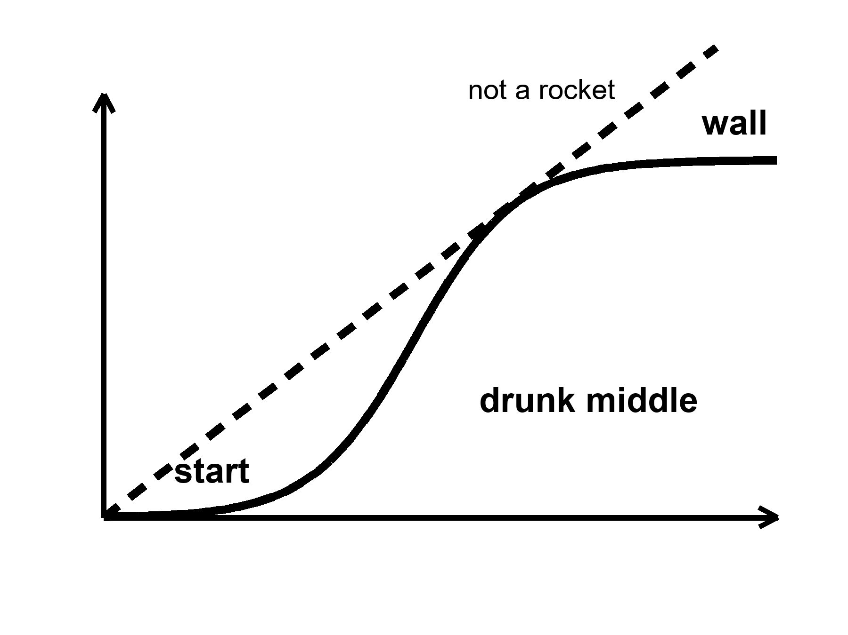
Figure 12. One S: slow, steep, flat. Labels: start, drunk middle, wall. Not a rocket.
where a logistic is a growth that feeds on what is left to gain, and therefore slows as the room fills.
Moore’s law was a social-engineering miracle dressed as physics: pack more switches, keep the bill tolerable, do it on a calendar an industry can bet a factory on. For decades the middle was drunk. Then the watts per switch stopped being polite, the lithography — the process of etching a circuit pattern onto a chip, at a scale smaller than a virus — became a cathedral, and squeezing the next sliver off a transistor’s size became a diplomacy. The curve bent. You can still buy more compute. You buy it with parallelism, with specialist chips, with buildings that drink rivers, with a bill that is no longer a hobby. The sermon that “compute doubles forever” was a middle-of-the-S costume. The costume sold a lot of slides. The wall is not a scandal. The wall is an invoice.
Sequencing rode a steeper drunk years and then met its own floor: the machine is cheap compared with a billion, the meaning is not. A clinic can read a genome and still not know what to do with most of the letters. Interpretation is a staff. A staff is an S-curve of training, liability, and a library of what the letters actually do. The drop in dollars-per-base was real. It was not a drop in dollars-per-wisdom.
Vaccines had S-curves before anyone drew one. The first clean hits — a toxin you can tame, a virus you can weaken — were drunk middles after long starts. The leftover diseases are ruder: a moving target, a poor market, a body that will not keep a title, a politics that will not keep a schedule. mRNA was a new stair in a platform. It did not make every illness a weekend.
Medicine as a whole is a museum of S-curves. Antibiotics are the starkest one: twenty-six chemical classes were found by 1962, in a soil-and-mold gold rush that felt, at the time, like a law of nature. Since then the field has found seven more classes, and only one of those since 1987. The easy soil was mined. What is left is resistance evolving faster than a shrinking search space can answer it, and a business problem on top of a biological one, since a drug you take for a week does not pay back its own discovery the way a drug you take for life does. Heart disease had a drunk middle of pills and stents and a wall of metabolic weather that is a farm and a street. Cancer had many small S-curves, disease by disease, and a leftover that is still a funeral. Imaging got cheaper and then met the bill for the person who has to read the image.
Why the rocket story sells.
Exponential is a feeling. It is a middle of an S photographed without the shoulders. A founder who lived through the drunk years of packets and chips thinks the photograph is a law. A law would not care about energy, materials, attention, or a meeting. A kitchen cares. Diminishing returns are what you get when the next unit of gain costs more than the last: more money, more energy, more rare staff, more side effects, more political fight. The last fifty years skimmed a lot of fat in a few sports. The next fifty, in those same sports, will pay more per increment if the shape is what the shape has usually been.
Warm: whatever is invented will still pay energy, coordination, and the body’s invoices. That is not a proof that nothing new will be invented. It is a proof that the invoice will not be waived because the slide is steep.
Cold: progress is guaranteed if we wait. Knowledge can be lost. A grid can fail. A library can burn. A generation can be taught a smaller book. The loaf, if you met it in the longer volume, does not owe a sequel. You do not need that volume. You need the kitchen fact: waiting is not a method.
S-curves get drawn on napkins for people who arrived with rockets. The napkin is a kindness. Someone has watched a sequencing lab go from a cathedral to a bench and then stall on a variant of unknown significance — and a chip shop go from a miracle to a diplomacy. Keep both. Do not extend either with a ruler to a year that has no furniture.
Mara’s meter got cheaper. The ice did not. Melting the ice is energy and a pump and a morning. The pump has an S-curve: the first reliable pump was a career, the tenth was a spare, the hundredth is a supply chain from a world that still has to send it. She logs the pH. The log is a tool. The tool will not become a fountain because the last fifty years were impressive.
How to read an invoice when the slide is still steep.
The drunk middle of an S is the part that teaches the wrong lesson. You live through years when every quarter is a miracle and you conclude that miracles are a rate. A rate is a ratio with a clock under it. The clock under Moore’s middle was a factory calendar and a voltage that still behaved. When the voltage stopped behaving, the rate did not apologize. It became a building that drinks a river so a specialist chip can pretend the old sermon is still true. Parallelism is real. It is not the same S. It is a new S that starts slow, gets drunk on a different fat, and will meet a wall of its own — watts, water, a staff who can keep the hall honest, a politics that will let the hall exist.
The same hygiene applies to a clinic. A drug that worked in a Phase 3 is a drunk middle for the people who got it. The leftover — the people who were not eligible, the rare harm that shows up in Phase 4, the zip code without a trial site — is the shoulder of the curve. Founders photograph the middle. the napkin keeps the shoulders.
Energy as an invoice is not a mood. A bit can be nearly free and a civilization still pay for aluminum, ammonia, a night nurse, a pump that melts ice. Materials as an invoice is not a mood. You can print a model of a gear and still wait on a catalyst that has one mine. Attention as an invoice is not a mood. Cheap packets made a radio clear and a morning expensive. Coordination as an invoice is Chapter 16. Here, keep the shape: the next unit of gain, in a kitchen that already skimmed the easy fat, costs more than the last. That is diminishing returns spoken without a graph.
Warm: new stairs can still open. A new platform can start a fresh S. Cold: the fresh S is not a repeal of invoices. It is a new drunk middle that will someday meet a wall, and the wall will still have names.
A drug that worked in Phase 3 is a drunk middle for the people who got it. The leftover — not eligible, rare harm in Phase 4, a zip code without a trial site — is the shoulder of the curve. Founders photograph the middle. Keep the shoulders. Middles are temporary. Name the wall or you bought a ray. Sequencing dollars collapsed while the act — this letter, this tissue, this trial — kept invoices. Moore’s middle was a factory calendar and a voltage that behaved; when the voltage stopped, the sermon did not apologize. Compute bent when watts stopped being polite; parallelism is a new S, not the old ray in a hat. Ask for the wall’s address, cost, energy, regulation, attention, war. Keep the S. Cash the middle only as a middle.
Appendix A12 writes logistic shape, Moore’s bend, and sequencing’s dollar drop as a table. Here, keep the S. The next chapter is the arithmetic abuse that turns fifty into ten thousand.
Where the popular version goes wrong.
The slide draws an S and pretends the top is a runway. It is a wall. Drunk middles photograph; walls do not. Ask which wall was waived before you cash the middle as destiny.
Rule: Keep the S. Cash the middle only as a middle. Name the wall or you bought a ray.

13. Ten Thousand Years Is Not ×200
Fifty into ten thousand is two hundred. That is arithmetic. It is not physics.
Claim, cold: last fifty × 200 = the furniture of the year 12,000. We cannot name that furniture. Do not print a 10,000-year gadget catalog. The catalog would be a costume, and the costume would be wrong in both directions: too shy about accidents, too loud about transistors.
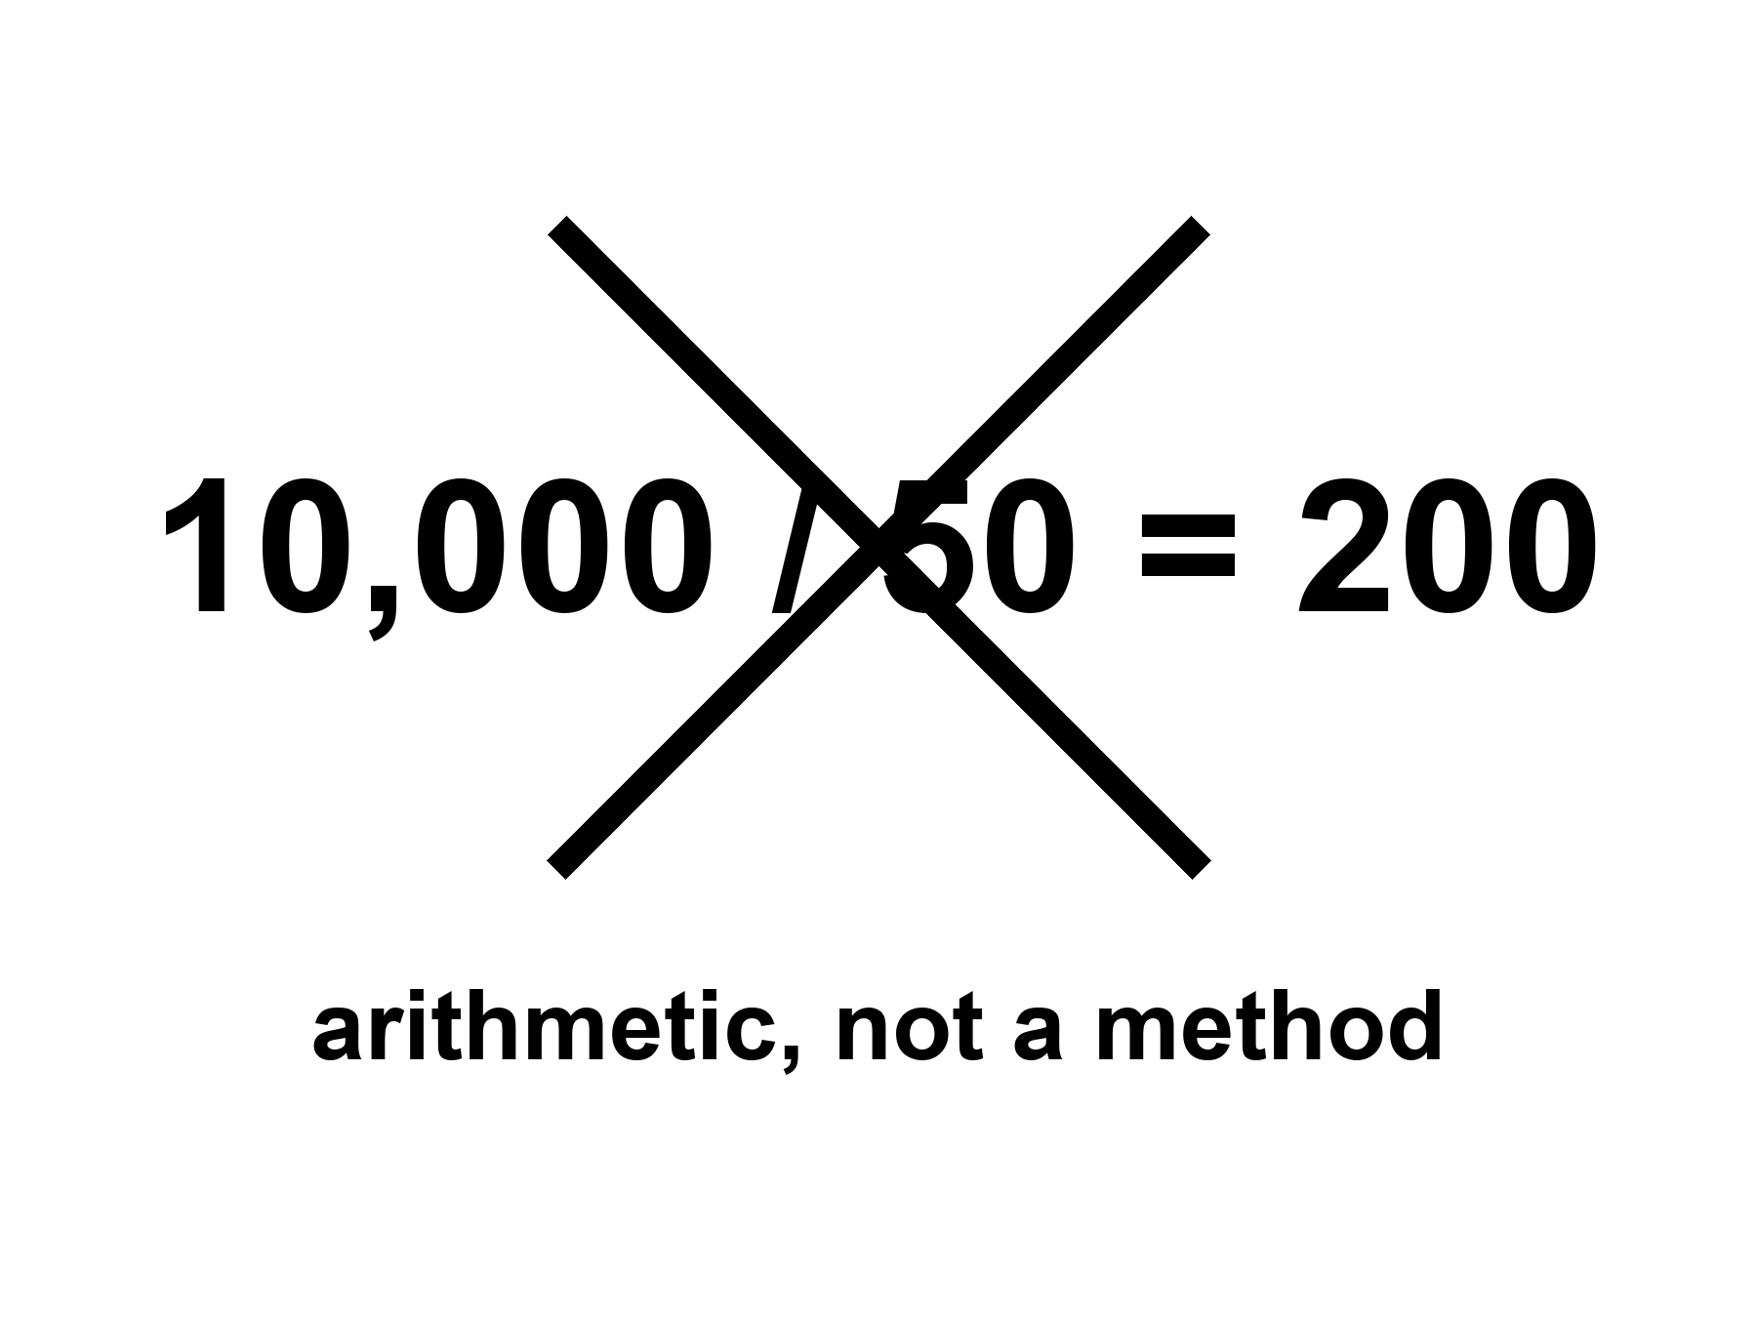
Figure 13. 10,000 / 50 = 200, crossed out. The label: arithmetic, not a method.
where 10,000 / 50 = 200 is a ratio of years, not a law that copies a kitchen 200 times.
What the abuse does: it takes a drunk middle — cheap bits, cheap letters, a vaccine platform — and treats it as a slope that continues through walls, wars, and the body’s many clocks. It then names the far kitchen as if naming were a forecast. Flying cities, helium bodies, spare brains, a mind in a file, energy too cheap to meter, a politics that finally agrees. None of that is selected by a ratio.
What an honest extrapolation is allowed to say:
Energy will still have a bill. Heat will still have to go somewhere. Coordination will still be a meeting, a ledger, a front. Biology will still be many clocks. Knowledge will still be losable. Children will still need a childhood that was not overwritten because a slide said enhancement. We cannot name the gadgets. We can name the invoices.
A gadget catalog for the year 12,000 is cold as a method and rude as a promise. This chapter will not write one. If a later reader lives in a kitchen we cannot imagine, they will not need our catalog. If they live in a poorer kitchen, because a war or a dark age or a simple failure of staff, they will need the invoices more than they need our optimism.
People reach for ×200 because the last fifty felt like more than a lifetime of change. Felt is a measurement of surprise, not of slope. A person born in 1975 met packets, a cheaper genome, a quieter childhood disease, a louder pocket, a climate needle that did not droop. That is a lot of furniture to rearrange in one career. Rearrangement is not a license to multiply the career by two hundred. The century before last rearranged furniture too: engines, wires, vaccines of an older class, a war that ate a generation. If you had multiplied that fifty by two hundred, you would have printed a 3900s kitchen that was all steam and no transistor, or all transistor and no steam, depending on which drunk middle you photographed. The method fails in the rearview. It does not get a promotion because we like this rearview better.
Look first. A slide that says the next 10,000 years of medicine and then shows a 200-year ape is not forecasting. It is Chapter 10’s carrot with a calendar. The calendar is a cue. The ape is a fake egg.
She will not see year 12,000. No one she can radio will. The loaf, if you like the courtesy, already has that year as a region; you cannot rent it. The honest body is a morning. The morning has a pH. The pH is not a gadget from a catalog. It is a number a plant will die over.
A worked example, so the arithmetic has to sit in public.
Take vaccines in the lucky kitchens. Fifty years moved a lot of rooms from death to boredom. Multiply that motion by two hundred and you do not get a 10,000-year ape who cannot get sick. You get a nonsense: either every remaining pathogen politely resigns, or you have invented a biology that is not this biology. The leftover rooms — a moving flu, a poor-market parasite, a politics that will not hold a cold chain — are the wall the ratio waived.
Take compute. Fifty years packed switches until the packing became a cathedral. ×200 is not two hundred more cathedrals of the same kind. It is a wish that heat, lithography, and mines will keep pretending to be a hobby.
Take sequencing. The read got cheap. The act — this letter, this tissue, this trial, this zip code — did not get two hundred times cheaper, and will not, if Chapter 17’s invoices are real.
The method fails the moment you name a sport. That is why the catalog is refused. A catalog is a list of sports with the walls deleted.
What the ratio smuggles when it sounds humble.
Sometimes the slide does not name flying cities. It names more of the same, only better. More healthy years. More clear packets. More letters read cheaper. That costume is warmer than a gadget catalog and still a method error. “More of the same” assumes the drunk middle continues, the walls stay polite, the institutions that delivered the last fifty still exist, and the body keeps accepting the same class of trick. Chapter 12 already said the S bends. Chapter 16 will say the meeting can fail. Chapter 3 already said the clocks are many. Multiplying a half-century of uneven wins by two hundred is a way to delete those sentences without arguing with them.
Temperatures, applied to the far kitchen:
Hot: we cannot name the furniture of year 12,000. That is not humility as a pose. It is a measurement of what a forecast is allowed to do when the variables include wars, dark ages, and biology that is not a transistor.
Warm: energy, heat rejection, coordination, many clocks, and losable knowledge will still be due. Children will still need a childhood that was not overwritten for a slide. Local fixes — a class of edit, a vaccine platform, a tool — can still open doors. Doors are not a downtown.
Cold: last fifty × 200 as a kitchen you can sell. A scheduled thousand-year ape. A mind in a file as travel. Progress as a law that fires if we wait. The catalog this chapter refuses to print.
The rearview is the cheapest experiment. Pick any fifty-year window that felt like destiny — steam, wire, antibiotic, packet — multiply by two hundred, and watch the product fail against the kitchen that actually arrived. The failure is not that people were stupid. The failure is that a ratio of years is not a dynamics. Dynamics include accidents. Accidents do not scale by two hundred. They interrupt.
One more hygiene, because founders love a loophole called expected value.
They will say: we cannot name the furniture, fine; we can still bet that the average kitchen in year 12,000 is richer if we multiply today’s slope. Expected value is a casino word. A casino assumes the game still exists, the dealer still deals, and the house has not burned. Chapters 11 and 16 named the fires. Knowledge can be lost. A grid can fail. A generation can be taught a smaller book. An average that assumes the game continues is not a forecast. It is a hope wearing a spreadsheet. Warm hopes are allowed. Cold hopes sold as method are not.
Mara will not see the far kitchen. She does not need to. She needs a pump that arrives, a film that stays honest, a joint that still opens a jar. Those are invoices with dates. A founder’s skyline labeled 12,000 has no date that can be embarrassed by a measurement. Look first. Ask which wall was waived. Ask which war was cancelled. Ask which childhood was treated as a construction site because a calendar said thank-you.
Felt is surprise, not slope. The last fifty years felt larger than a lifetime because the kitchen changed underfoot. Name a sport — vaccines, compute, sequencing — and the ratio fails the moment a wall appears. There is no catalog for year 12,000 that a body, or a pharmacy, can cash. Extrapolation without a wall is a costume. Cross out the sum. Keep the invoices that will still be due: energy, coordination, a body that ages, a meeting that can fail. Put the costume on the hanger.
Appendix A13 writes the ratio, the rearview failure, and a short list of invoices that will still be due. Here, keep the crossed-out sum. If a founder shows you a skyline labeled 12,000, ask which wall they waived and which war they cancelled.
Where the popular version goes wrong.
The slide promotes the noun and crops the receipt. Look first: ask what was measured, what still needs Earth or a body, what the checklist still leaves empty.
Rule: Ten thousand years is not ×200. Arithmetic is not a method. Refuse the gadget catalog.

14. A Fast Trip Is Not a Long Life
Chapter 13 refused a catalog for the year 12,000. One door to that year is real, and physics holds it open. It opens one way. It charges the traveler the same decades everyone else pays.
Claim, hot: a clock that moves fast, or sits deep in a gravitational well, ticks at a different rate from a clock left behind, and the difference has been measured many times over. Claim, cold: that this is a longevity product. It changes your date. It does not add a heartbeat to your count.
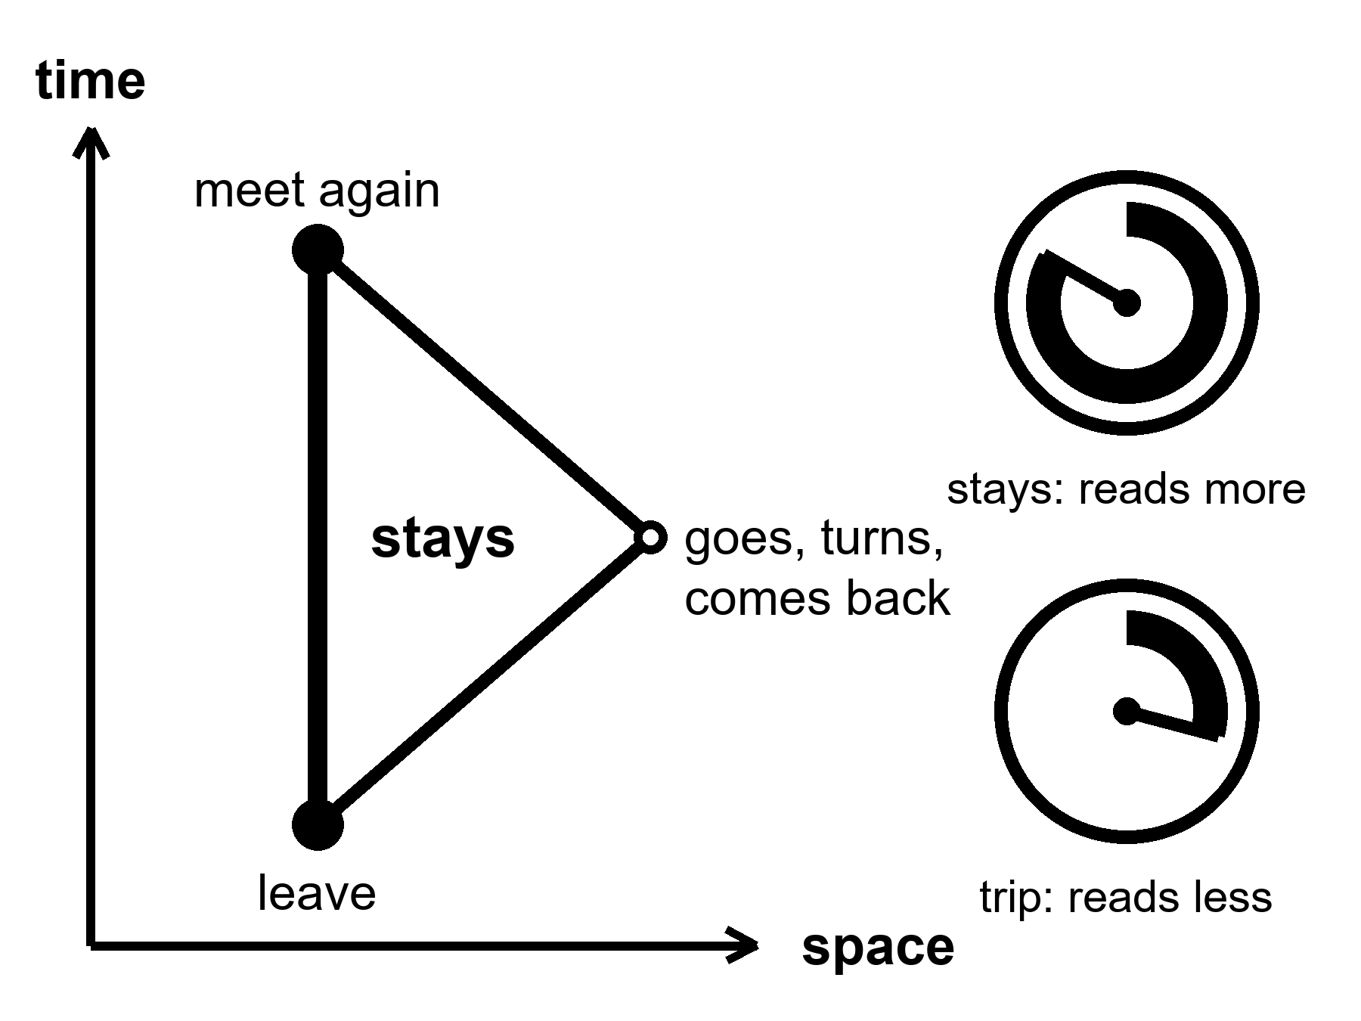
Figure 14. Time runs up the page. Two paths join the same two events. The straight path is the one that stays, and its clock reads the most. Notice that the path that turned around reads less.
where the clock along a path reads the length of that path, measured the way time and space measure it together, and a bend can only shorten the reading.
Draw it with a pencil. Let time run up the page and space run across. A body sitting still is a line straight up. A body that moves is a line that leans. A life is one such line, from a first event to a last. Physicists call that line a worldline, and this book means only the plain thing by it: the whole path, not a snapshot.
Here is the one rule you need. A clock carried along a path reads the length of that path, and length here is not ruler length. Leaning costs you. Between two fixed events, the straight path reads the most, and every bent path reads less. The name for this is maximal aging. The body that is never pushed ages the most.
That is the whole twin story with the paradox taken out. Two events: a departure and a reunion. One twin stays on the straight line. The other leaves, turns around, and comes back. The turn is real. Someone fired an engine, and an accelerometer — a sensor that feels a push or a pull, the same kind that tells a phone which way is up — in the ship would have shown it. Nobody has to argue about who is really moving, because only one of them bent.
This picture-first way of teaching relativity, with a pencil, graph paper, and arithmetic you can check, is the way Lewis Carroll Epstein’s Relativity Visualized teaches it. A reader who wants to keep drawing should go there. The pictures in this chapter are drawn for this kitchen. The debt is the method.
Now the sentence the slides drop. Nothing in the traveler feels slow.
Her heartbeat, her telomeres, the healing of a cut, the whole staff of clocks from Chapter 3 all tick together on the one clock that runs along her own path. A candle in the ship burns at its usual rate. A second is a second. By her own count she lives the same couple of billion heartbeats as anyone. What changes is how much of the world’s calendar goes by while she spends them.
The exchange rate is arithmetic. At ninety percent of the speed of light, her year is a little over two of the home years. At ninety-nine percent, about seven. At 99.9 percent, about twenty-two. At 99.99 percent, seventy-one.
Take the year 12,000. Give her a perfect ship that speeds up at one Earth gravity, the gentle floor-push of an ordinary room, for a quarter of the trip, slows at the same rate for the second quarter, turns, and does it again. She lands home twelve thousand years from now. Her own clock reads about thirty-four years.
She has spent thirty-four years of her life. She arrives in a kitchen nobody can name, in a language that has moved, among people who never voted for her seat. She cannot report back to the ones who sent her. They are dust. Chapter 13 was right about the catalog. This is the one door to the year 12,000, and it is a skip. It is not a refill.
None of this is a costume. Muons, the heavy cousins of the electron, live about two millionths of a second at rest. Sent around a storage ring — a circular accelerator track that holds particles racing in a loop — at CERN, the European particle-physics laboratory, in the 1970s at 99.94 percent of the speed of light, they lasted about twenty-nine times longer in the lab. In 1971 two physicists flew atomic clocks around the world on scheduled airliners and compared them with clocks left on the ground. The flown clocks came back off by tens to hundreds of billionths of a second, behind when they flew east and ahead when they flew west, as the theory said.
The satellites that tell your phone where it is carry clocks that would run wrong by about thirty-eight millionths of a second every day if nobody corrected them. Uncorrected, a position fix would drift by more than ten kilometers a day. A year aboard the space station leaves the crew younger than the twin at home by about nine thousandths of a second. Real. Small. Paid.
Speed is one knob. Depth in a gravitational well is the other.
Einstein’s leap was to notice that standing on a floor and being pushed by a rocket feel the same. If a rocket floor changes what clocks do, then a planet’s floor must change it too. A clock lower in a gravitational field runs slower than a clock higher up. At Earth’s scale the effect is tiny, and laboratory clocks can now resolve it: they can tell apart the height of a single step stool, about thirty-three centimeters. Live your whole life in a cabin a kilometer up a mountain and you are ahead of the sea-level people by about a quarter of a thousandth of a second by your eightieth birthday. That is the bill for a lifetime of altitude.
Her own kitchen has the effect. Mars is a shallower well than Earth, and it sits farther out in the sun’s well. A clock on Mars runs about half a millisecond a day faster than the same clock at home. Her radio is late by four to twenty-one minutes, depending on the week. Those are different things. The radio is late because light takes time to cross. The clock is ahead because the two worlds sit in different wells. She can fix the first with patience. The navigation cell fixes the second with a correction term, sent up the same slow line and logged beside her pH.
Then the picture bends. In Einstein’s account, gravity is not a pull. It is the shape of space and time together, and a thrown stone follows the straightest path there is. Straightest again means longest clock. The stone takes the path on which its own clock reads the most. Same rule, different page.
Push the well as deep as it goes and you have a black hole. As mathematics that is hot. Astronomers have found the real things. No clock has ever been carried there and back. A clock held still near the edge would read far behind the clocks far away. The price is an engine that never stops and, for a small hole, tides that would pull a body apart before it arrived — a smaller hole packs the same crushing gravity into a tighter space, so the pull on your feet can outdo the pull on your head by more than a body can survive. Whatever it learned would reach home stretched and late.
Rohan, who knows the pump and every bad joke about it, catches her reading the correction term.
“Half a millisecond a day,” he says. “You’ll be ahead of mission control by the time you’re old.”
“About seven seconds over a career,” she says. “I’ll take it.”
“That’s the whole prize?”
“That’s the whole prize.”
“If you want the big one,” he says, “go fast enough and come home after they’ve discontinued the pump.”
She logs the pH. The film on the basil does not slow in a ship. Her clock, the plant’s clock, and the chemistry’s clock keep the same time, because they are all hers, on one path. That was always the whole trick. The body keeps its own clock. Relativity only changes what the other clocks say about it.
Now the invoice, because this book always brings one.
Energy. To bring one tonne to 99.9 percent of the speed of light takes about two billion trillion joules. That is about three years of everything humanity burns, dams, splits, and harvests, for one tonne, one way, with nothing aboard to eat or breathe. Stopping costs the same again.
Fuel. A rocket has to carry the fuel it will burn later. For the round trip to year 12,000, even a perfect photon rocket, matter and antimatter turned entirely into light, a machine no one knows how to build, needs more than a quadrillion times the ship’s own mass in fuel. The rocket equation is a wall, and it was named in advance.
Coordination. Someone has to keep the ship, the fuel, and the money for thirty-four of her years while the world outside spends twelve thousand of its own. Chapter 16 is the meeting that can fail. This trip has no one left to call.
Home. The kitchen she left has no seat for her.
Temperatures, applied to the fast trip.
Hot: moving clocks and low clocks disagree with clocks left behind. It is measured in muons, airliners, satellites, and laboratory stools. A traveler’s ship time and the world’s time can differ without limit in the arithmetic. The traveler lives no more ticks.
Warm: any settled world will need its own time standard and a correction to tie it to home. That is a spreadsheet, not a miracle.
Cold: a fast trip sold as an anti-aging plan. A body that ages slowly by its own count. A ship to the year 12,000 as a way to see how it turns out. A physics fact repackaged as a longevity product.
Where the popular version goes wrong.
The slide says fast travelers, astronauts, and people who live at altitude age slower, as if slowness were a refill. Nothing in them is slow. Every clock in the body still ticks together on the one clock the body keeps. What moved was their date, by thousandths of a second for astronauts and by millennia only for a ship no one can fuel. Chapter 19 will say that a file is not this line.
Appendix A14 keeps the arithmetic and the sources. Here, keep the picture: straight is longest, and a bend costs.
Rule: Relativity moves your date, not your ticks. A fast trip is a skip, not a refill.

15. A Long Sleep Is Not a Long Life
Chapter 14 found one real door to a far year: go fast, come home late, and pay for the skip in fuel no one can carry. There is a second, quieter door on the same wall. Instead of moving the traveler’s clock relative to everyone else’s, slow the traveler’s own clock down. No speed limit stands in the way of that one. A metabolism is not the speed of light.
Hot: cooling the body, or suppressing its metabolism, measurably changes how much damage some tissues take from a fixed span of real time. Cold: that a long sleep is a way to skip the years without spending them, the way the fast trip was sold as a way to skip them without aging.
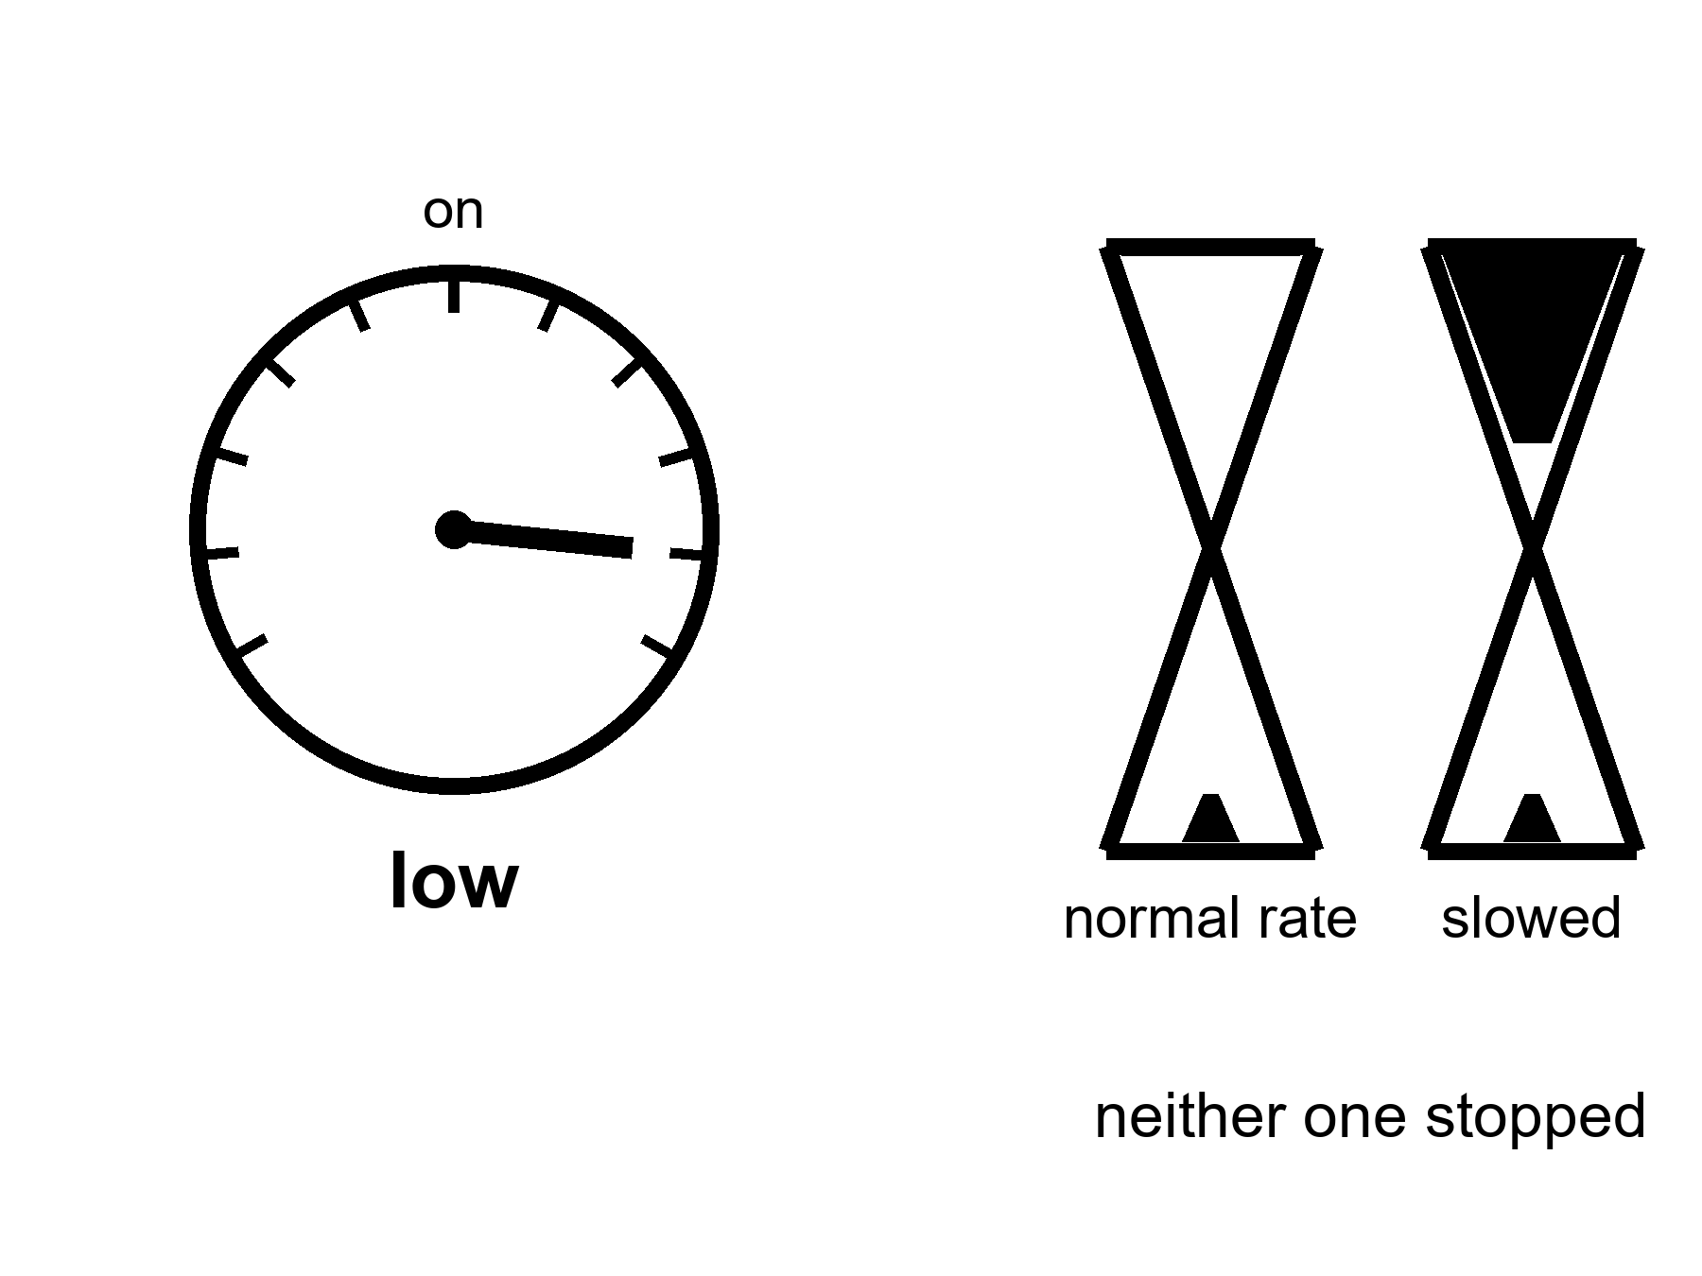
Figure 15. A furnace dial turned down from “on” to “low.” Below it, two identical hourglasses: one draining at the normal rate, one draining slower — neither one stopped.
where “torpor” is a real, reversible drop in body temperature and metabolic rate, seen naturally in hibernating mammals and induced experimentally, in narrower forms, in humans.
Start with the reason this door gets proposed at all: a crew, not a body.
A crewed trip to Mars runs six to nine months each way. Every one of those months needs food, water, air, exercise equipment to fight muscle and bone loss, and something for restless minds to do, which on a six-month drive is also true of the school run and is solved there with considerably less engineering. Space agencies have studied — on paper, in animal experiments, and in a NASA-funded human research program — whether a crew could instead be cooled into a hibernation-like state for the transit: lower body temperature, suppressed metabolism, tube feeding, robotic muscle stimulation to prevent atrophy, and a wake-up on arrival. The habitat that would carry them, and the outline of what the state would need to look like, already has a name in the engineering literature, which is more than can be said for the state itself. Nobody is building it yet. As of this writing there is no evidence any space agency is preparing to place a healthy crew into synthetic hibernation; the human research is aimed at learning whether the state can be induced and reversed safely at all, not at scheduling a flight, whatever the concept art would have you believe.
Human medicine already runs a narrower version of the same idea, and its record is honest and mixed.
After a cardiac arrest, cooling a patient’s body by a few degrees for about a day — targeted temperature management — was shown in an early trial to raise the odds of a good neurological outcome, and the practice spread through emergency medicine on the strength of that result. Later, larger, more careful trials complicated the story: a 2013 trial found little difference between a deeper cooling target and a milder one, and a 2021 trial of over eighteen hundred patients found no significant difference between cooling and simply preventing fever, especially for the more common kind of cardiac arrest. The field did not abandon temperature management. It narrowed the claim: slowing the body’s metabolic demand during a specific injury, in a specific window, can matter, but “cooler is better” was never a general law, and the benefit is neither as large nor as universal as the first headlines said.
The animals that actually hibernate show something stranger than either story.
An arctic ground squirrel in deep torpor lets its core body temperature fall close to freezing and its metabolic rate drop to a small fraction of normal, which is a party trick no committee has ever approved for a human. During that state its brain accumulates a chemical change — a buildup of a protein modification — that in a human would be read as a marker of advanced Alzheimer’s disease. Within hours of warming back up, the squirrel clears it completely, and its neurons, which had pulled back their connections to survive the cold, regrow them past where they started. This is not evidence that cold protects a human brain the way it protects a hibernator’s; humans are not adapted hibernators, and no one has shown the same reversal works in us, whatever the enthusiasts on the internet would like it to mean by Tuesday. It is evidence that a real animal has already solved the hard part of this idea, cycling a brain through a state that would alarm a doctor and back again, many times a winter, for a whole life, without once filing a research grant. That solved problem is one reason torpor research keeps getting funded, whatever a crewed Mars mission ends up doing with it.
Mara sends Rohan a question she has been sitting on since her own outbound leg: whether the crew who planned her transit ever seriously priced the deep-sleep option instead of the long, boring, fully conscious months she actually spent awake in a couch that was not built for a body that could feel time passing.
His answer takes its usual day to arrive. “They ran the numbers,” it says. “Less food, less water, smaller habitat. All real savings. Somebody in an office loved it.”
“And the aging?” she sends back, once she has had a night to decide the question is not rhetorical.
“Nobody’s claiming that part yet. Officially it’s a life-support answer, not a longevity one. Off the record, every mission planner secretly hopes it’s both, the way everyone secretly hopes the diet will also fix their marriage.”
“The squirrels get both,” she says. “We don’t know if we would.”
By the time his next message lands, he has clearly had time to think about it properly, which is either the one advantage of the delay or the one thing it steals. “The squirrels have been doing this for longer than we’ve had a written language. Give it a few centuries. They didn’t need a committee either.”
“So the plan is: wait for evolution to finish the paperwork.”
“The plan,” he says, “is a well-funded question mark with excellent PowerPoint. I wouldn’t have booked the flight, for what that’s worth now.”
She writes the pH down instead of an answer. Some invoices are not due yet, and some were already paid in a couch, months ago, by a version of her who did not get a vote.
Here is what the honest version of this door costs.
Engineering is the first bill: nobody has induced and safely reversed a multi-day torpor state in a healthy adult human; the research so far studies smaller pieces of the problem — drugs, cooling protocols, monitoring — not a finished, flight-ready system. Evidence is the second bill: the clearest human data, cardiac-arrest cooling, shows a real but narrow and shrinking benefit tied to acute injury, not a general slowdown of aging available to a healthy traveler. Species is the third bill: the best evidence that metabolic slowing can be truly protective, not just neutral, comes from animals built by a hundred million years of selection to do this safely every winter, and a human is not that animal with a blanket added. Purpose is the fourth bill, and the most easily forgotten: every serious program studying this is trying to solve logistics for a crew in transit, which is a real, worthwhile, and completely different problem from trying to add years to a life.
Temperatures, applied to induced torpor.
Hot: hibernating mammals genuinely reverse, within hours, brain changes that would read as severe disease in a human; targeted cooling has a real, narrow, evidence-supported role in specific acute injuries like cardiac arrest.
Warm: whether any of this transfers to inducing safe, reversible torpor in a healthy human, for any purpose, is an open and actively funded research question, not a settled no.
Cold: a scheduled human hibernation flight; torpor as a general anti-aging tool; the assumption that slowing the clock during transit would also slow the traveler’s own aging, which nobody has shown and the cardiac-arrest evidence does not support as a general rule.
Where the popular version goes wrong.
The slide shows a hibernating bear next to a sleeping astronaut and calls the second one a life extension technology. Look first: ask whether the study measured a life-support saving, an acute-injury outcome, or an aging outcome — the three are not the same claim, and only the first two have real data behind them yet.
Appendix A15 keeps the trial numbers and the hibernator citations in full. Here, keep the dial: turned down, not off, tested hardest so far on an injured heart and a squirrel’s own winter, not yet on a healthy traveler’s calendar.
Rule: A slower clock is not the same claim as a longer life. Ask which one the study actually measured.

16. Coordination, Wars, Institutions
The limit is often a meeting, a ledger, a famine, a front — not a transistor.
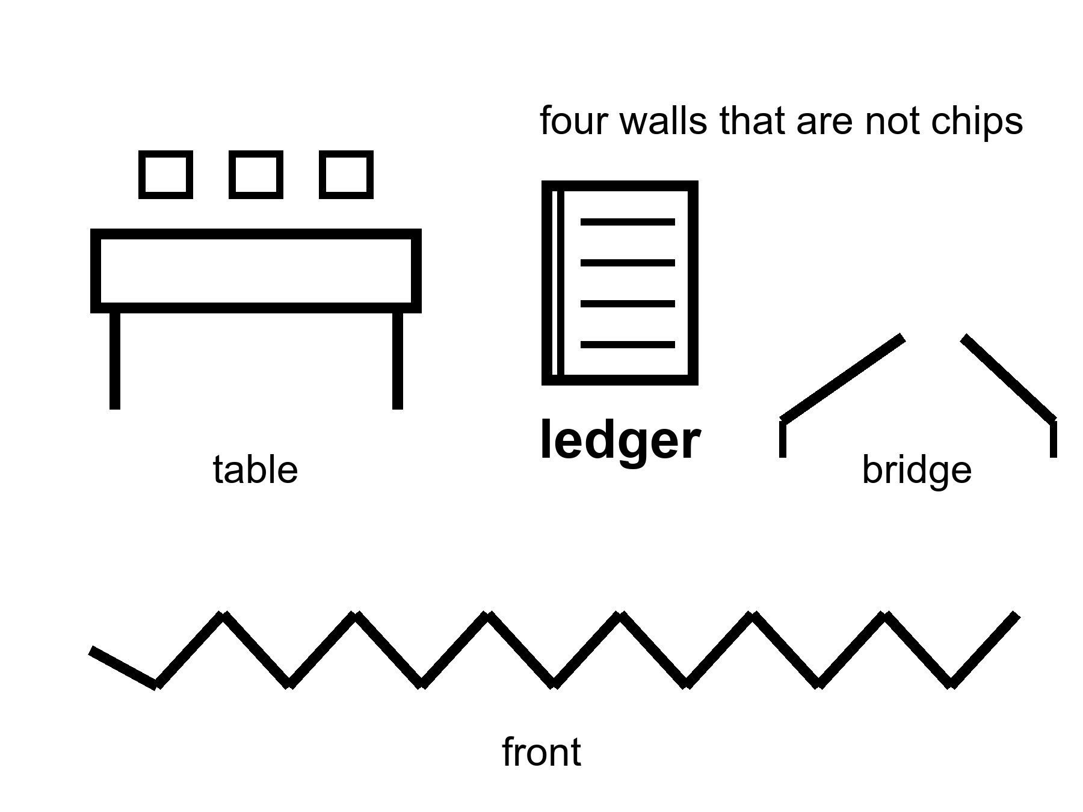
Figure 16. A table, a ledger, a broken bridge, a front. Four walls that are not chips.
A transistor does not vaccinate a neighborhood. A neighborhood is a schedule, a fridge, a rumor, a nurse, a person who will not come because the last campaign lied. A transistor does not keep a grid up in a heat wave. A grid is a union, a spare transformer, a politician who approved the spare, a copper mine, a storm. A transistor does not close a loop on a dead world. A loop is Chapter 12 of the other book’s three nouns, and this chapter’s meeting.
Institutions are slow kitchens. They store the method for running a trial, paying a nurse, keeping a river drinkable, not shooting the technician. When they work, they look like boredom. When they fail, they look like a sudden return to a ruder century. The last fifty years, in the lucky zip codes, were an institution story as much as a chip story: agencies that could still say no, journals that could still retract, a cold chain that could still hold a vial. In the unlucky zip codes they were an institution story too: a clinic that closed, a ledger that was stolen, a front that ate the graduates.
The clearest live example is a disease this book already called a win. Vaccines closed rooms of death, and one of those diseases, wild poliovirus, has been reduced from a global menace to two countries and a double-digit case count some years. It has not been closed, and it has not been closed because the last mile is not a chemistry problem. In Pakistan alone, more than two hundred vaccination workers and the police who guard them have been killed since campaigns began, in a geography that overlaps almost exactly with the areas hosting armed groups that spread the rumor the vaccine is a foreign plot. The virus does not care about the rumor. It cares that the door did not open. A cheap, effective, decades-old tool sits unfinished because a meeting, not a molecule, could not be won.
War is not a subplot. War is a way knowledge dies and a way knowledge is hurried. A front can produce a vaccine schedule and a crater in the same decade. A species that wants a 10,000-year catalog must first want a 10,000-year habit of not burning the library. That habit is not selected by a slide. It is selected, if at all, by politics, which is a meeting that can fail.
Famine is an energy and coordination failure with a body count. It does not care that a lab can edit a letter. It cares that a crop failed, a road was cut, a price was a weapon. The body keeps its own clock; a hungry body keeps a faster one.
Germline enhancement as a front, not a gadget.
Chapter 5 left a door closed. Changing the string — the genome’s long string of letters — in a way that is germline, meaning the change is passed to every cell of the child’s body and to their children after them, in a child who cannot consent, is technically closer than it was. It is still a meeting, a law, a church, a market, a fear, a race between ledgers. A front is this chapter’s kind of wall. Look first. A slide that says enhancement about a childhood is the carrot with a new face. The carrot’s off-switch, which Chapter 10 already said was never on the hiring plan, was not hired here either. This book will not print the catalog of designer children. It will name the invoice: you do not overwrite a construction site because a ruler said year 12,000 would thank you.
A hospital board decides which local fix it can afford this year. The board is real in a thousand towns. It has a sickle-cell-class win — a cure for an inherited blood disease — on the table and a line of other doors, and a budget that is a political weather. The transistor that made the win possible is not in the room. The ledger is. The meeting is. A war two seas away is in the room as a price. Nobody on that board feels like a villain. They feel like a kitchen. The kitchen is the limit more often than the enzyme.
Mara hears, on the delay, that a date slipped because a module did not leave a factory. The factory is an institution. The slip is Chapter 3 of the destinations book, if you have it; you do not need it. A meeting moved a year. A year is not destiny. A meeting is not a transistor. She logs the pH. The plant does not have a board. The plant has a chemistry. The chemistry can be bullied. The bullying still needs a spare part from a world that still has meetings.
Four walls that are not chips, spoken slowly enough to keep.
A meeting. A trial protocol is a meeting that learned to write itself down. A vaccine schedule is a meeting that has to survive a rumor. A hospital board is a meeting that allocates a scarce carpenter. A peace is a meeting that did not fail this year. None of these is selected by packing more switches. Packing more switches can make the slides prettier. The vote still happens in a room with a clock and a person who can say no.
A ledger. Money is not the only ledger. A cold chain is a ledger of temperatures. A river that stays drinkable is a ledger of what was not dumped. A staff of technicians is a ledger of training that can be emptied by a front or a wage. When a founder says the science is ready, ask which ledger still has to clear. Chapter 17’s price-as-delivery is one ledger. This chapter’s stolen clinic budget is another. Both can stop a hot win at the door.
A famine. Food is energy stored in a body that has other clocks. A crop failure is physics and weather and a road. A price used as a weapon is politics. Editing a letter in a lab does not plant a field. A species that talks about thousand-year apes while a ledger of calories fails is performing helium in one zip code and a ruder century in another. The body keeps its own clock; a hungry body keeps a faster one, and then a slower one, and then none.
A front. War hurries some knowledge and burns the rest. It graduates a generation into a grave and calls the survivors a miracle of logistics. Libraries burn. Labs become craters. Supply chains become weapons. A 10,000-year habit of not burning the library is not a transistor curve. It is a politics that has to be re-won, decade after decade, by people who will not see year 12,000 either.
Institutions, when they work, look like boredom on purpose. Boredom is how a fridge stays cold and a nurse stays paid and a retraction still happens. Boredom is expensive. It requires a tax, a trust, a night shift, a person who will still show up when the feed is louder than the job. The last fifty years’ stairs rode on that boredom in the lucky kitchens. Pretending the stairs were only chips is how you forget to fund the boredom, and then wonder why the next S-curve stalls in a meeting.
Look first at germline talk in this light. A childhood is a construction site. Overwriting the string because a ruler pointed at a grateful future is a front dressed as care. The off-switch was not hired. The invoice is consent, law, church, market, fear, and a race between ledgers that do not share a zip code. This book names that invoice and puts the catalog down.
Warm: institutions can learn. A board can choose the sickle-cell-class door this year. A peace can hold. A cold chain can be rebuilt. Cold: progress as a law that does not need the meeting. Hot: the limit is often the table, the ledger, the broken bridge, the front — not the enzyme.
A transistor does not vaccinate a neighborhood. Neighborhoods are schedules, fridges, rumors, nurses, trust. Institutions look like boredom when they work and like a ruder century when they fail. War kills knowledge and sometimes hurries it. Famine is energy and coordination with a body count. Germline enhancement is a front — meeting, law, church, market, fear — not a gadget. A peace is infrastructure; so is a night nurse and a grid that stays up in a heat wave. None of it follows a transistor curve. When any of it fails, the local fix does not arrive, however cheap the molecule became. The hospital board is a kitchen. The enzyme is not in the room. The ledger is.
Appendix A16 writes institutions as a failure mode, war as a knowledge risk, and why a trial is a meeting. Here, keep the table. Part IV is the invoices on the body itself: who gets the local fix, what plasticity actually costs, why a file is not a life, and the morning that is left when helium is put down.
Where the popular version goes wrong.
The slide promotes the noun and crops the receipt. Look first: ask what was measured, what still needs Earth or a body, what the checklist still leaves empty.
Rule: Meetings, ledgers, famines, and fronts can delete methods. Progress is not a law that fires if we wait.

PART IV — The Honest Body

17. Medicine’s Invoices
A local fix is a win with a bill. The bill is not only money. It is a trial that can fail, a side effect that can stay, a conditioning regimen that is not a vitamin, a zip code that was not invited.
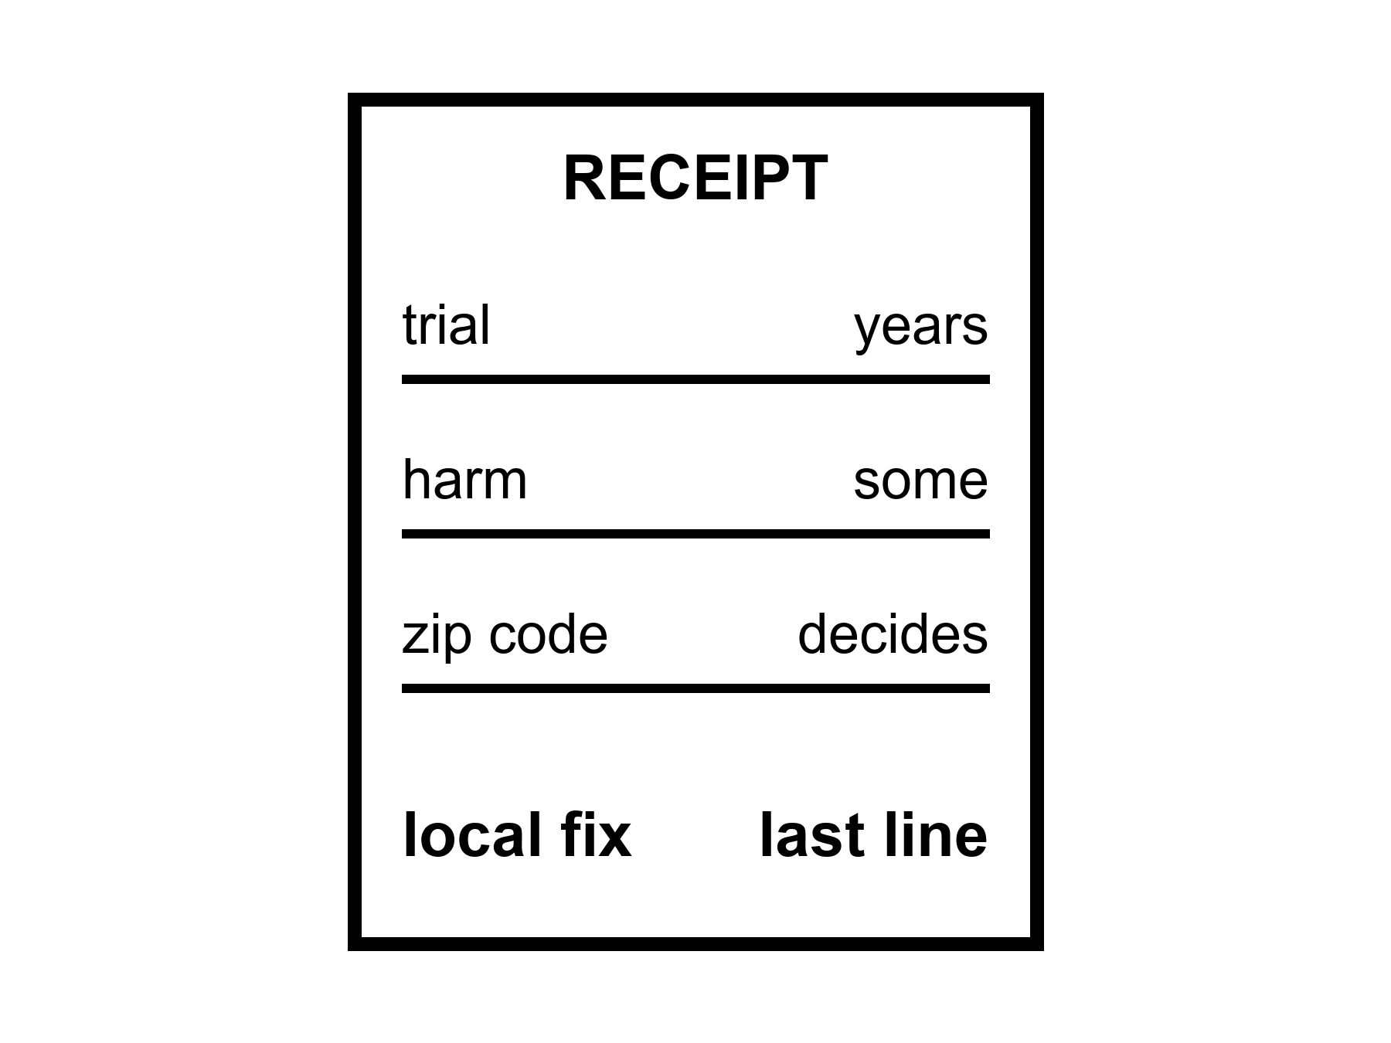
Figure 17. A receipt: trial, harm, zip code. The local fix is on the last line, not the first.
Hot as a class: sickle-cell-class edits, a handful of enzyme replacements (a missing body chemical, delivered by infusion for life), a retinal truck, a CAR-T (a patient’s own immune cells, retrained to hunt a blood cancer), a hip, a cataract, a pill that turns a cliff into a negotiation. Cold as a default: everyone shares those gains. The invoices are unequally paid.
A trial is how a kitchen refuses to take a founder’s word. It is slow, expensive, rude to hope, and still the least-bad way we have learned to not poison a population with a story. Trials fail. They fail because the trick did not work, because the trick worked in a mouse, because the trick worked and the harm was louder, because not enough people could be found, because a war moved the staff. A failed trial is not a proof that the next letter cannot be edited. It is a proof that the invoice includes a no.
Side effects are not fine print. They are the entry fee. Wipe a marrow to make room for an edited lineage and you have bought a month that can kill you on the way to a life that can save you. A drug that clears a plaque and also rattles a vessel is a negotiation, not a halo. A stimulant that buys a morning and steals a sleep is Chapter 9’s toolbox with the lights on. Naming the fee is not pessimism. It is the difference between a tool and a sermon.
Who pays.
A price in the low millions per person, in present ledgers, is a local fix that a kingdom can buy for a few and a village cannot buy for its own. Insurance, a ministry, a charity, a lottery of a lawsuit: these are the real delivery trucks for many of the wins. Delivery of the molecule — getting the fix into the right cells at all — was Chapter 5’s problem. Delivery of the payment is this chapter’s. Modest further healthy-year gains this century in rich-country medicine are warm. Everyone shares them: cold. The same decades that cheapened a sequence did not cheapen a hospital night in some ledgers; they dearened it. An S-curve in a lab is not an S-curve in a bill.
Inequality is not a subplot you add for manners. It is a clock. A body in a zip code without a trial site does not have the same many clocks as a body next to a campus. The clocks are the same biology. The access is a different pot. Healthspan as a product, if it remains a rich-country hobby, is a product that will be sold as a species story and billed as a membership.
Look first. Do not overwrite a childhood in a poor kitchen because a rich kitchen’s slide said enhancement. The child in the poor kitchen may need a vaccine that already exists and a fridge that already exists. The slide likes the new scissors. The fridge is ruder and hotter.
What a trial is, when you sit still with it.
Phase 1 asks: does this kill you on the way in? A handful of people, a dose that climbs, a staff that watches a liver number. Phase 2 asks: does anything useful happen, and to whom? Phase 3 asks: compared with what we already have, in enough bodies that a statistic can be rude. Phase 4, if you get there, is the kitchen after the press release — rare harms, real zip codes, a trick that was clean in a campus and messy in a night clinic. Each phase is a meeting. Each meeting can say no. A no is not a conspiracy against helium. A no is how you do not staff a funeral with a slogan.
Mice lie in a particular way. They live fast, they are inbred, they do not pay rent, they do not have a seventy-year atherosclerosis — arteries silting up over a lifetime — they do not have a human immune memory of a century of viruses. A mouse that lived longer is a paper. A paper is allowed. A paper is not a woman at an airlock. Translation is the unpaid invoice of every fountain slide. Chapter 3 already said the clocks are many. Translation is why a shout at one clock in a mouse dies in a woman who is still running five.
A trial doctor enrolls people and then sits with the ones the trial did not choose. The sitting is the job. There is a win on the wall and a stack of letters that say not eligible. Eligible is a biological word and a geographic word and an insurance word. Do not let a founder use that wall as a downtown. The wall is a door that opened for some. Chapter 7 already said the house has other doors. This chapter says some houses do not get a carpenter.
Mara’s capsule has a label and a delay. Someone paid. A ministry, a contractor, a theater of “crew health.” She takes the dose for the joint. She does not become a different species, and she does not become a proof that her sister will get the same dose.
Her sister’s name is Priya, and the letter that comes in on the same downlink as everything else says the trial two ferries from her clinic closed enrollment before her scans came back. Not a villain. A number: the study needed a narrower biology than hers, and narrower biology fills faster in a city with three hospitals feeding it than in a coastal clinic with one. Priya will get, if she is lucky, the boring wins instead: a blood-pressure pill that has existed since before Mara was born, a vaccine that already exists, a surgeon who can still be afforded because the operation is not the one on the poster. Mara reads the letter twice before she answers it, because the honest answer is that a local fix bought for a joint on a dead world and a local fix that closed enrollment on a coast are two ends of the same invoice, and the ledger did not ask either of them what they would have voted for. Boring is hot. Helium is cold. She writes back the only true thing she has: that she is glad Priya still has the surgeon, and sorry that gladness is the whole of what she can send on a fifteen-minute delay.
The receipt, line by line, without a founder’s font.
Trial. A protocol, a statistician, a data lock — the day a trial’s numbers stop being editable — a meeting that can say no. Cost in years and money and hope. Failure is on the invoice as a line item, not as a scandal.
Harm. Conditioning that can kill on the way to a save. A side effect that stays. A drug that buys a morning and steals a sleep. Naming the fee is how a tool stays a tool.
Zip code. Distance to a trial site. A fridge. A nurse. An insurance word that decides whether the molecule is a gift or a rumor. Access is a clock that demographers already know how to count; marketers prefer not to.
Price. Millions per person, in some present ledgers, for a class of edit that is real and narrow. Delivery of payment is delivery of the win. A village without a kingdom’s ledger does not get the last line of the receipt.
Staff. Someone has to run the apheresis — hours hooked to a machine that filters out the needed cells — watch the liver number, teach the family what “not eligible” means without lying. Staff is an S-curve. You cannot download it.
CRISPR-class edits stay local in this book’s mouth: this gene, this tissue, this invoice. They do not become a fountain because the scissors got famous. A sickle-cell-class win on the hospital board is hot as a door and cold as a default for everyone. The temperature split is the hygiene. Laundering starts when the door is photographed and the receipt is cropped.
Warm: modest further healthy-year gains this century in rich-country medicine, if institutions hold. Hot: local fixes exist and have bills. Cold: everyone shares them on a schedule, and the bill was only money.
A morning in the clinic, without a founder’s font.
Rohan sits with a family while Mara’s capsule paperwork is still a rumor on a delay. The wall has a photograph of a win. The desk has a stack that says not eligible in a font designed to look neutral. He does not lie. He names the three clocks: the biology that did not match the protocol, the geography that put the trial two ferries away, the insurance word that turned a molecule into a rumor. The family wanted a downtown. They leave with a blood-pressure pill that already exists and a surgeon’s name that can still be afforded. Boring. Hot. The photograph on the wall does not get to vote.
What “local” costs when you refuse the costume.
A sickle-cell-class edit is a door. The door has a conditioning month that can kill on the way to a save, a staff that cannot be downloaded, a ledger that decides whether the door is a gift or a membership. Hot as a class of win. Cold as a default for every zip code. Warm only if you keep the receipt on the counter where helium cannot sweep it off. Delivery of the molecule was Chapter 5’s truck. Delivery of the payment is this chapter’s. Two trucks. Same rule: a molecule without a route is a press release.
Say it so a smart person does not check her phone: a trial is a meeting that can say no; a mouse paper is not a woman at an airlock; inequality is a clock; keep the receipt.
Where the popular version goes wrong.
The slide crops the receipt. It shows the door that opened and deletes the zip code, the conditioning month, the not-eligible stack, and the nurse who cannot be downloaded. It treats a mouse paper as a woman at an airlock. It calls inequality a subplot instead of a clock. Look first: if the photograph has no invoice, it is marketing wearing a lab coat.
Rule: Keep the receipt. Name eligible as three clocks at once — biology, geography, insurance. Refuse helium as a schedule for everyone. The local fix is the last line, and only for the addresses that can open the door.

18. Adjusting Is Not Spare Capacity
Plasticity is real and expensive. We meet new challenges with the organ we have, plus tools, plus other people. That is already the method. It is not a tank of unused mind waiting for a password.
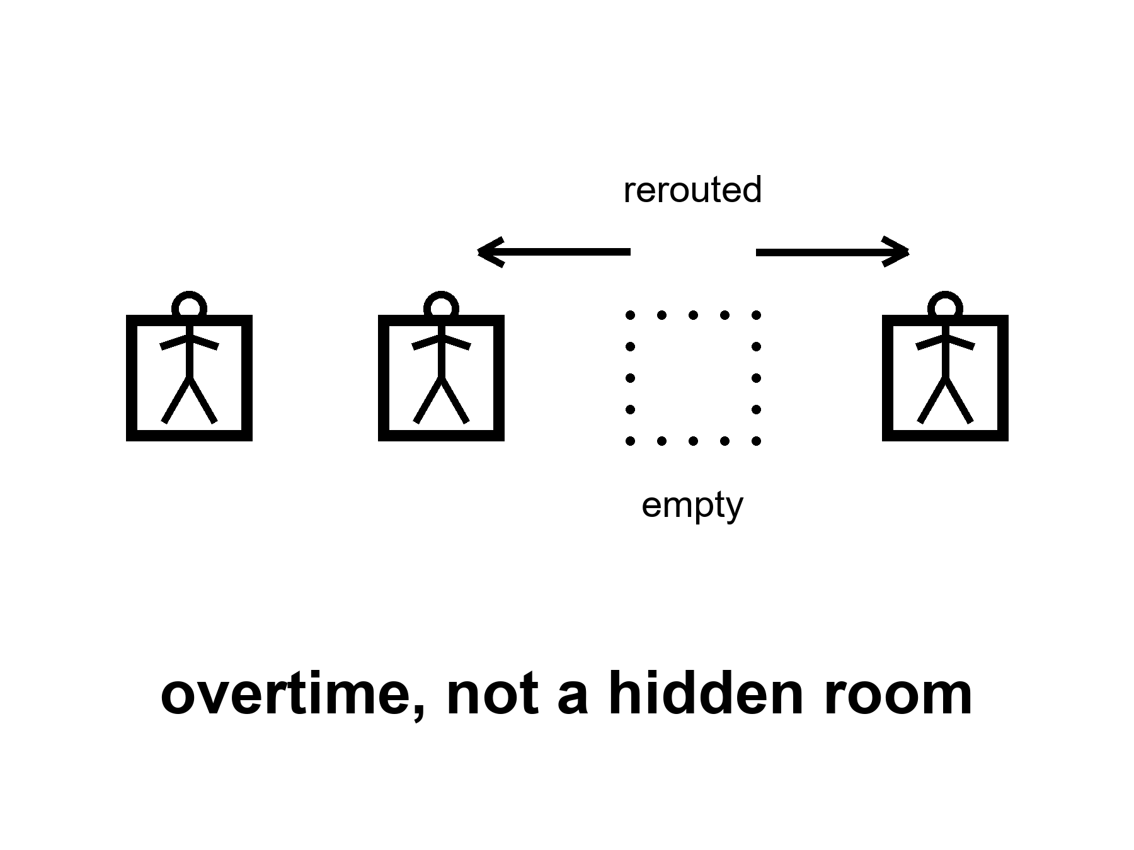
Figure 18. A staff rerouting after a chair is empty. Overtime, not a hidden room.
Hot: a brain can change what it does. Practice thickens a skill. Sleep consolidates. A child whose seizures are severe enough to require removing half the brain can still talk, later, with a cost. An adult can recover a piece of a hand after a stroke, with a year of ugly work. A musician’s map of the fingers is not a civilian’s. A taxi driver’s map of a city, in the old days of paper, was a hippocampus — the brain’s map-room, met already in Chapter 8 — that had been hired extra. None of this is a spare ninety percent. It is a staff doing overtime and rerouting.
Expensive is the word the ten-percent story skips.
Rerouting costs time, watts, frustration, a therapist, a family that will walk the same hallway a thousand times, a sleep that must actually happen. It costs the function you borrowed from. A skill you thicken can thin a neighbor if you are not careful; more often it just eats the mornings you would have spent on a different skill. A child construction site can reroute more cheaply than an adult office. That is development, not a cupboard. Adults pay more per increment. Diminishing returns live in skulls too.
Tools are part of the method, not a confession of failure. Writing is a tool. A checklist is a tool. A hearing aid is a tool. A notebook on a dead world is a tool. Other people are the oldest tool: a crew, a kitchen, a science that is a conversation with the dead and the delayed. A species that meets a new challenge by inventing a tool and teaching it is not a species that had ninety percent off. It is a species that was already on duty and hired help.
New challenges — a climate needle, a new pathogen, a camp on a dead world, a job that does not exist yet — will be met this way or not met. They will not be met by unlocking a hidden loft. Chapter 8 emptied the loft. Chapter 9 put tools on the table. Chapter 10 said the carrot will try to sell the loft again. This chapter is the labor: overtime, not helium.
A second origin might have hired a web, a committee, a mind that is only itself when plugged into itself. Courtesy: that zoo is not this book’s. This ape adjusts with this skull, this sleep, this staff of other apes, this notebook. It is already a great deal. It is not a spare tank.
She learns a new pump the week the old one dies. The learning is ugly. Rohan already knew the pump. She did not. Plasticity is Rohan talking and her hands doing the wrong thing twelve times and then the right thing. No cupboard opened. A colleague and a tool and a morning she would vote for because the water still has to melt. She logs the pH. The log is part of the adjustment. Sentiment named the basil. The log kept it alive.
What overtime looks like when you refuse the loft story.
A stroke takes a hand’s map and leaves a person who has to rebuild a reach with sweat and a therapist’s boredom. The rebuild is real. The bill is a year of mornings that cannot also be spent inventing a new job, a new language, a new self that the slide promised was free. Sensitive periods in a child are cheaper plasticity, not a proof that adults have a tank. Adults pay more per increment. That is hot as a developmental fact and cold as a marketing denial.
Practice thickens a skill and eats a calendar. Sleep consolidates and cannot be replaced by a sermon about unlocking. A crew on a dead world meets a new failure mode the way crews always have: someone talks, someone writes a checklist, someone does the wrong thing until the right thing sticks, someone else already knew. That is Chapter 9’s toolbox with dirt on it. Tools and other people are not confessions that the skull was idle. They are how a staff that was busy from the start hires help.
The ten-percent sentence loved a hidden room. Chapter 8 emptied it. This chapter’s job is the labor theory of mind that remains: you meet novelty with rerouting, watts, frustration, and a notebook. Climate needle, new pathogen, camp chemistry, a job title that did not exist when you were twenty — same method or no method. There is no password. There is overtime.
What the bill itemizes, when you refuse to romanticize it.
Time. A year of hallway walks is a year not spent on a different skill. Plasticity is a budget. Budgets have opportunity costs.
Watts. The skull already runs expensive. Learning adds overtime on top of the baseline bill Chapter 8 named. You cannot invent a free reroute.
Frustration. Error is not optional. Twelve wrong grips on a pump are the method. A slide that sells unlocking deletes the ugly middle because ugly does not fundraise.
Borrowed function. Sometimes the staff that covers for a lost chair was doing another job. Recovery can thin a neighbor map. More often the neighbor is just a morning you no longer have.
Teachers. Rohan on the delay. A therapist. A notebook written by someone dead. Other people are not a workaround for a cupboard. They are the oldest line on the invoice.
Temperatures, short:
Hot: brains change with use, injury, sleep, and teaching; the change costs.
Warm: tools and institutions are part of how this ape adjusts at species scale.
Cold: a spare ninety percent waiting for a key; helium as unlocking; adjustment as proof you were not already on duty.
Mara’s pump week is the whole argument in a blister of time. Rohan’s voice on the delay. Her hands wrong, then less wrong. A log that is not her and still keeps the plant alive. She would vote for the Tuesday. She would not vote for a story that says the learning was free because a cupboard opened. The cupboard was always empty. The staff was always on duty. The overtime was the method.
Look first when a founder says we will adapt. Adapt is a verb with a receipt. Ask who walks the hallway. Ask what sleep was protected. Ask which tool was invented and which childhood was treated as a construction site because adaptation sounded cheaper than a fridge. Adjusting is not spare capacity. It is the capacity you already had, spent — plus help you hired — plus a morning you will not get twice.
A second blister of time, after the pump week.
The joint is a two. The radio is late. Rohan is on the delay teaching a valve she has never seen. She wants the learning to be free — a cupboard opening, a spare self stepping forward. It is not free. It costs the morning she would have spent on the basil log, the sleep she almost skipped, the frustration that is the method. Twelve wrong grips. A right one. No loft. Chapter 8 emptied the loft; this chapter is the invoice for using the staff you already had.
What institutions buy that skulls cannot.
A checklist is a tool. A night nurse is a tool. A school that protects sleep for the people who will walk the stroke hallway is a tool. Species-scale adjustment is not a password; it is overtime plus help plus mornings that do not come twice. Cold: selling that package as unlocking. Warm: naming tools and other people as the method, with no need to call the skull idle. Hot: brains change, and the change costs.
Say it so she stays in the chair: plasticity is real; spare capacity was a sales word; keep the log.
Where the popular version goes wrong.
Adaptation is sold as a free loft: unlock, reroute, done. The kitchen has told you all along that the loft was empty. What looks like spare capacity on a slide is overtime with dirt on it — sleep protected or stolen, a therapist or not, a colleague who knew the pump going in, twelve wrong grips before a right one. A brand that skips the receipt is selling helium as unlocking.
Hot-chair, one breath: the brain you have is already on duty. Practice, sleep, teaching, and other people are the method. A founder who says we will adapt with no receipt is selling the loft Chapter 8 emptied. Ask who walks the hallway. Ask what sleep was protected. Ask which childhood was treated as a construction site because adaptation sounded cheaper than a fridge.
Clinics have known this for years, no sermon required. Stroke teams log overtime. Music teachers log overtime. Crews on a dead world log overtime when a pump dies. The notebook is not romantic. It is the spare that survives the pitch when spare capacity was the brand.
Rule: Plasticity is overtime, not a loft. Keep the log. The notebook is the only spare that keeps showing up.

19. Copies, Uploads, and Cold Immortality
A file is not a worldline.
Cold: a mind poured into a machine, running forever, you in the pour. Allowed as a story. Not selected by present levers. Not selected, either, by a careful reading of what a copy is.
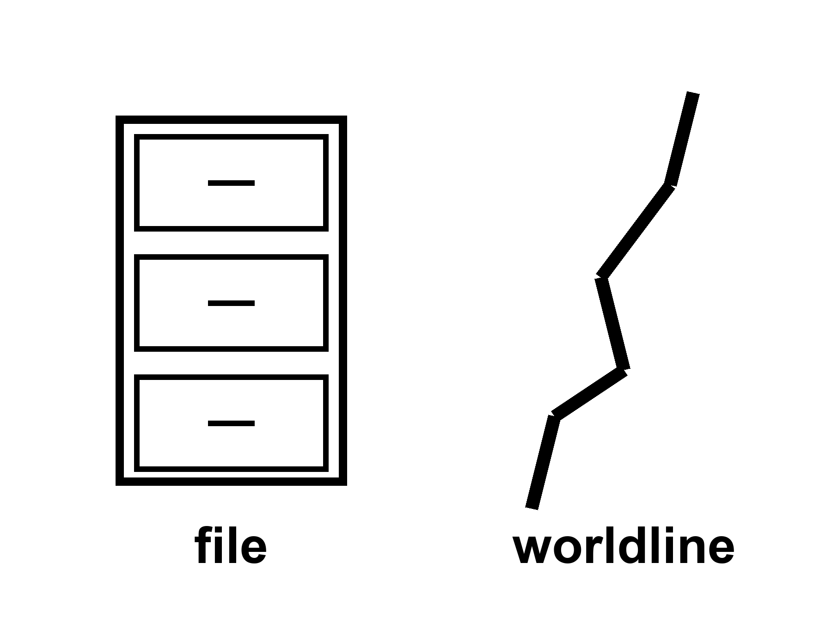
Figure 19. One thread; a box beside it labeled file. The box is not the thread.
If you have the longer book, you have already been told that branches are not destinations and that a required last mind at the end of time fails the leftover shove. Courtesy: that is all. This kitchen can teach the smaller sentence. A scan of a brain, if we had one fine enough — we do not — would be a map. A map is not a walk. Running the map on a substrate that is not the meat would be, at best, a second person who thinks they remember your Tuesdays. The first person would still be in the meat, aging, or dead. Travel did not happen. A photocopy of a letter does not move the sender.
The carrot loves the file. The file looks like an off-switch for death and a spare tank for the mind and a 10,000-year catalog all at once. It is three colds in a trench coat. Death is not an engineering problem with a single port. The mind is not ninety percent waiting to be ported. The catalog is not a method.
What is warm, and should be kept: prostheses, a chip that returns a lost function, a closed-loop stimulator that quiets a tremor, a cochlear implant that is a tool with scars. Local. Chapter 5’s word. A restoration is not an upload. A restoration is a hearing aid with a worse invoice and a better miracle-story. Take the restoration if the Tuesday votes for it. Put the forever-mind down.
Omega-ish stories — a last computation, a required immortality of information, a universe that must end as a mind — stay cold. They were not selected by the accelerating stretch — the universe’s expansion, which is speeding up — and they are not selected by a clinic. Anthroposophy and a craftsman cosmos are a different game. This book does not play them.
Incompleteness, if you need a wall: a formal system cannot be its own finished proof — no set of rules can fully verify itself from the inside. A map of a mind is not obliged to be the mind. That is enough. No sermon from a named book. No helium in a footnote.
She will not be uploaded. The sentence is a kindness. The capsule may keep a joint useful. The radio will stay late. The basil will still need a number. A file of her would be a file. The pH log is already a file, and it is not her. She hits the airlock. The seal is a body fact. Bodies end. The ending is not a failure of a port. It is the size of a worldline.
Copy versus travel, without incense.
A photocopy of a letter leaves the sender at the desk. A twin born tomorrow is not you moved; it is a second person with a shared past up to a cut. A perfect scan — which we do not have — would still be a map unless something continuous carried the walk. Continuity is what death interrupts. Interruption is not solved by naming a hard drive. The second person on the substrate may insist they remember your Tuesdays. Their insistence is a psychology. It is not a ticket stub from your worldline.
What people mean when they say upload, sorted so the temperatures can stick.
Sometimes they mean a backup: a record for historians, a medical chart, a pH log. That is a file. Files are useful. Files are not persons. Mara’s log is already this case.
Sometimes they mean a prosthesis network: sensors and stimulators that keep a body in the game. That is restoration. Local. Warm when the Tuesday votes for it. Not a pour.
Sometimes they mean a second runner who wakes up sure they are you. That is a copy. Hot as a distinction: the first worldline did not travel. Cold as a product if sold as immortality-for-the-original.
Sometimes they mean the original somehow continues in the machine. That claim needs a carrier for continuity that we do not have and a clinic that does not exist. Cold.
The carrot stacks three colds and calls the stack a product. Off-switch for death: cold as a single port. Spare tank for the mind: already emptied in Part II. Catalog for year 12,000: refused in Chapter 13. A file that promises all three is a trench coat. Look first. Ask what was measured. Ask what still ages. Ask who is left in the meat when the copy boots.
Identity talk without a sermon: the kitchen does not need a finished metaphysics. It needs one refusal. Do not let a map launder a walk. Do not let a second person’s confidence launder a ticket. Do not let a restoration’s miracle-story launder a forever. Take the implant if the joint of hearing is what you paid for. Put the port down.
Warm: prostheses and closed-loop tools that return a Tuesday. Hot: a file is not a worldline; travel did not happen. Cold: poured forever-you as a scheduled product; required last mind; helium as a port.
Mara’s kindness to herself is practical. She will not be uploaded. The joint may stay useful. The log will outlast a season and still not be a person. The airlock still needs a seal that fits a body that ends. Ending is not a bug in the export settings. Ending is the size at which a morning can still matter. A species that spends its treasure on better Tuesdays is not a species that failed to find the port. It is a species that stopped waiting for helium long enough to hit the airlock.
Kitchen picture, no incense.
Mara’s pH log is already a file. It keeps the plant alive across a delay. It is not her. If someone copied the log onto a prettier drive and called the drive Mara, the basil would still need a number from hands that age. The copy would remember Tuesdays. The remembering would be a psychology. The worldline in the meat would still be the worldline in the meat. Travel did not happen. A photocopy of a letter does not move the sender; a twin born tomorrow is not you relocated; a perfect scan — which we do not have — is still a map unless something continuous carried the walk. Continuity is what death interrupts. Naming a hard drive does not repair the interruption.
Sort the word upload before the carrot stacks it.
Backup for historians: a file. Useful. Not a person. Prosthesis network that returns a Tuesday: restoration. Local. Warm when the kitchen votes. Second runner who wakes sure they are you: a copy. Hot as a distinction — the first worldline did not travel. Cold as a product if sold as immortality-for-the-original. Original continues in the machine: needs a carrier for continuity we do not have. Cold.
Incompleteness is enough of a wall if you need one: a map of a mind is not obliged to be the mind. No sermon from a named book. No helium in a footnote. Omega-ish required last minds stay cold; they were not selected by a clinic and they are not selected by the accelerating stretch. Take the implant if hearing is what you paid for. Put the port down.
Say it so she does not reach for her phone: a file is not a worldline; a restoration is not a pour; hang the three colds apart.
Where the popular version goes wrong.
Upload is sold as travel. It is not. A map is not a walk. A second person who wakes sure they are you is a psychology, not a ticket stub from your worldline. A prosthetic that returns a Tuesday is a restoration — warm when the kitchen votes for it — and still not a pour. The carrot hangs three colds on one coat (death’s off-switch, spare mind, catalog to year 12,000) because the coat photographs. Hang them apart. Each claim has to earn its own temperature.
Hot-chair, one breath: if the copy boots and you are still in the meat, travel did not happen. If the copy boots and you are dead, the copy is still not your ticket stub — it is a second person with a story. Restorations that return a Tuesday remain warm-to-hot and local. Forever-you as a scheduled product stays cold. Hang death’s off-switch, the spare mind, and the year-12,000 catalog on separate hooks until each earns a temperature. The coat photographs. The hooks tell the truth.
Mara’s kindness is practical. She will not be uploaded. The joint may stay useful. The log will outlast a season and still not be a person. The airlock still needs a seal that fits a body that ends. Ending is not a bug in the export settings. Ending is the size at which a morning can still matter.
Rule: A file is not a worldline. Take the local restoration if Tuesday votes. Refuse the pour. Bodies end. Copies do not travel.

20. The Honest Body
Cash the recognitions.
Lifespan is not healthspan. That split is hot. The product, if you want one, is mornings you would vote to repeat, not a longer evening in a chair.
Aging is many clocks, not one fuse. Hot-to-warm. A shout at one clock does not reset the kitchen.
Gene fixes are local. Sickle-cell-class wins are hot. A fountain is cold. 150, 200, 1,000 as a scheduled product: cold. Modest further healthy years this century in rich-country medicine: warm. Everyone shares them: cold.
We already use the organ. The ten-percent sentence is false. Hot as a correction. Plasticity is real and expensive. A spare-tank unlock is cold.
The carrot has no off-switch. A longer life is more calendar for the same loop. Look first before you call that an upgrade. Do not overwrite a childhood because a slide said enhancement.
The last fifty years were real and not a straight line. Progress is more often an S. Ten thousand years is not ×200. The limit is often a meeting, a ledger, a famine, a front. A file is not a worldline. Forever-mind stays cold.

Figure 20. Hands, a basil tray, a blister, a pH log. The caption: do not wait for helium.
She names the basil. Sentiment does not get to vote. The capsule may buy her a useful season. It will not buy her helium, and it will not unlock a brain she was not already using. She is not a different species. Her hands still age. The dirt still has a chemistry. The chemistry can be bullied. That was always the whole trick. Hit the airlock. Log the pH. Take the local win. Put the sermon down.
If you wanted a thousand-year ape, you should leave with a colder, better want: more mornings that are worth logging. If you wanted a spare ninety percent, you should leave with the organ you were already using, plus a notebook, plus a night’s sleep, plus someone like Rohan who already knows the pump. If you wanted year 12,000’s kitchen, you should leave with the invoices that will still be due, and without a catalog we cannot name. A destinations book, if you want it, will keep her seal and refuse a downtown. A loaf book, if you want it, already refused a cosmic now and a required last mind. You do not need them. You can stop here. The hands will still be the hands tomorrow.
A last inventory, spoken in the tin so it has dirt on it. The capsule is late. The label is still optimistic. The joint is a two today and not an eight. That is a local win. She would vote for this Tuesday: the airlock, the basil, Rohan’s bad joke about the pump, a radio that carries a slipped date and does not get to vote. She would not vote for a longer evening in which the pulse continues and the hands will not open a jar. She does not have a spare mind in the cupboard. She has a notebook. She does not have a file that is her. She has a log that is not her. She does not have year 12,000. She has a film that will go alkaline if she gets sentimental. That is the honest body. It is not small. It is the only size that has ever reliably been for sale.
Cash the inventory by temperature, so a slide cannot rearrange it on the way out.
Hot. Lifespan is not healthspan. The ten-percent sentence is false. Hands age after a useful dose. Sickle-cell-class edits are a real class of local win. The last fifty years produced uneven stairs — vaccines, sequences, packets, cheaper compute — that were not myths. A file is not a worldline. Fifty into ten thousand is two hundred, which is arithmetic, not a method. The limit is often a meeting, a ledger, a famine, a front.
Warm. Aging is many clocks. Modest further healthy years this century in rich-country medicine, if institutions hold. Progress is more often an S than a rocket. Plasticity is real and expensive; tools and other people are part of the method. Whatever is invented still pays energy, coordination, and the body’s invoices. Restorations — hearing, tremor, a joint season — can be worth taking without becoming helium.
Cold. A fountain. A scheduled 150-, 200-, or thousand-year ape. Unlocking a spare tank of mind. Last fifty × 200 as named furniture. Forever-you in a file. A required last mind. Progress as a law that fires if we wait. A childhood overwritten because a ruler said enhancement. The gadget catalog this book refused to print.
How to spend a Tuesday after the inventory. You can keep a capsule without a sermon. You can keep a hearing aid without a spare-tank story. You can keep a sickle-cell-class door open on the hospital board without calling it a downtown. You can teach a pump on a delay without unlocking a loft. You can refuse a file that claims to be a person and still love a log that keeps a plant alive. None of that is small-mindedness. It is temperature hygiene applied to a morning.
Priya, on the coast, still needs the boring wins. The fridge. The vaccine that already exists. The surgeon who can still be afforded. A book that only sings to the lucky zip code has failed its own receipt. Inequality is a clock. Chapter 17 said so. This closing keeps it on the counter so helium cannot sweep it off.
The letter that finally answers Mara’s letter takes its usual day and a half, and says only that the surgery went the boring way: the surgeon showed up, the anesthesia held, the recovery is a hallway walked slowly and then less slowly. No downtown. No fountain. A body that still has to be walked back into working by a staff that was already on duty, on a coast a season’s cargo run away from a joint that is a two today instead of an eight. Mara reads it twice, the way she read the first one, and logs the pH before she lets herself feel anything about it, because the plant does not know its owner is relieved and would die anyway if the film went alkaline. Two sisters, two invoices, paid in the same currency for once: boring, hot, and real.
What to want instead is not a smaller life. It is a colder, better product: mornings you would vote to repeat. The radio will be late. The delay is light. Light does not care. You do not have to care about helium. You have to care about the Tuesday — the one in the greenhouse and the one on the coast, paid for the same boring way, by two different staffs who were already on duty.
Where the popular version goes wrong.
The slide sells helium as a product and crops the Tuesday. Look first: cash the recognitions once; vote for mornings worth repeating; keep Priya’s boring wins on the counter.
Rule: Do not wait for helium. Cash the recognitions once. Vote for the Tuesday you would repeat — and for the Tuesday that did not get the capsule. Seal it.

APPENDIX — The Scientific Detail

How to Read These Notes
Each note An twins popular chapter n. Units are SI unless stated. Brand names rot; classes of win do not.
String theory, if named: cannot currently be tested. It is not needed for a joint or a genome.

A0 / A1. A Local Dose Is Not a Species Change
Hot / warm / cold as in Chapter 1. A local edit that reaches a clinic can warm. A fountain does not warm because the local edit did.
Local: this tissue, this season, this invoice. A joint drug, a lubricant, a replacement, an anti-inflammatory: tools. They do not rewind telomeres, immune grudges, or a hippocampus.

A2. Life Expectancy, HALE, and the Supercentenarian Tail
(1) Life expectancy at birth is a period summary of death rates, not a promise to a baby. HALE (healthy life expectancy) subtracts years lived with disability, weighted.
Rich-country LE: women often low-to-mid 80s; men a little lower (Japan, Switzerland, Spain, Australia, Italy, Nordics as a band). United States: high 70s in recent ledgers after a dip — a rich-country warning, not a law of biology.
Longest documented human life: ~122 years. Tail, not a mean, not a protocol. Supercentenarians (≥110) are a validation sport, not a clinic.
Maximum observed lifespan has not sprinted the way averages did. Averages moved largely by not losing the young.
Modest further healthy years this century in rich-country medicine: warm. Everyone shares them: cold.
A number sold as your real age. Methylation-based “biological age” clocks (Horvath’s original clock, then PhenoAge, GrimAge, DunedinPACE) predict real outcomes — disease, mortality — in large research cohorts: hot as correlates, in that setting, on blood samples, in the cohort that validated them. A 2026 reliability study found that the two most-referenced clocks behind today’s commercial tests, GrimAgeV2 and DunedinPACE, have only moderate-to-good technical reproducibility and were among the least reliable across repeated draws from the same person (pooled intraclass correlation — a 0-to-1 score for how well repeat tests on the same person agree with each other — of 0.4–0.7, none reaching “excellent”), and that a single meal, a stressful week, air pollution, or a trip to altitude can knock one reading into “poor” reliability on its own (Sehgal et al., Aging Cell, 2026). Most direct-to-consumer sellers do not publish which algorithm they run, and a saliva sample carries none of the blood-based validation that makes the research-grade clocks predictive at all. A number that moves with what you had for lunch is not HALE with better branding.

A3. Hallmarks, the Dish Fence, and Why One Switch Is Not on the Counter
(3) Dish-division range: many human cell types in a dish divide about 40–60 times, then senesce. Mechanism accent: telomere attrition and a DNA-damage alarm. Mice are not women (longer telomeres, shorter lives).
Hallmarks (López-Otín class lists grew from 9 toward 12): genomic instability, telomere attrition, epigenetic drift, loss of proteostasis, deregulated nutrient sensing, mitochondrial dysfunction, senescence, stem-cell exhaustion, altered intercellular communication, disabled autophagy, chronic inflammation, dysbiosis. A list of twelve is a confession that there is not one fuse.
Aging clocks (epigenetic predictors): hot as correlates, warm as mechanism, cold as a rewind of a person to twenty.

A4. Naked Mole Rats, Greenland Sharks, and the Limits of “No Aging”
(10) hazard(age) ≈ constant past maturity, for the naked mole rat past its own reproductive maturity — “negligible senescence” (Ruby, Smith, and Buffenstein, eLife, 2018): mortality hazard does not rise with age out to about 25× the age of maturity, unlike every other mammal studied to date. Maximum verified lifespan >37 years; breeding females retain fertility into a third decade; body composition stable from about 2 to 24 years.
Mechanism, on the record: very-high-molecular-mass hyaluronan (more than 5× the human or mouse form, up to about 2.5 MDa), conferring early-contact growth inhibition and near-total cancer resistance (Tian et al., Nature, 2013). A transgenic mouse overexpressing the naked-mole-rat gene for making it (nmrHas2) showed higher tissue hyaluronan, lower spontaneous and induced cancer, reduced inflammation, and extended lifespan and healthspan (Zhang et al., “Increased hyaluronan by naked mole-rat Has2 improves healthspan in mice,” Nature 621, 196–205, 2023).
Greenland shark: eye-lens radiocarbon dating of 28 female sharks put minimum lifespan at 272 years; the largest specimen (502 cm) was estimated at 392 ± 120 years (range 272–512); maturity at roughly 150 years (Nielsen et al., Science, 2016). The longest-lived vertebrate confirmed to date.
Turritopsis dohrnii: reverts from medusa to polyp via transdifferentiation after damage or starvation; theoretically unlimited cycling at the colony/lineage level; individual medusae still die of predation and disease.
Jonathan (Aldabrachelys gigantea hololissa), Saint Helena: hatched circa 1832, about 193 years old as of 2026, the oldest verified living land animal; shows ordinary age-related decline (cataract blindness, lost sense of smell), not negligible senescence.
None of the four is a transferable off switch. Only the mole-rat mechanism has so far been moved into a different species, and there it bought healthspan and cancer resistance, not arrested aging.

A5. CRISPR-Class Edits: This Gene, This Tissue, This Invoice
(4) Local fix: this gene, this tissue, this person, this price, this entry-fee harm.
Sickle-cell-class: a single-letter hemoglobin problem; autologous edit of blood-forming stem cells; often wake fetal hemoglobin by breaking a BCL11A-class switch rather than correcting the letter; conditioning chemotherapy; hospital stay; present prices in the low millions of dollars per person. Exagamglogene-class CRISPR and lentiviral gene-addition cousins: hot as a class (2023-era clinic facts). Not a fountain.
Delivery is most of the problem (AAV, lentivirus, lipid nanoparticles — fatty capsules that ferry genetic material into a cell; liver ≠ brain). Immune memory can forbid a second truck. Germline editing is a front (A16), not a gadget.
Local-fix candidates, pharmacological. Two repurposed drugs carry most of the current human evidence. An mTOR-inhibitor class drug (rapamycin, a transplant drug) and an AMPK-pathway drug already licensed for diabetes (metformin) are the most-tested candidates for slowing age-related decline. The larger human trial of the diabetes drug against aging-related outcomes needs on the order of $75 million and has drawn on philanthropy and public grants rather than industry sponsorship, because a decades-old generic drug has no patent left to sell a company on; as of this writing it has not reported results, and primary results are not expected before 2027–2028. A parallel field trial gives the mTOR-inhibitor drug to several hundred pet dogs — the first rigorous outside-the-lab test of a pharmacologic aging intervention with lifespan and healthspan endpoints in any species — and is still enrolling. Senolytics (drugs that clear senescent cells) are hot in mice; the clearest human test so far, a Phase 2 trial of a senolytic small molecule injected into the knee for osteoarthritis, missed its primary endpoint in 2020 in a 183-patient study, and the company dropped the program. Class, not halo: neither an mTOR inhibitor nor an AMPK-pathway drug is a fountain, a stalled trial does not close a mechanism, and none of this is a green light for a human dose taken outside a trial.

A6. Four-Factor and Three-Factor Reprogramming: Papers, Dates, and the Teratoma Bill
Full four-factor reprogramming (a four-protein cocktail identified in 2006, sufficient to return a somatic cell fully to a pluripotent state, and the basis of the entire induced-stem-cell field): run continuously in vivo in mice, it produced teratomas from multiple organs and circulating iPS cells with totipotency-like features (Abad et al., “Reprogramming in vivo produces teratomas and iPS cells with totipotency features,” Nature 502, 340–345, 2013).
Cyclic full-factor dosing: short pulses (2 days on, 5 days off) of all four proteins in a mouse model of a severe progeroid genetic defect — not ordinary aging — improved several aging hallmarks and extended median lifespan by 33% and maximum lifespan by 18%, with no teratomas reported at that schedule (Ocampo et al., “In Vivo Amelioration of Age-Associated Hallmarks by Partial Reprogramming,” Cell 167, 1719–1733, 2016).
Three-factor local reprogramming (omitting the growth-associated fourth protein): in mouse retinal ganglion cells, restored a younger DNA-methylation pattern and transcriptome, promoted axon regeneration, and reversed vision loss in a glaucoma model and in naturally aged mice; required the demethylases TET1/TET2 (Lu et al., “Reprogramming to recover youthful epigenetic information and restore vision,” Nature 588, 124–129, 2020).
First human trial: an FDA-cleared investigational new drug application for a three-factor reprogramming gene therapy delivered by intravitreal injection (an injection into the eye itself), targeting two optic neuropathies, cleared 28 January 2026 — the first cellular-reprogramming therapy cleared for human testing. Phase 1 only; safety, not efficacy; one organ, one route.
Temperatures: hot as a mouse-tissue and mechanistic result; warm as an active, well-funded research program; cold as a whole-body or general anti-aging claim.

A7. Cancer, Plumbing, Neurodegeneration: Many Doors
Cancer: plural careers of a cell; prevention still the cheap hot work; some five-year survivals moved, others barely. A longer ape is a longer mutational exposure unless you invent a surveillance state inside every tissue (cold as a product).
Atherosclerosis: lipids, pressure, smoke, shear, clot. Pills, stents, bypasses: incremental, hot as classes. Not a rewind of seventy years of dinner.
Neurodegeneration: Alzheimer’s, Parkinson’s, vascular, Lewy, frontotemporal, ordinary narrowing — plural. A plaque-clearing drug with a modest delay is a local, argued result, not a resurrection.
150 / 200 / 1,000 years as scheduled products: cold.

A8. The Ten-Percent Sentence, Lesions, and the Energy Bill
(2) Brain ≈ 2% of body mass, ≈ 20% of resting metabolic rate. A miser mesh does not keep a 90% dark warehouse at that wattage.
The “10%” sentence has no volumetric survey behind it. James-style effort talk mutated into a floor plan. Lesion maps (stroke, hippocampus, cerebellum, white-matter cuts) are a cartography of on duty. Hemispherectomy and slow tumors show development and time can reassign jobs — not that ninety percent was decorative.
False; correction hot. Do not dress as a future unlock.

A9. Tools with Invoices: Sleep, Hearing, Stimulants, Implants
Sleep: consolidation, clearance, a night shift; fragment it and cognition pays. Hearing: loss is a dementia-risk factor in ledgers; aids are tools. Stimulants: small, messy, known invoices (sleep, appetite, habit). Education: the oldest cognitive tech.
Implants that return a lost function (cochlear, tremor loops): local restorations with scars. Unlocking a spare ninety percent: cold.

A10. Wanting, Liking, and Mismatch with More Calendar
Wanting (seek, cue, go) ≠ liking (completion stamp). Supernormal cues outbid the thing (the fake egg). A longer healthspan is more calendar for the same Pleistocene loop, not a wise king as a default.
Book 1 Chapter 30 taught the loop in another kitchen (shuffle, fake). One courtesy. The argument here does not need a second origin.

A11. Vaccines, Packets, Sequence, Compute — and Named Walls
Last ~50 years, uneven and real: childhood-disease rooms closed in lucky kitchens; mRNA as a platform stair; sequencing from ~10⁹-dollar draft to clinic-scale invoices; packets and error-corrected links; cheap compute.
Walls: energy, materials, attention, war, institutions. A stair is not a ruler.

A12. Logistic Growth, Moore’s Bend, Sequencing’s Collapse
(6) Logistic / S-curve: slow start, steep middle, wall as the room fills.
(5) Sequencing cost per human-scale genome dropped by many orders of magnitude from the first draft; interpretation and action did not drop with the same slope.
Moore’s packing had a drunk middle and a bend (watts, lithography as cathedral, parallelism and specialist silicon as the continuation). Exponential is often a middle photographed without shoulders.

A13. Why 10,000 / 50 Is Arithmetic, Not a Method
(7) 10,000 / 50 = 200 is a ratio of years. It is not a physical method and fails in the rearview (any prior fifty, multiplied, prints the wrong furniture).
No gadget catalog for year 12,000. Honest remainder: energy, heat, coordination, many clocks, losable knowledge.

A14. Proper Time, Time Dilation, and the Gravity of Clocks
(8) τ = ∫ √(1 − v²/c²) dt along a path. A clock reads its own proper time τ, the spacetime length of its path. Between two fixed events the unaccelerated path has the largest τ (maximal aging, in the sense of Taylor and Wheeler). Every bent path has less. The twin trip has no paradox: only one path bends, and acceleration is absolute, because an accelerometer reads it.
(9) Δτ/τ (the fractional change in a clock’s rate) ≈ ΔΦ/c² in a weak field, with ΔΦ (the change in gravitational potential) ≈ g h (gravitational acceleration times height) near a surface. For h = 1 km this is 1.1 × 10⁻¹³, about 9.4 ns per day, about 0.27 ms over 80 years. In 2010 optical clocks resolved a height difference of 33 cm.
Every process on a path, chemical or atomic, reads the same τ. No experiment inside a closed ship shows the ship’s own rate. That is why the traveler lives no extra ticks. The method of drawing paths on a page and reading clocks off their lengths follows Epstein’s Relativity Visualized; the drawings here are original. The maximal-aging statement and its bookkeeping are in Taylor and Wheeler.
Case | Number | Note
Lorentz factor at 0.90c, 0.99c, 0.999c, 0.9999c | 2.29, 7.09, 22.4, 70.7 | γ = 1 / √(1 − v²/c²)
Muon storage ring, CERN, 1977 | γ ≈ 29.3; lifetime 2.20 µs → 64.4 µs | Bailey et al.
Airliner clocks, 1971 | ≈ −59 ns eastward, ≈ +273 ns westward | Hafele and Keating
GPS satellite | +45.7 µs/day (gravity) − 7.2 µs/day (speed) = +38.4 µs/day; ≈ 11 km/day of ranging error if uncorrected | Ashby
Space station, 400 km, 7.67 km/s | +3.6 (gravity) − 28.3 (speed) = −24.7 µs/day; ≈ −9 ms per year | crew read less
Mars against Earth | Mars clock ≈ +0.49 ms/day; ≈ 7 s over 40 years | circular-orbit average of the sun’s well, each planet’s well, and orbital speed; varies over the year
Earth–Mars light time | 4.4 to 21 minutes, one way | delay, not dilation
1 g round trip, home 12,000 yr later | ship time ≈ 33.8 yr; peak γ ≈ 3,100 | four phases: speed up, slow down, turn, repeat; home time 4(c/g) sinh η, ship time 4(c/g) η, with η ≈ 8.73 per phase
Ideal photon rocket for that trip | fuel-to-ship mass ratio e^(4η) ≈ 1.5 × 10¹⁵ | all energy as light, no losses: a bound, not a design
Kinetic energy of one tonne at 0.999c | (γ − 1) m c² ≈ 1.9 × 10²¹ J, about 3 years of world primary energy (≈ 6 × 10²⁰ J/yr) | one way, before stopping, before fuel

Temperatures. Hot: moving clocks and low clocks disagree with clocks left behind; measured in muons, airliners, satellites, and laboratory clocks. Warm: a settled world needs its own time standard and a relativistic correction to tie it to home. Cold: a fast trip as a longevity plan; a body that ages slowly by its own count; a ship whose fuel is never tallied.

A15. Torpor, Therapeutic Hypothermia, and What Slowing Metabolism Buys
Spaceflight proposals: torpor-based Mars-transit habitat concepts have been studied on paper, plus NASA-funded animal and human physiology research (including the Studying Torpor in Animals for Space-Health in Humans program), since the mid-2010s. Aim: reduce consumables and habitat mass for a 6–9 month transit, not extend the crew’s own lifespan. No crewed application is scheduled or imminent as of this writing.
Clinical evidence: early trials of post-cardiac-arrest therapeutic hypothermia (32–34°C for about 24 hours) showed improved neurological outcome versus normothermia (about 55% vs. 39% favorable outcome, for ventricular-fibrillation arrest). Later, larger trials narrowed the claim: a 2013 randomized trial found no significant difference between a 33°C and a 36°C target; a 2021 trial of 1,861 patients found no significant difference between hypothermia and simply preventing fever, especially for non-shockable rhythms. Current practice: targeted temperature management remains standard for select patients, with a narrower and more contested benefit than the original 2002 trial suggested.
Hibernator neuroscience: in torpid arctic ground squirrels, brain tau protein becomes hyperphosphorylated to a degree resembling advanced Alzheimer’s pathology, and dendritic connections retract; both fully reverse within hours of arousal, with a compensatory overshoot in synaptic density on rewarming. No human data exists on whether any part of this transfers; humans are not adapted hibernators.
Temperatures: hot as hibernator biology and as a narrow, injury-specific clinical benefit; warm as an open, actively funded research question for induced human states; cold as a scheduled human hibernation flight, or metabolic slowing as a general anti-aging tool.

A16. Meetings, Ledgers, Famines, Fronts
A transistor does not vaccinate a neighborhood or keep a grid up. Institutions store methods; they fail; knowledge dies in fires and fronts. Famine is energy and coordination with a body count.
Germline “enhancement” is a political and ethical front, not a SKU. Look first: do not overwrite a childhood because a slide said the year 12,000 would thank you.

A17. Trials, Harm, and Who Pays for the Local Fix
Trials are how a kitchen refuses a founder’s word; they include no as an outcome. Conditioning, cytokine storms, vessel risk: entry fees, not fine print.
Price-as-delivery: a low-millions local fix is a ministry-or-insurer object. Rich-country healthspan gains warm; universal share cold.

A18. Plasticity Is Real and Expensive
Sensitive periods make children cheaper to reroute than adults. Stroke recovery is overtime, not a hidden room. Practice thickens a map and eats mornings. Tools and other people are part of the method.
Adjusting ≠ spare capacity.

A19. A File Is Not a Worldline
A map of a brain is not a walk. (A14 draws the line a walk makes.) A run of the map is, at best, a second person. The first person remains in the meat or is dead. Travel did not happen.
Restorative chips: local, warm-to-hot as tools with scars. Uploads / forever-mind / required Omega-ish last computation: cold. Book 1 already broke the required last mind on the shove; this note does not reopen the leftover glow.

A20. Inventory of Claims, by Temperature
Hot: moving clocks and low clocks disagree with clocks left behind (measured), so a fast traveler’s date moves and her tick count does not; lifespan ≠ healthspan; hands age; 10% brain sentence is false; sickle-cell-class local wins exist; last ~50 years saw real uneven gains; most near-term humans are not a different species because of a capsule; at least four species combine an ordinary body with negligible senescence, a centuries-long clock, or a damage-triggered developmental reset, and one of those mechanisms has already been moved into a different species; a cyclic four-factor and a local three-factor reprogramming schedule each measurably helped specific mouse tissue, and a first human safety trial (one organ) exists as of January 2026; hibernators fully reverse, in hours, a brain change that would read as severe disease in a human.
Warm: a settled world needs its own time standard, corrected to home; many aging clocks (map real, unified switch not on the counter); modest further healthy years this century in rich-country medicine if institutions hold; S-curves as a pattern; plasticity as expensive reroute; restorative devices; an mTOR-inhibitor and an AMPK-pathway drug as tested, unproven repurposed candidates; whether partial reprogramming or induced human torpor extends beyond their first narrow results.
Cold: a fast trip or a deep well sold as an anti-aging plan; fountain / 150–200–1000 as scheduled products; everyone shares the gains by default; spare-tank unlock; last 50 × 200 = year 12,000’s kitchen; a gadget catalog for that year; progress guaranteed if we wait; uploads as travel; required forever-mind; an animal’s trick as a transferable capsule; whole-body reprogramming or a reprogramming pill; a commercial biological-age number as a measured fact rather than a noisy estimate; scheduled human hibernation as an anti-aging product.

Equations at a Glance
# | Relation | Role
(1) | LE vs HALE | Two pots
(2) | ~2% mass, ~20% resting energy | Brain bill
(3) | Dish fence ~40–60 | Dish limit, not a mystic fuse
(4) | This gene, this tissue, this invoice | Local fix
(5) | Sequencing $ drop | Stair, not wisdom
(6) | Logistic / S | Shape of a gain
(7) | 10,000/50 = 200 | Arithmetic, not physics
(8) | Proper time along a path | Straight is longest
(9) | Clock rate in a weak field, g h / c² | Depth in a well slows a clock
(10) | hazard(age) ≈ constant past maturity | Negligible senescence, not zero mortality
(11) | Inventory in A20 | Temperatures

Further Reading (tiered)
Start here: WHO HALE notes; a hallmarks-of-aging review; a sickle-cell gene-therapy class paper (not a brand halo); any honest history of antibiotics’ S-curve.
For Chapter 14 (clocks and relativity): Lewis Carroll Epstein, Relativity Visualized (Insight Press), the pencil-and-paper spacetime pictures this chapter follows. Edwin F. Taylor and John Archibald Wheeler, Spacetime Physics, 2nd ed. (W. H. Freeman, 1992), for proper time and maximal aging with the bookkeeping. Neil Ashby, “Relativity in the Global Positioning System,” Living Reviews in Relativity 6 (2003). J. C. Hafele and R. E. Keating, “Around-the-World Atomic Clocks,” Science 177 (1972), 166–170. J. Bailey and colleagues, “Measurements of relativistic time dilation for positive and negative muons in a circular orbit,” Nature 268 (1977), 301–305. C. W. Chou and colleagues, “Optical clocks and relativity,” Science 329 (2010), 1630–1633.
For Chapter 4 (comparative biology): R. Ruby, M. Smith, and R. Buffenstein, “Naked mole-rat mortality rates defy Gompertzian laws by not increasing with age,” eLife 7 (2018). X. Tian and colleagues, “High-molecular-mass hyaluronan mediates the cancer resistance of the naked mole rat,” Nature 499 (2013), 346–349. Z. Zhang and colleagues, “Increased hyaluronan by naked mole-rat Has2 improves healthspan in mice,” Nature 621 (2023), 196–205. J. Nielsen and colleagues, “Eye lens radiocarbon reveals centuries of longevity in the Greenland shark,” Science 353 (2016), 702–704.
For Chapter 6 (partial reprogramming): M. Abad and colleagues, “Reprogramming in vivo produces teratomas and iPS cells with totipotency features,” Nature 502 (2013), 340–345. A. Ocampo and colleagues, “In Vivo Amelioration of Age-Associated Hallmarks by Partial Reprogramming,” Cell 167 (2016), 1719–1733. Y. Lu and colleagues, “Reprogramming to recover youthful epigenetic information and restore vision,” Nature 588 (2020), 124–129.
For Chapter 15 (torpor and slowed metabolism): the NASA-funded Studying Torpor in Animals for Space-Health in Humans (STASH) program, for the current state of induced-torpor research. H. Nielsen and colleagues, “Targeted Temperature Management for Cardiac Arrest with Nonshockable Rhythm,” New England Journal of Medicine 381 (2019). The TTM2 trial, NEJM Evidence 1 (2022), for the largest and most recent reappraisal. Any review of arctic ground squirrel tau-protein reversibility during hibernation, for the hibernator-neuroscience result.
Worked numbers added in the craft pass, by chapter. Ch 1: the Global Burden of Disease Study 2021 (osteoarthritis, ~595 million cases worldwide; hand osteoarthritis, ~194 million), The Lancet Rheumatology (2023). Ch 2: J.-M. Robine and M. Allard’s re-verification of Jeanne Calment’s documented age against the 2018 identity-fraud allegation, The Journals of Gerontology (2019). Ch 5: the exagamglogene autotemcel pivotal trial (44 treated, 29/30 crisis-free at 12 months), New England Journal of Medicine (24 April 2024). Ch 7: the Clarity AD (lecanemab) and TRAILBLAZER-ALZ 2 (donanemab) Phase 3 results, for the roughly quarter-to-third slowing of decline on the CDR-SB scale. Ch 9: the 2020 and 2024 Lancet Commission reports on dementia prevention, for hearing loss as the single largest modifiable risk factor; any recent self-report survey of daily phone checks, for the intermittent-reward comparison. Ch 11: the Human Genome Project’s closing cost (~$3 billion, 2003) against a present sub-$1,000 whole genome, National Human Genome Research Institute cost tables. Ch 12: the count of antibiotic chemical classes found by 1962 versus since, as reviewed in Antibiotics (2022). Ch 16: reporting on attacks on Pakistan’s polio vaccination workers and the persistence of wild poliovirus in Afghanistan and Pakistan, Global Polio Eradication Initiative situation reports (2026).
Avoid as medicine: a fast trip or a deep well as an anti-aging plan; a 1,000-year roadmap; the 10% sentence as a future; last-fifty × 200 as a method; a comparative-biology “secret” as a capsule; whole-body reprogramming; a commercial biological-age number as a diagnosis; scheduled human hibernation.

Glossary
Healthspan. Years you would vote to repeat.
Local fix. This gene, this tissue, this bill.
S-curve. Slow, drunk, wall.
Carrot. A seek loop with no off-switch labeled picture only.
File. A map. Not a worldline.
Proper time. The time a clock reads along its own path. The only clock a body ever keeps.
Maximal aging. Between two events, the unpushed path reads the most; a bend reads less.
Negligible senescence. A hazard of death that stays flat past maturity. Not zero. Not immortal.
Partial reprogramming. A nudge back toward a cell’s younger markings, stopped short of the door marked identity lost.
Torpor. A real, reversible drop in body temperature and metabolic rate. A slower clock, not a paused one.

